**Literacy**

**Writing**

* Choose what I want to write about with support, inspired by what I have listened to, watched or read.
* Use knowledge of initial sounds/phonemes to write letters.
* Develop confidence to create own ideas for writing.
* Begin to explore creating texts through play.
* Begin to describe characters and explain likes and dislikes using appropriate vocabulary.

**Reading**

* Recognise that a sentence is something that makes sense on its own.
* Build confidence in selecting and using Reading Tools to help make sense of a text.
* Predict what will happen next in a text.
* Identify environment print and use strategies to explore less familiar print.

**Talking and listening**

* Describe characters and explain likes and dislikes using appropriate vocabulary.
* Share text preferences with others, e.g. likes and dislikes, favourite story and give simple reasons for preference.

**Numeracy**

**Number**

* Number word sequences.
* Subitising to 10.
* Partition numbers .
* Find one more and one less.
* Combine 2 or more quantities to find the total.
* Addition skills.

**Fractions**

* Recognising half of an object.
* Recognise quarter of an object.t

**Money**

* Identifying coins and their value.

**Patterns**

* Copying, continuing and creating patterns with objects, shape and numbers.

**Time**

* Sequencing months in the year
* Identify and engage in devices used to measure or display time.

**Shape**

* Recognise 2D shapes and

3D objects.

**Primary 1**

**Term two**

**Curriculum Map**

Visit our blog:

[https://blogs.glowscotland.org.uk/gc/2021stalbertsp1c](https://blogs.glowscotland.org.uk/gc/2021stalbertsp1c/?p=5&preview=true)

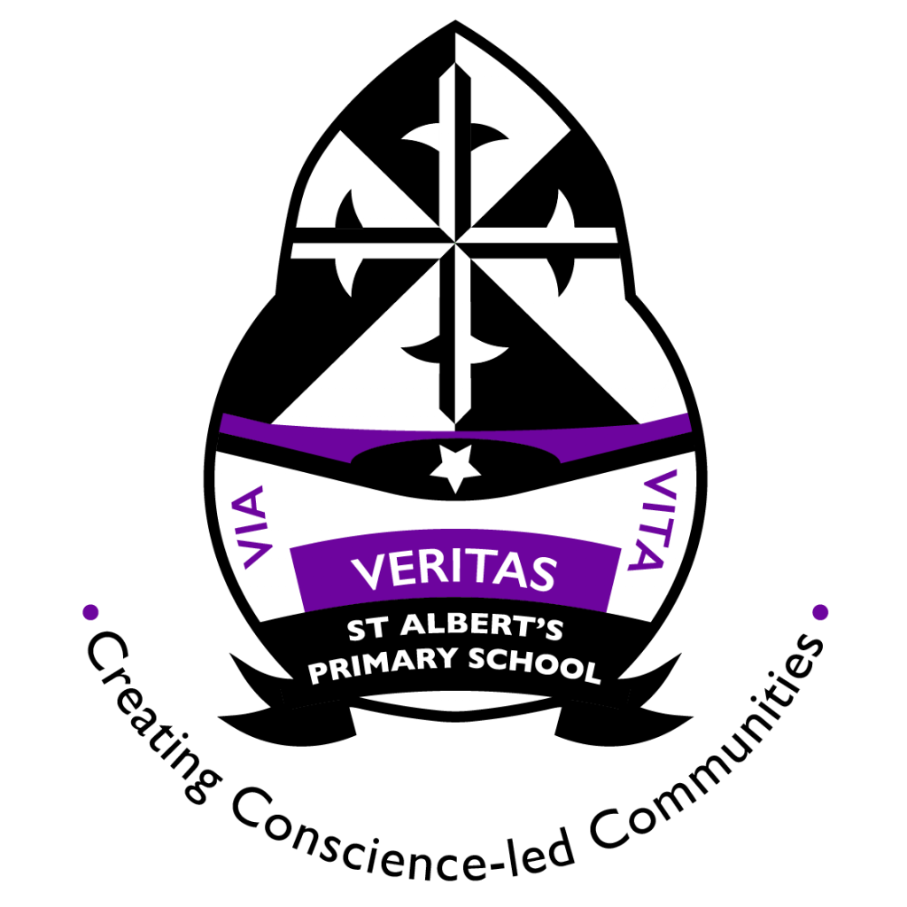

**Interdisciplinary Context for Learning**

As you may already know, the COP26 summit tackling climate change is taking place in Glasgow in November. We will be discussing how we can make a change in or own environments and also looking at trying to persuade others in the local and wider communities to do the same. Our main focus will be-

* Describing and recording the weather, its effects and how it makes us feel.
* Investigating how water can change from one form to another.
* Explore and discover different ways of representing ideas in imaginative ways.

**Expressive Arts-**

**Art**

* Discovering and choosing ways to create images and objects using a variety of materials.
* Create a range of visual information.
* express and communicate my ideas, thoughts and feelings through activities within art and design.

**Music**

* Exploring sound and rhythm using musical instruments and sharing thoughts and feelings about musical experiences.

**Health and Wellbeing/PE**

In PATHs we will explore good choices when we are feeling different emotions, friendships and solving problems with friends. We will also explore different feelings and coping strategies when we have these.

In PE this term we will be focussing on balance, travelling and sequence of movements.