**Numeracy**

**Number**

* Number word sequences.
* Counting forwards and backwards to 20
* Find two more and two less.
* Subtraction skills.

**Money**

* Identifying coins and their value.
* Finding the total of coins through addition calculations.

Measurement

* Compare and describe the lengths, heights ,mass and capacities using everyday language,
* including longer, shorter, taller, heavier, lighter, more and less

**Shape**

* Recognise 2D and 3D shape by name.
* Sort 2D and 3D shapes by characteristics.

**Literacy**

**Writing**

* Convey ideas through play to show understanding of real life purposes for writing e.g. shopping lists, restaurant menus and appointment sheets
* **With support, start to select texts that can be explored for enjoyment**
* **Share likes and dislikes, favourite stories and explain why**
* Enjoy exploring texts and listening to stories read aloud by reading role model
* **Use knowledge of phonics to begin to write own words and sentences.**

**Reading**

* Use knowledge of familiar patterns and stories to find out or predict what will happen next
* Identify some familiar print through play
* Use knowledge of phonics to decode unfamiliar words

**Talking and listening**

* Describe characters and explain likes and dislikes using appropriate vocabulary.
* Share text preferences with others, e.g. likes and dislikes, favourite story and give simple reasons for preference.
* Develop awareness of turn taking in conversations.

**Primary 1**

**Term three**

**Curriculum Map**

Visit our blog:

<https://blogs.glowscotland.org.uk/gc/2021stalbertsp1a>

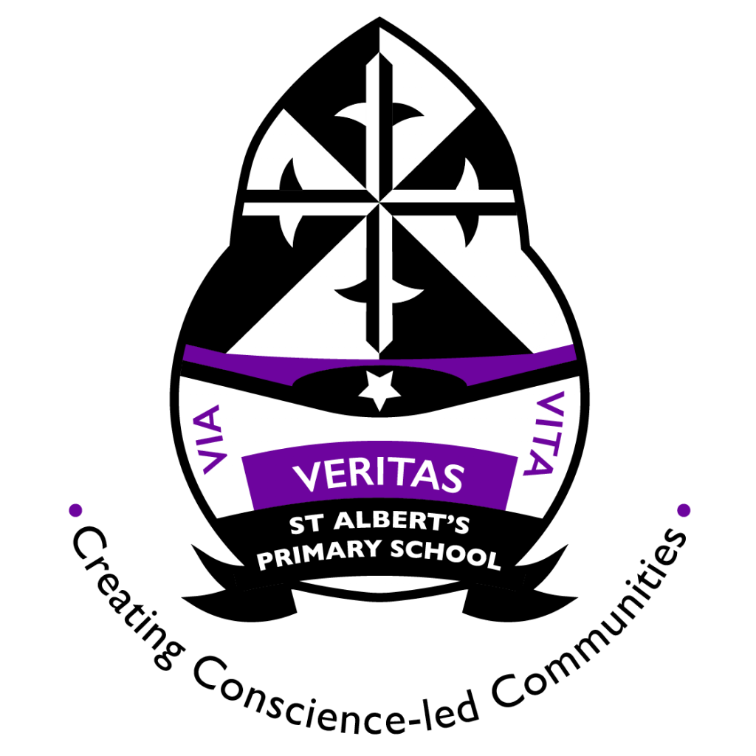

**Interdisciplinary Context for Learning**

This term our whole school focus is looking at innovation in a historical context. Our main focus will be on the camera and images-

* Investigating what was used to capture images prior to the camera.
* Finding out how the camera was invented.
* Exploring how the camera has changed over time and how we use it has changed over the past century.

**Expressive Arts-**

**Art**

* Discovering and choosing ways to create images and objects using a variety of materials.
* Using IDL topic as stimuli for design.

**Drama**

* express and communicate ideas, thoughts and feelings through drama.

**Health and Wellbeing/PE**

In PATHs we will explore good choices when we are feeling different emotions, friendships and solving problems with friends. We will also explore different feelings and coping strategies when we have these.

In PE this term we will be focussing on balance, travelling and sequence of movements as well as fitness, how we can keep fit and why it is important for a healthy body.