**Numeracy**

* Revision of Number Stories to 30
* Addition and Subtraction Sums
* Hundreds, Tens and Units
* Number patters such as counting in 2s, 5s and 10s
* Revision of Mental Maths Strategies
* Measure

**Primary 3**

**Term One**

**Curriculum Map**

Visit our blog:

https://blogs.glowscotland.org.uk/gc/2020stalbertsp3/

**Learning for Sustainability**

* Learning about plants

**Health and Wellbeing**

* **PATHS**
* **Emotions**
* **Healthy Eating**

**P.E**

* Ball Games
* Increasing Fitness

**Expressive Arts**

* Drama – telling stories
* Music – learning to identify instruments and musical concepts.
* Art – using colour to show emotion.

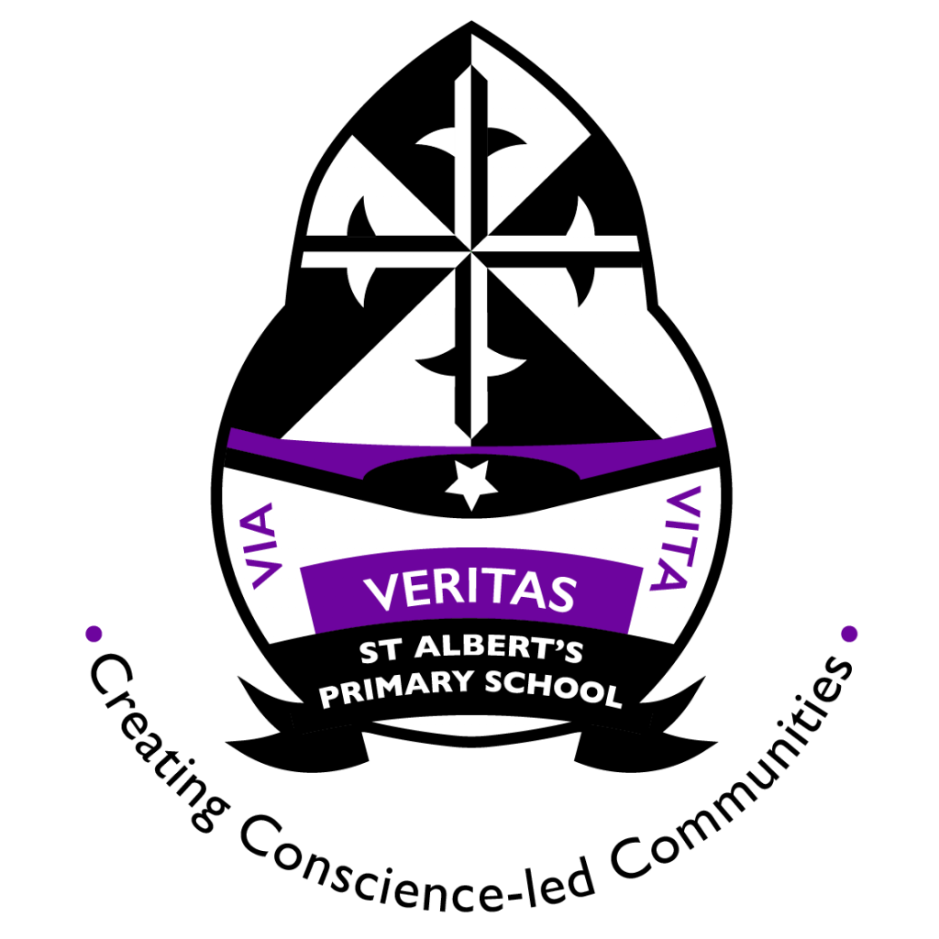

**Literacy**

* Revision of sounds
* Revision of common words
* Revision ofcreating sentences (Capital letters and full stops)
* Using adjectives and WOW words
* Revision of Reading Strategies

**Science Technology/ Forest School**

* Researching for topic.
* Planting Seeds.