**Numeracy**

* Money – identifying coins, making totals, records amounts.
* Time- tell the time using digital and analogue clocks
* Information Handling
* Place value
* Multiplying and dividing

**Primary 2/3**

**Term 4**

**Curriculum Map**

**Visit our blog**

[https://blogs.glowscotland.org.uk/gc/2020stalbertsp23](https://blogs.glowscotland.org.uk/gc/2020stalbertsp23/?p=330&preview=true)

**STEM**

* Inheritance- human and plants.
* Energy sources and. sustainability

**Health and Wellbeing**

* PATHS
* People who help us

**P.E**

* Movement skills- linking actions together to create movements and patterns

**Expressive Arts**

Dance- creating short dance sequences

Art- responding to work of artists

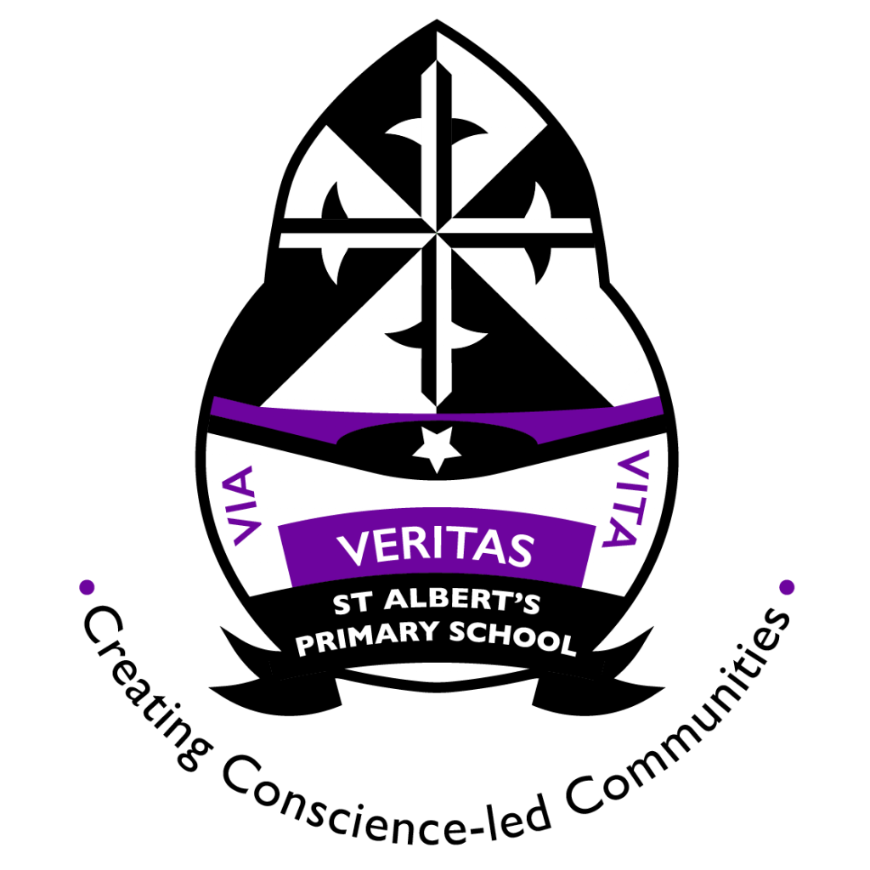

**Literacy**

* Persuasive writing
* Handwriting and presentation
* Developing vocabulary- verbs, adjectives, nouns and pronouns
* Spelling tricky/ common words

**Science Technology/ Forest School**

* Eco Drama
* School and class library
* Digital Research