TrresB

**Learning for Sustainability**

Biodiversity

Trees, birds and food webs

……..

……………..

**Numeracy**

* Revision of Number Stories to 30
* Addition and Subtraction Sums
* Place value
* Number patters such as counting in 2s, 5s and 10s
* Revision of Mental Maths Strategies
* Measure

**Primary 2/3**

**Term One**

**Curriculum Map**

Visit our blog:

https://blogs.glowscotland.org.uk/gc/2020stalbertsp23/

**Health and Wellbeing**

* PATHS
* Emotions
* Healthy Eating
* Hygiene- hand washing

**P.E**

* Ball Games- hand and eye coordination
* Increasing Fitness levels

**Expressive Arts**

* Drama – telling stories
* Music – learning to identify instruments and rhythm
* Art – colour, tone and famous artists.

**Science Technology/ Forest School**

* Research for topic
* Energy sources

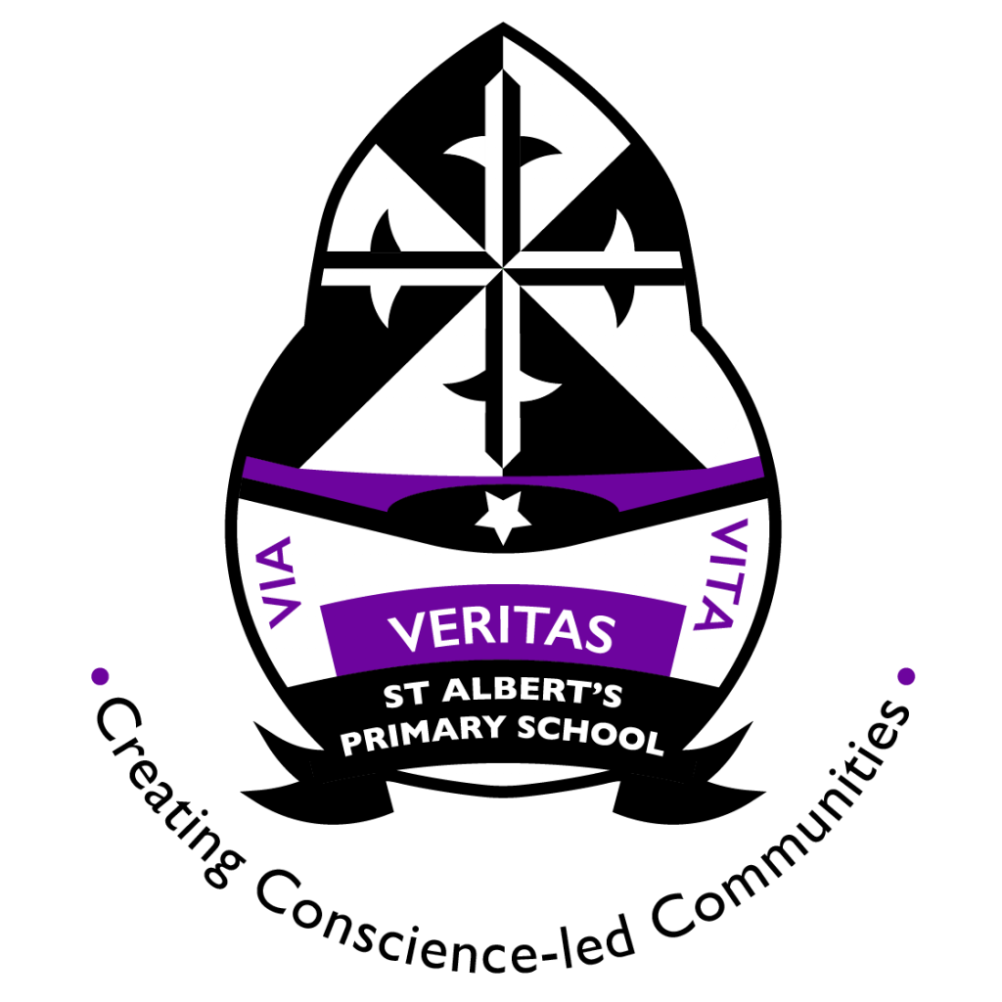

**Literacy**

* Revision of sounds
* Revision of common words
* Revision of creating sentences (Capital letters and full stops)
* Using adjectives and WOW words
* Revision of Reading Strategies