**Health and Wellbeing**

* Recognise and express Feelings - using the story ‘The Colour Monster’
* PATHS - Making new friends, sharing and using Kind Hands
* Learn to cooperate and work as part of a team.
* Understand how to follow class and school rules and who to ask for help.

**Numeracy/Maths Topic**

* Know and order numbers to 10
* Know numbers before and after to 10.
* Count Objects to 10.
* Pattern – recognise and create.
* 2D Shape - name and recognise properties.
* Positional Language – ‘on’, ‘in’, ‘next to’, ‘in front’, ‘behind’

**Primary One**

**Term One**

**Curriculum Map**

Visit our blog

https://blogs.glowscotland.org.uk/gc/2020stalbertsp1b/

**Expressive Arts and Physical Activity**

* Self portraits
* Patterns
* Outdoor Team Games
* ‘It’s Good to be me because I can…’ ‘Jump’, ‘Run’, ‘Climb;

**Learning for Sustainability**

* Biodiversity – Identifying plants and trees in the school grounds.
* Mini Beasts and Animals – Habitats and Hibernation

**Literacy**

* Rhyming – Recognise rhyming words, continue a rhyming string
* Phonics – Recognise, say and write the sounds: s,a,t,i,p,n,
* Read simple CVC words using those sounds e.g. ‘sat’ ‘pin’ ‘tin’ ‘tap’
* Listen to and answer questions about rhyming stories.
* Write own name independently.

**‘All About Me’**

* Me – Likes and dislikes, self-portraits.
* My Body – Labelling parts of the body, understanding what we use our bodies for and how to keep fit and healthy.
* My talents and abilities – Understanding everyone is different and that I am unique.

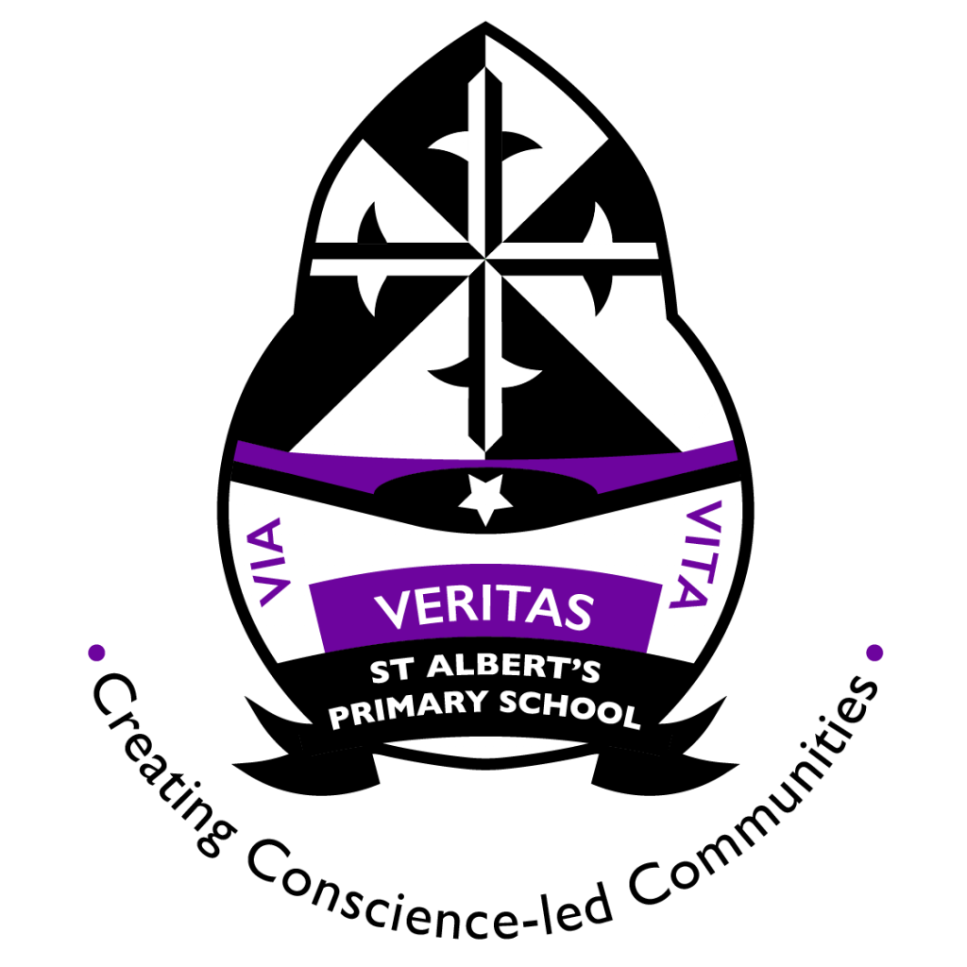

**Things you can do at home**

* Count forward and back from 0-10. Point out numbers in the environment.
* Make patterns with things you have at home – cutlery (knife, fork, knife, fork), Socks (Stripy, spotted, Stripy, spotted)
* Sing songs and rhymes in any language!
* Read poems and rhyming stories (such as Julia Donaldson)

**Useful Websites**

<https://www.youtube.com/user/breakthruchris>