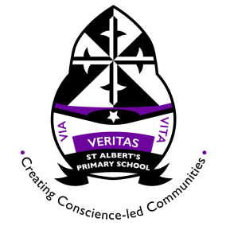
St Albert’s Primary School Weekly Homework. Class: P5 Week beginning: 18.11.2019
In the table below you will see you homework tasks for the week. Please try to do as many of these as possible. You can choose to do them on other nights as long as you get them done. Homework will be collected on Friday morning.

Day | Literacy | Numeracy |  | Other
Monday | Spelling Words:  Smarty Pants: mimic, laptop, sank, neck, magpie, rapid, rapid, quench, outing, rescue.  Whizz Kids & Clever Cookies: goose, geese, sparse, corpse, dense, horse, increase, promise, reverse, pulse.  Master Minds: reverse, pulse, cease, collapse, immense, disperse, converse, suspense, nonsense, lighthouse.  Practise spelling the 10 words you have been given.  Try to write them out 3 x each and put each word into a sentence. | Please complete the worksheets on Equivalent Fractions.  Always remember to multiply or divide the numerator and denominator with the same number. |  | The blog now has some websites listed that may help you with homework (or give you additional tasks to do at home).
Tuesday | Log in to Bug Club to read the chapter or the book that you have been issued. Think carefully about the questions you have been asked about this text. | You can find out what our class has been learning this week by looking at our class blog. Here is the QR code for the class blog:
Wednesday | Complete the mind map all about Sound. Have a think about what you already know and what Ross has been teaching us in our Music lessons.  Also think about what you learned this week in IDL. | Please bring your PE kits in on Mondays and Wednesdays.
Thursday

