**STEM/Art Installation (Turner Prize Competition)**

* How are movies made?
* The history of the cinema and how sound and picture are created.
* Making our own movies.

**Numeracy**

* Times tables
* Division Facts
* Fractions
* Information Handling
* Word problems
* Telling 12-hour & 24-hour time
* Developing understanding of decimal numbers.

**Primary 5**

**Term Two**

**Curriculum Map**

Visit our blog

*https://blogs.glowscotland.org.uk/gc/2019stalbertsp5/*

**Our local community**

Preparing for the Christmas Fayre and taking part in various school fundraising events.

**Literacy**

* Spelling using Jolly Spelling
* Reading different types of literature
* Introduction of reciprocal reading
* Learning and using new reading skills and strategies
* Procedural writing and poetry.

**Expressive Arts**

* Music – learning to identify instruments and musical concepts with Ross;
* Art work linked to RERC and STEM through creation of Art Installation for Turner Prize competition.

**All about me**

* Feelings
* Emotions
* Interacting with others in social settings
* Coping with negative emotions.

**Health and Wellbeing**

* PATHS
* Creating and sustaining new friendships
* Overcoming challenges with our peers.

**P.E**

* Badminton
* Increasing Fitness levels.

**Science Technology**

* Researching for topic.
* Learning about the history of movie making, from silent movies to today’s cinema.

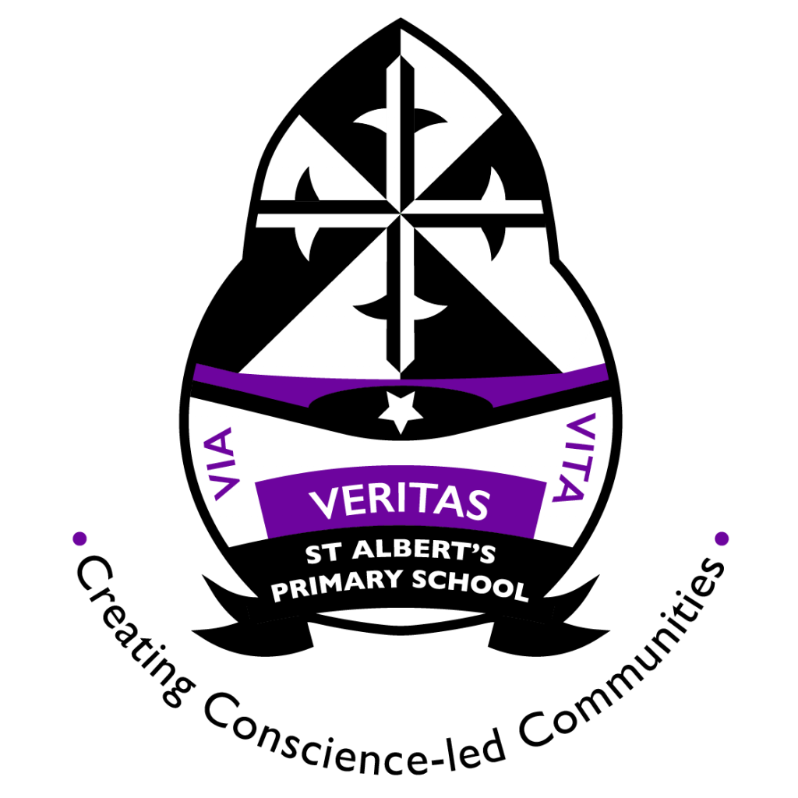

**Things you can do at home**

* **Encourage reading of different texts.**
* **Help pupils with learning number stories/ times tables.**

**Useful Websites**

<https://www.topmarks.co.uk/> (All areas)

<https://www.pobble365.com/> (Writing)

<https://www.bbc.co.uk/newsround> (Current events)

<https://www.starfall.com/> (Reading support)