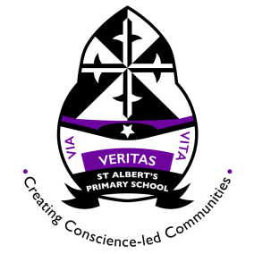
St Albert’s Primary School Weekly Homework. Class: P5 Week beginning: 28.10.2019
In the table below you will see you homework tasks for the week. Please try to do as many of these as possible. You can choose to do them on other nights as long as you get them done. Homework will be collected on Friday morning.

Day | Literacy | Numeracy |  | Other
Monday | Read for enjoyment for 30 minutes. You could choose to read a novel, a short story, a comic book, a graphic novel, but make sure to pick something that you enjoy! | Complete the ‘Whole Numbers’ Worksheet that you have attached. |  | The blog now has some websites listed that may help you with homework (or give you additional tasks to do at home).
Tuesday | Log in to Bug Club to read the chapter or the book that you have been issued. Think carefully about the questions you have been asked about this text. | You can find out what our class has been learning this week by looking at our class blog. Here is the QR code for the class blog: |  |  | 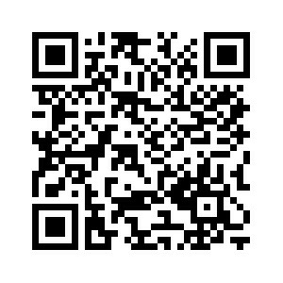
Wednesday | Practise spelling the next 20 spelling words from the list of 100. You will be tested on these this Friday. The words are: my, than, first, water, been, called, who, oil, sit, now, find, long, down, day, did, get, come, made, may, part.  Try to write them out 3 x each and put each word into a sentence. | Please bring your PE kits in on Mondays and Wednesdays.
Thursday |  |  | Complete the ‘How Far Did My Food Travel?’ worksheet that is attached to this homework sheet.

