St Albert’s Primary School Weekly Homework. Class: P5 Week beginning: 21.10.2019
In the table below you will see you homework tasks for the week. Please try to do as many of these as possible. You can choose to do them on other nights as long as you get them done. Homework will be collected on Friday morning.

Day | Literacy | Numeracy |  | Other
Monday |  | Complete the Pie Chart Data Handling Workhseet that you have attached. |  | Please check the blog later this week to find some recommended websites to help with homework tasks (and to give you some suggestions for more work at home).
Tuesday | Log in to Bug Club to read the chapter or the book that you have been issued. Think carefully about the questions you have been asked about this text. | You can find out what our class has been learning this week by looking at our class blog. Here is the QR code for the class blog: |  |  | 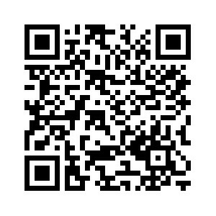
Wednesday | Practise spelling the next 20 spelling words from the list of 100. You will be tested on these this Friday. The words are: some, her, would, make, like, him, into, time, has, look, two, more, write, go, see, number, no, way, could, people.  Try to write them out 3 x each and put each word into a sentence. | Please bring your PE kits in on Mondays and Wednesdays.
Thursday |  | Complete the Rounding to the Nearest 1,000 worksheet that is attached to this homework sheet.

