St Albert’s Primary School Weekly Homework. Class: P5 Week beginning: 23.9.2019
In the table below you will see you homework tasks for the week. Please try to do as many of these as possible. You can choose to do them on other nights as long as you get them done. Homework will be collected on Friday morning.

Day | Literacy | Numeracy |  | Other
Monday |  | Complete the times table worksheet on the other side of this sheet. |  | Please make sure that you have all the notes from your solo talk in school so that you can easily turn this into a written report in class.
Tuesday | Log in to Bug Club to read the chapter or the book that you have been issued. Think carefully about the questions you have been asked about this text. | You can find out what our class has been learning this week by looking at our class blog. Here is the QR code for the class blog: | 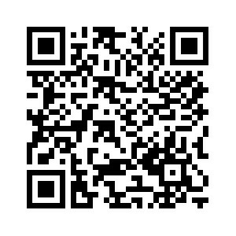
Wednesday | Continue to next 20 spelling words from the list of 100. You will be tested on these this Friday. The words are: there, use, an, each, which, she, do, how, their, if, will, up, other, about, out, many, then, them, these, so. | Please bring your PE kits in on Mondays and Wednesdays.
Thursday |  | Play some Maths games by logging on to topmarks.co.uk.

