**Primary 2**

**Term 3**

**Curriculum Map**

Visit our blog

[*https://blogs.glowscotland.org.uk/gc/2019stalbertsp2/*](https://blogs.glowscotland.org.uk/gc/2019stalbertsp2/)

**History Topic**

* Slavery – Harriet Tubman
* The Rights of a Child

**Numeracy**

* Volume
* Grid References
* Symmetry
* Counting forwards and backwards from 100

**French**

* Days of the week
* Months of the year
* Weather

**Literacy**

* Blending sounds.
* De-coding tricky words.
* Character
* Discussion
* Reading Strategies
* Story books for enjoyment

**Expressive Arts**

* Drama – Re-enacting, hot seating and emotions.
* Music – The change in music over the years.

**Religious Education**

* Our Emotions
* The Boy Jesus
* The story of Moses.

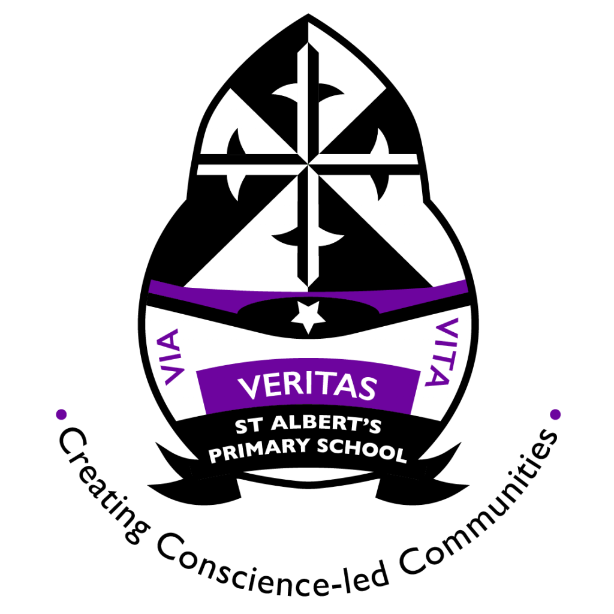

**Things you can do at home**

.

* Explore local parks and outdoor spaces.
* Read with your child at home
* Identify number and sounds in the environment
* Homework

**Useful Websites**

<https://www.bbc.co.uk/bitesize/levels/zgckjxs>

<https://www.topmarks.co.uk>

**Science Technology**

**Online Safety**

**Computer Confidence**

**States of Water**

**–Liquid, Solid, Gas.**

**Health and Wellbeing**

* PATHS
* Our Emotions
* Confidence in our work
* The wider community

**P.E**

* Ball Skills
* Team games