**Numeracy**

* Place value – Understanding that the value of 1 in 10,11 etc is 10.
* Addition and subtraction within 20.
* 3D shapes – Building Castles
* Measure – Making potions and Pancakes
* Money – Pirate treasure

**Traditional Tales**

* Cinderella & Other versions from around the world – exploring the school wide topic of slavery.
* The Magic Paintbrush – Chinese New Year
* Robin Hood – characters & settings
* Little Red Riding Hood – Exploring alternative story endings.

**Primary One**

**Term Three**

**Curriculum Map**

Visit our blog

https://blogs.glowscotland.org.uk/gc/2019stalbertsp1b/

**Literacy**

* **Phonics –**
* Learning new sounds
* Blending sounds together to read words, sentences and reading books
* Learning to recognise ‘tricky words’
* **Literacy –**
* Stories – Setting, Character, Alternative Endings, Creating and Writing imaginative stories.

**Expressive Arts**

* Drama – Acting out traditional tales and alternative endings
* Music – Developing listening and repeating skills, emotions in music.
* Art – Specific Artist Studies

**Imaginative Worlds**

* Learning how to create and write stories using fantasy and adventure stories as stimulus; Superheroes, Pirates and mermaids, magic, Mythical beasts, Monsters.

**Science Technology/ Forest School**

* Electricity - Safety
* Textiles/

Materials –

Costumes & Props

* Construction/

Engineering –

Castles

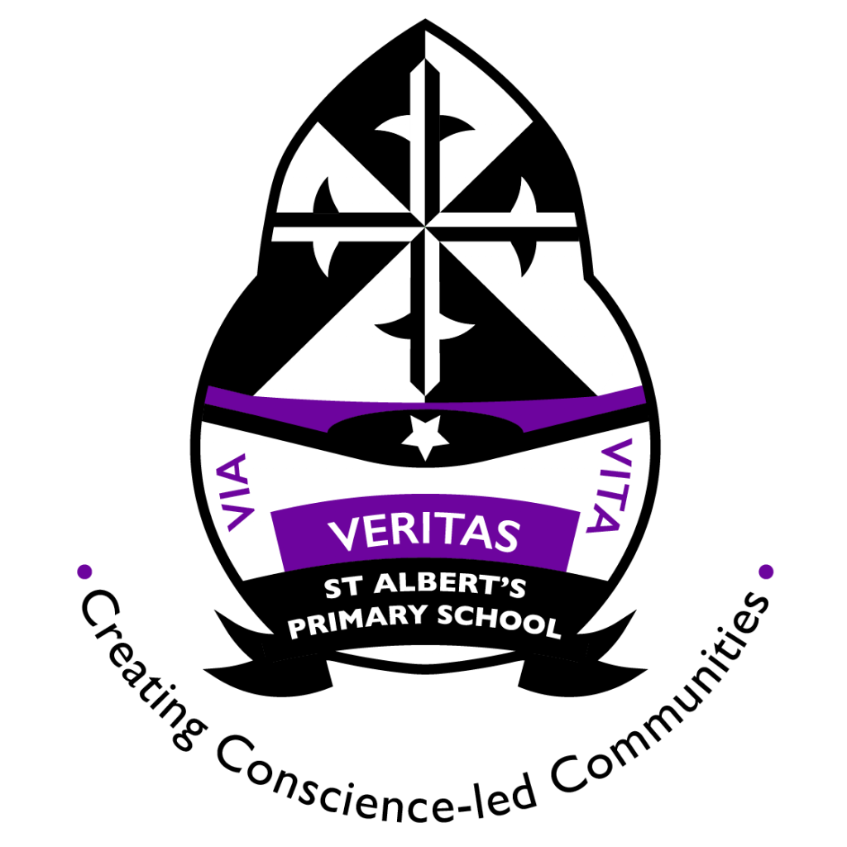

**Health and Wellbeing**

* UN Rights of the child
* PATHS
* Healthy Eating
* Teeth Brushing
* Gymnastics @ The Palace of Art

**Things you can do at home**

* Read and attempt the weekly homework with your child – It tells you everything you need to know about their learning that week.
* Encourage your child to read their reading book with you as much as possible.
* Practice numbers 0-50 with your child. Point out numbers to your child wherever you go!
* Read adventure stories and traditional tales to your child in your home language.