Home Learning Grid Monday 8th June 2020
Each day choose activities to complete at home. There are 12 activities for the whole week!
Gather your toys and create patterns. You can put them in patterns using colour, shape or size.  Can you think of other patterns? | 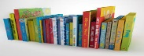  Have an outdoor reading party with your family. Each of you could pick your favourite book to read.  Remember to bring yummy snacks and drinks too! | Make a card for someone in your family or a friend and send it to them to make them smile.
Write a story about an adventure you and your friends have together.  Miss Milne wrote a story about all the teachers having an adventure in a magical land made of candy. | Look at the Infant Youtube Channel. Are there any videos you haven’t seen yet? Which video is your favourite and why?  https://www.youtube.com/channel/UCh5GQLl6kdUmUJFwGaO-ijg | 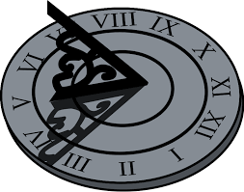  Follow the instructions on the link to make your own sundial.  https://www.pbs.org/parents/crafts-and-experiments/diy-sundial
Do some Cosmic Kids Yoga to stretch out all those muscles. Why not try this Very Hungry Caterpillar video:  https://www.youtube.com/watch?v=xhWDiQRrC1Y | Count to 100 forwards and backwards. Why not make it a game with your family at home or sing along with a video.  https://www.youtube.com/watch?v=1dkPouLWCyc | Join Mr Corrigan on the Infant Youtube Channel at 2.30pm on Thursday for a story.
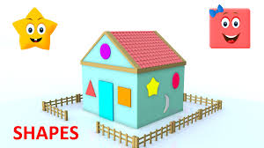  How many different shapes can you find in your house and garden? Can you write them all down? | 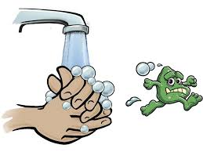  Write a set of instructions on how to wash your hands. Ask someone to help you write. | Check out this video full of water science experiments. What do you notice happens in each one? Could you try any of them at home?  https://www.youtube.com/watch?v=9L2ARmPpA78

