**STEM Topic**

* The brain and our feelings.
* Art/technology- art installation design.

**Class 1**

**Term Two**

**Curriculum Map**

Visit our blog

*https://blogs.glowscotland.org.uk/gc/2019stalbertsclass1/*

**Numeracy**

* Number processes
* Fractions
* Decimals
* Money

**Our local community**

* Regular shopping trips to support cooking in class

**Literacy**

* Phonics- individual sound programme
* Storytelling
* Reflective News
* Creative Writing
* Character design
* Bug club reading books

**Expressive Arts**

* Drama/Music- Nativity Play
* Music- Musical notes and their beat.

**Religious Education**

* We are all individuals.
* Advent.
* Nativity.

**Science Technology/ Forest School**

* Using & developing sensory garden.

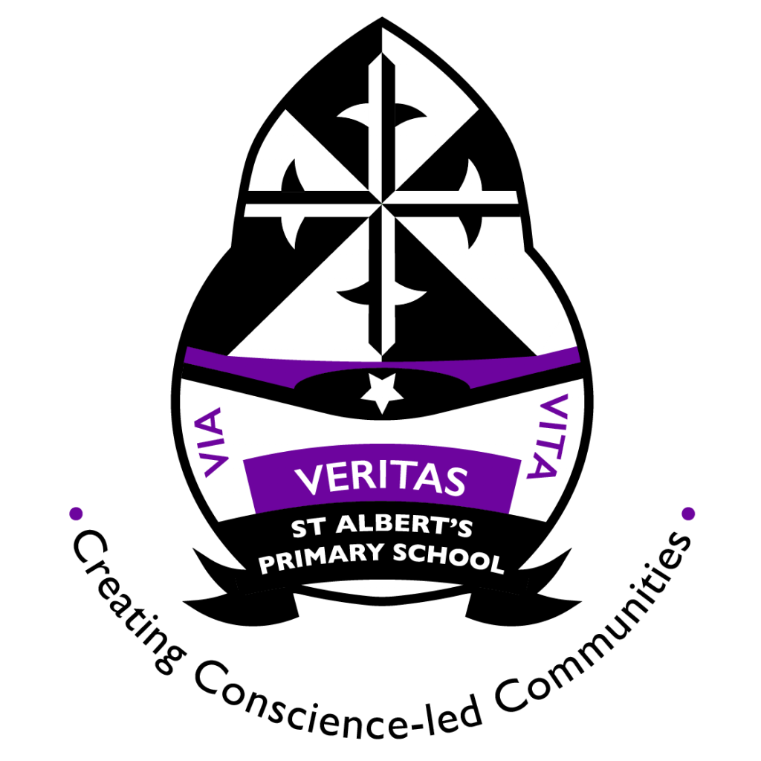

**Health and Wellbeing**

* PATHS
* Our Emotions
* We are individuals

**P.E**

* Swimming
* Gross motor activities

**Things you can do at home**

* Discuss your child’s school day.
* Complete reading books at home.
* Email one photograph from the weekend to the teacher for reflective news writing.

**Useful Websites**

[www.sumdog.com](http://www.sumdog.com)

www.starfall.co.uk