The Correction Code in action.  I am writing to you to raise my concerns about the orcas you are keeping in captivity these animals are very intilligent and should be free and surely you cannot think that it’s good to keep these animals separated from their families  I am writing to you to raise my concerns about the orcas you are keeping in captivity. These animals are very intelligent and should be free. Surely you cannot think that it’s acceptable to keep these magnificent creatures separated from their families?  I am writing to you to raise my concerns about the orcas you are keeping in captivity FS these animals are very SP intilligent and should be free and SS surely you cannot think that it’s good Bw to keep these ^animals separated from their families P | Parents and Carers  And Carers  C |  | Lochend Community High School  Developing Good Literacy  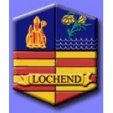  A guide to understanding the Correction Code

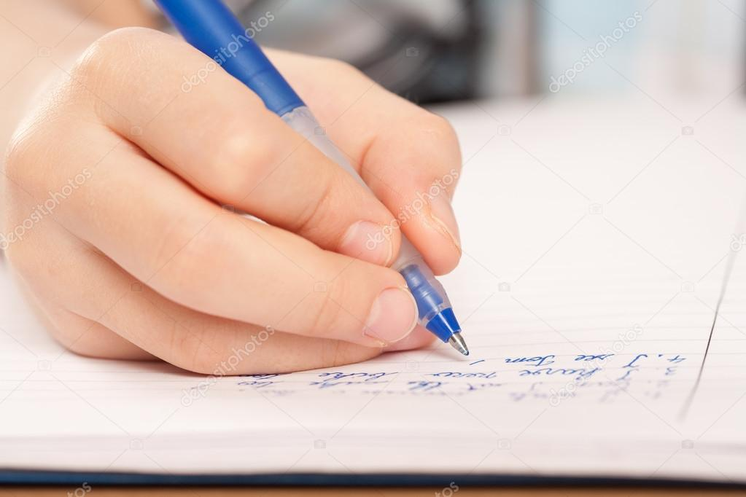  What is it?  A Correction code supports improving written literacy because it focuses on formal aspects such as sentencing, punctuation, spelling and grammar. Ideas often come first when writing but understanding how to shape these to make the best meaning is a key skill. At Lochend we aim to roll out a code which can be used across the curriculum and guide our young people towards improving their expression in all forms of writing. | What does it look like?  Teachers will use the code below to encourage pupils to edit their own writing and reinforce skills.  Code Indicates  TS Topic Sentence  Sp Spelling  CL Capital Letter  FS Full Stop  P Punctuation  Gr Grammar  Bw Better word  Exp Expression  SS Sentence Structure  ^ Something Missing  NP New Paragraph  Developing Good Literacy | How does it work?  Any written pieces across subject areas can have the code applied. For example, Creative writing in English or Discursive writing in Social Subjects but fundamentally the code supports literacy benchmarks from single sentence answers to more extended written pieces.  The example below is an extract from the Education Scotland Benchmark document from June 2017 and describes Level 3 literacy  - Applies a range of strategies and resources to spell most words correctly including unfamiliar or specialist vocabulary.  - Uses more complex punctuation, where appropriate, to convey meaning or in an attempt to enhance writing, for example, inverted commas, exclamation marks, question marks, colons, parentheses and/or ellipses. Punctuation is varied and mainly accurate.  - Writes almost all sentences in a grammatically accurate way.

