Croftfoot Primary
School Handbook

2018 – 2019

WELCOME TO CROFTFOOT PRIMARY

I would like to welcome you and your child to Croftfoot Primary School. This handbook is designed to give parents and carers an insight into our school, our priorities, vision, values and aims.

At Croftfoot Primary we aim to provide a happy, stimulating and secure learning environment in which children feel motivated to learn. We strive to ensure that everyone in our school community feels valued and respected. Relationships are at the heart of all that we do, with nurture being at the core of our vision, values and aims.
We work tirelessly to ensure that children are provided with a wide range of opportunities to develop their own skills and talents. Knowing your child as an individual is extremely important to us.
We believe that, to enable each child to achieve their full potential, it is important to develop and maintain a positive partnership between home and school. We strive to keep you fully informed of developments and seek your views whenever possible. Children are consulted and are given a wide range of opportunities to influence the development of the school.
We have an active Pupil Council, and all children have the opportunity to participate in Whole School Committees. Staff, children and families are involved in setting the priorities for the School Improvement Plan and helping us to be the best we can be.
We strongly believe that education and learning should be fun and your child’s happiness is our number one priority. Our school is a place where children learn, develop and yet enjoy themselves in a totally safe and friendly environment.

Please do not hesitate to contact me if you wish to discuss any matters which may be of concern or interest to you. I look forward to working with you and your children.

Yours sincerely
Mrs Martine Leitch

Headteacher

Our Vision

At Croftfoot Primary, we aim to create a safe and nurturing environment for all. A vibrant school where children are motivated, enthusiastic to learn and achieving their full potential. We will be creative, innovative and open to taking on new challenges. A place where everyone is respected and valued, with children and relationships at the heart of all we do.

Our values and aims
Relationships
-A positive role model within school and the community
-Contribute to the local and wider community
-Show empathy towards others
-Support, challenge, encourage and empower myself and others
-Set high expectations for treatment of self and others

Respect
-Demonstrate respect at all times
-Respects rights and embrace diversity
-Look after school property and environment

Nurture
-Encourage others
-Kind and caring
-Good listener
-Understanding
-Support and value others

Achievement
-Know and value my own strengths.
-Take ownership of my learning by setting personal targets and goals.
-Motivated and determined to achieve showing perseverance when challenged.
-Curious and confident with an open and enquiring mind.
-Share and celebrate my own and others success in and out of school.
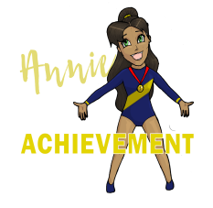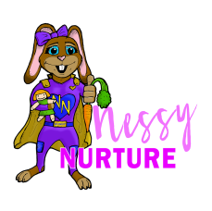

SCHOOL INFORMATION

School Name Croftfoot Primary School

Address 265 Croftpark Ave
Croftfoot
Glasgow
G44 5NT

Telephone: 0141 637 4007

Fax: 0141 637 7487
E-mail: headteacher@croftfoot-pri.glasgow.sch.uk
Web Site: www.croftfoot-pri.glasgow.sch.uk

Important Links:

Twitter | https://twitter.com/croftfootschool
School Website | https://blogs.glowscotland.org.uk/gc/croftfootprimary/
School App | https://app.piota.co.uk/croftfootprimaryschool/

Background information:

- Co-educational school

- Non-denominational
- Stages taught: P1-P7
- Current Roll: 342
- Capacity: 468, (under review)

SCHOOL STAFF

A full list is available on the school website and parents will be updated on any changes as required. Our Senior Leadership Team are:

Headteacher | Mrs Martine Leitch
Depute Head P1 to P3 | Mrs Arlene McClure
Depute Head P4 to P7 | Mrs Lindsay McKinlay
Principal Teacher (PEF) | Mrs Gail Wilson
Principal Teacher (PEF) | Mrs Christine Cameron

ENROLMENT

Registration of Primary 1 children takes place in November and again in January. This is advertised widely in local press etc. Prospective parents are welcome to visit the school and should contact the school office.

Families living out with the catchment area are welcome to make a placing request to attend Croftfoot Primary School but must enrol their child at their local school as a first step. Further information is available using the following link https://www.glasgow.gov.uk/index.aspx?articleid=18426
ORGANISATION OF CLASSES

The following guidelines set by Scottish Government apply.
P1 | maximum 25
P2&3 | maximum 30
P4-7 | maximum 33
Composite classes | maximum 25

Composite classes have pupils from more than one stage.

 | THE SCHOOL DAY
 | _
Morning | 09:00 – 10:30
Morning Interval | 10:30 – 10:45
Morning contd. | 10:45 – 12:15
Lunch | 12:15 – 13:00 (P1 to P4)  12.30 – 13:15 (P5 to P7)
School Closes | 15:00
Please note that P1 children are dismissed at lunchtime until the first Monday in September after which they will remain in school until 15:00.

SCHOOL HOLIDAYs
Details of holiday dates are available on the Glasgow City Council website: https://www.glasgow.gov.uk/index.aspx?articleid=17024

PUPIL ABSENCE

Within Glasgow Primary School good attendance is encouraged at all times and children rewarded accordingly. Parents are asked to advise if their son or daughter is going to be absent. This should be done as early as possible on the first day of absence. If the young person is going to be absent for some time, it would be helpful to know at the earliest opportunity.
The school uses daily text messaging to inform parents and carers of absence if no contact is made. All unexplained absence is investigated by the school and appropriate action taken. All calls must be made to the Pupil Absence Reporting Line on 0141 287 003
PUPIL ABSENCE REPORTING: ONLINE

Glasgow's mainstream primary and secondary schools operate a generic pupil absence reporting service during the school week. From August 2018 Parent/Carers or a named contact person can report their child's absence by using an online form and should register with myaccount to access this.
The form will make it easier to report a pupil's absence or appointment during our peak periods.
A pupil's sickness absence must be reported prior to 09.30 am on the day of the absence.
If your child has been sent home from school, or you have been asked to collect your child from school, do not complete our online form and liaise directly with the school

MEDICAL AND HEALTHCARE

The school health team visits at various times during the year for routine health checks, vaccinations and medical examinations. Parents are kept informed by letter.
If a child becomes ill during the course of the school day, he/she may require to be sent home. Please ensure that you keep the school informed of all contact details.

Parents should inform the school of any medical requirements relating to their child. If a child requires medication during the school day, parents must complete the appropriate medical form. This is available on request from the school office.

EMERGENCIES
We make every effort to maintain a full educational service, but on some occasions circumstances arise which lead to disruption. Schools may be affected by, for example, severe weather, and temporary interruption of transport, power failures or difficulties of fuel supply.

In such cases, we shall do all we can to let you know about the details of our closure or re-opening by using letters, texts and the local media etc.

SCHOOL UNIFORM

The school uniform is:

- Blue shirt and school tie

- Blue polo shirt
- V-neck sweat shirt/cardigan with school logo
- Grey trousers
- Grey skirt

Sweatshirts, cardigans, polo shirts with the school logo and school ties are available for purchase at the school office.

Our uniform was agreed in consultation with pupils and parents. It is expected that all children attending Croftfoot Primary School will adhere to this dress code.

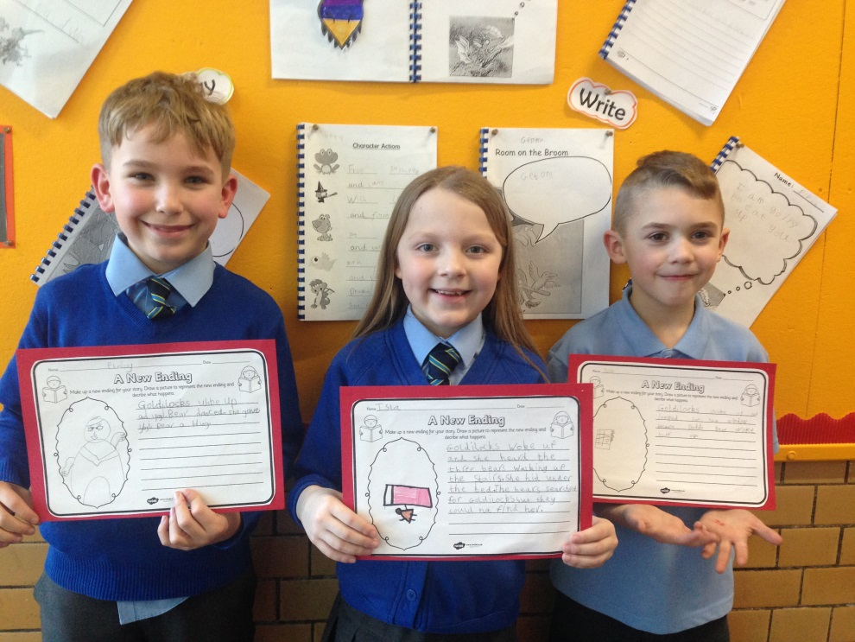
PE KIT

Our PE Kit is black or navy shorts and a pale blue polo shirt or t-shirt.

It is important that pupils come prepared to learn and for PE this requires appropriate clothing. All jewellery must be removed. Pupils who are not participating in PE must have a note or a medical certificate. Pupils who are unable to participate in practical PE should still bring their kit to allow them to assist in the lesson by refereeing, keeping scores or assisting with the distribution of equipment. This ensures that they are still able to take part in some way in the work of the class and do not miss out on the knowledge and understanding of the course.

There are forms of dress that are unacceptable in school, such as items of clothing which:

- Potentially encourage factions (such as football colours)

- Could cause offence (such as anti-religious symbolism or political slogans)
- Could cause health and safety difficulties (such as loose fitting clothing, jewellery)
- Could cause damage to flooring
- Carry advertising particularly for alcohol or tobacco
- Could be used to inflict damage on other pupils

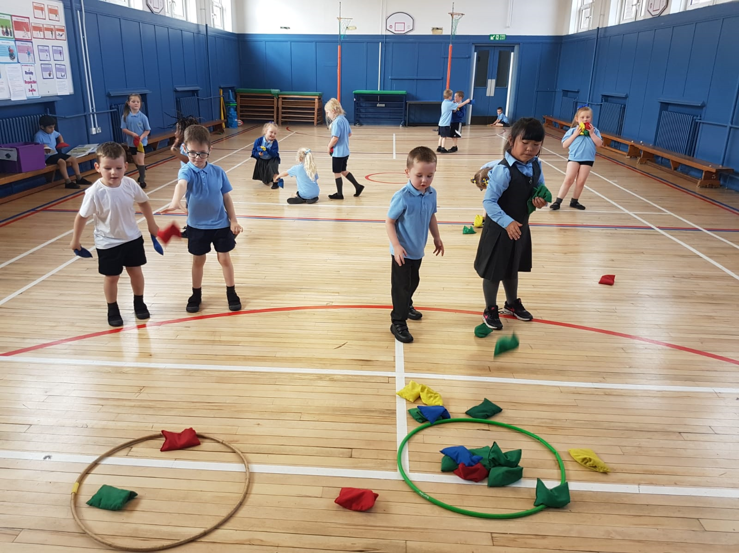

CLOTHING AND FOOTWEAR GRANTS

Parents/Carers receiving Income Support, Job Seekers Allowance (Income Based), Working Tax Credit (with a total annual income of less than £15,050*), Housing Benefit, or Council Tax Benefit will normally be entitled to monetary grants for footwear and clothing for their children. Information and application forms ma y be obtained from schools and at

https://www.glasgow.gov.uk/index.aspx?articleid=17885

SCHOOL MEALS

Our school provides a lunch service which offers a variety of meals and snacks. Special diets for children with medical requirements can be provided. Please inform the Headteacher.
Children who prefer to bring packed lunches are accommodated in the dining hall.

All children in P1-4 are entitled to a free school meal.

Children and young people of parents/carers receiving Income Support, income-

based Job Seekers Allowance, Working Tax Credit (where income is less than £6,420), Child Tax Credit only (where income is less than £15,910*) and income-related Employment and Support Allowance are entitled to a free midday meal. Information and application forms for free school meals may be obtained from schools and at https://www.glasgow.gov.uk/index.aspx?articleid=17885

TRANSPORT

The education authority has a policy of providing free transport to all pupils who live out with a certain radius from their local school by the recognised shortest walking route. This policy is more generous than the law requires. This means that the provision of transport could be reviewed at any time. Parents/Carers who consider they are eligible should obtain an application form from the school or at https://www.glasgow.gov.uk/index.aspx?articleid=17882

TRANSFER FROM PRIMARY TO SECONDARY SCHOOL

Children and young people normally transfer between the ages of 11 ½ and 12 ½, so that they will have the opportunity to complete at least 4 years of secondary education. Parents and carers will be informed of the school arrangements no later than December of P7.

Children from our school normally transfer to:

King’s Park Secondary School

14 Fetlar Drive
Glasgow
G44 5BL
Phone: 0141 582 0150

Email: headteacher@kingspark-sec.glasgow.sch.uk
www.kingspark-sec.glasgow.sch.uk

King’s Park Secondary School staff work with our pupils from Primary 6 onward to prepare them for the transfer to secondary school.

COMMUNICATION WITH PARENTS

At Croftfoot Primary School we use a variety of ways to keep in touch.

Open Door Policy – the senior leadership team is keen to be available for all parents and carers. Please either pop in to the school office or phone for an appointment. Due to their teaching commitments, they may not be able to see you if you don’t have an appointment.

Newsletters – will be sent out on a regular basis to keep parents informed about the work of the school.

Letters – further information which requires a response may be sent out in letter form.

School APP – PIOTA School App, available from the app store

School website – contains a great deal of information about the school. It is a good idea to check this regularly. (Our website is currently under review)

Text messaging – You may also receive text reminders about events/school closures etc.

Meetings - Parents and carers are welcome in the school to discuss any aspect of their child’s development and progress. To avoid disappointment, it is advisable to make an appointment. There are various opportunities throughout the year when parents can discuss their child’s progress with the class teacher and view the child’s work.

Parents and carers are welcome at other events throughout the school year e.g. workshops, information evenings, class performances, religious and other assemblies. The school newsletter and website will keep you informed.

EMERGENCY CONTACT INFORMATION

At the start of each school session, parents will be issued with the annual data check form. Please ensure that this is completed and returned to the school. It is also important that you let us know if there are changes to your telephone number(s) or to those of your emergency contacts throughout the year.

PRIVACY STATEMENT AND DATA PROTECTION- USE OF

INFORMATION ABOUT CHILDREN AND PARENTS/CARERS

As a local authority our schools and early year’s establishments process information about children and young people in order to provide education and care. In doing so we must comply with the Data Protection Act (1998). This means, amongst other things that the data held about children and young people must only be used for specific purposes.

However, you should be aware that we may use this information for other legitimate purposes and may share this information where necessary with other bodies responsible for administering services to children and young people, or where otherwise required by law. We may also use any information for research purposes. However, all personal data is treated as confidential and used only in accordance with the Data Protection Act and the Information Use and Privacy Policy approved by the City Council.

For further information please see our full privacy statement at www.glasgow.gov.uk/privacy

APPOINTMENTS DURING SCHOOL HOURS

If your child has an unavoidable appointment, please give them a letter for their class teacher and then collect them from the school office at the specified time.

CURRICULUM

Curriculum for Excellence 3-18

Curriculum for Excellence has been introduced to raise standards of learning and teaching for all 3 to 18 year olds. It aims to help prepare children and young people with the knowledge and skills they need in a fast changing world. As part of Curriculum for Excellence all children from pre-school to the end of S3 will receive a rounded education known as a Broad General Education (BGE). Curriculum for Excellence is all about bringing real life into the classroom and taking lessons beyond it.

Through the experiences we provide at Croftfoot Primary School we want our children to become Successful Learners, Confident Individuals, Responsible Citizens and Effective Contributors. We are committed to providing children with a broad general education and focus on eight curriculum areas.

Expressive Arts |  | Health & | Languages |  | Mathematics
 |  | Wellbeing
Religious & Moral |  | Sciences | Social Studies |  | Technologies

Progress in learning is indicated through curriculum levels as detailed below.
Level |  | Stage
Early |  | The pre-school years and P1 or later
First |  | To the end of P4, but earlier or later for some
Second |  | To the end of P7, but earlier or later for some
Third & Fourth |  | S1-S3, but earlier for some

Expressive arts: The inspiration and power of the arts play a vital role in enabling our children and young people to enhance their creative talent and develop their artistic skills.

Health and wellbeing: Learning in health and wellbeing ensures that children and young people develop the knowledge, understanding and skills which they need now and in the future to help them with their physical, emotional and social wellbeing.

Science: Science and its practical application in healthcare and industry are central to our economic future, for our health and wellbeing as individuals and as a society.

Social Studies: Through social studies, children and young people develop their understanding of the world by learning about other people and places both past and present, societies, their beliefs and values.

Religious and moral education: Religious and moral education includes learning about Christianity, Islam, Judaism and other world religions, and supports the development of beliefs and values.

Languages: Knowing other languages and understanding other cultures is a 21st century skill set for students as they prepare to live and work in a global society.

Mathematics: Mathematics equips us with the skills we need to interpret and analyse information, simplify and solve problems, assess risk and make informed decisions.

Technologies: The range of subjects in technical education has changed significantly over the last two decades and now includes craft, design, engineering and graphics.

There will be opportunities throughout the year for parents and carers to learn more about aspects of the curriculum and to be consulted about significant changes if appropriate.

Useful websites

www.curriculumforexcellencescotland.gov.uk
www.educationscotland.gov.uk/parentzone/index.asp

RELIGIOUS OBSERVANCE

Our school is fortunate to have a close link with the local church. The minister assists with the Christianity element of Religious and Moral Education and provides opportunities for religious observance. Parents have the right to withdraw their child from religious observance and should inform the school in writing.

ASSESSMENT AND REPORTING

All children are assessed both formally and informally throughout the year. This allows children and their teachers to identify their strengths and areas for improvement. A variety of assessment methods are used to enable staff to pass on information to parents about the progress of their child. Assessment records are kept by the class teacher and form the basis of discussion at Parents’ Evenings in November and March. An annual report is sent to parents towards the end of each school year.

If you have any concerns about your child’s progress do not hesitate to contact the school.

PUPIL PROFILES

Every child leaving primary school in Scotland has their key achievements in school, at home and in the community documented within a P7 profile. The content of the profile is decided by the young person. The profile is a positive record of their achievements and emphasis their strengths. The profile provides a valuable way for learners to share valuable information about their achievements with their parents and teachers in secondary school.

SUPPORT FOR PUPILS

The school has a duty to ensure that all pupils have equal access to the curriculum, with appropriate support for their needs if required. This applies to the content of lessons, teaching strategies and minor adaptations to the school environment. There are a wide range of factors which may act as a barrier to learning. We are committed to working closely with parents and carers to ensure that they are fully involved in any decisions about support for their children’s needs.

Any parent or carer seeking further advice regarding this policy should contact the Headteacher in the first instance.

Further information relating to additional support needs is available on the Glasgow City Council website –

https://www.glasgow.gov.uk/index.aspx?articleid=18941

Information on the Glasgow City Councils’ Parental Involvement Strategy can also be found at https://www.glasgow.gov.uk/index.aspx?articleid=17870

GETTING IT RIGHT FOR EVERY CHILD (GIRFEC)

The GIRFEC approach is about how staff in all children’s services meet the needs of young people by working together where necessary to ensure that children reach their full potential. www.scotland.gov.uk/gettingitright

SCHOOL IMPROVEMENT

On an annual basis, you will receive a copy of our Standards and Quality report. Copies from previous years are available on the school website. The Standards and Quality report highlights progress in key curricular areas such as literacy, numeracy and health & wellbeing. Our priorities for improvement are detailed in our School Improvement Plan which is discussed with our Parent Council. Any parent or carer seeking a copy of the plan can contact the school office or check out our website.

PROMOTING POSITIVE BEHAVIOUR

Children’s Rights as outlined in the UNCRC (United Nations Convention on the Rights of the Child) are fundamental to a good school ethos. Adults in our school will work with children to ensure they are aware of their rights and fully respect the rights of others. Therefore, the approach within Glasgow Primary School is to build a positive ethos that demonstrates care and respect for all. Positive behaviour is recognised and celebrated. Our school operates a system of class charters to set out expected behaviour. This is celebrated through Golden Time treats, awards at assemblies and certificates sent home to parents etc.

The highest standards of behaviour are expected of pupils at all times. Where this is not the case, a variety of sanctions are used. Parents are asked to co-operate with the school in encouraging a sense of responsibility and good behaviour in their children.

HOME LEARNING

Continuing to learn at home helps children to achieve more and is a vital part of our partnership with parents. Please check your child’s schoolbag for communication about home learning and specific tasks. We are currently reviewing our homework policy.

PUPIL COUNCIL

Our Pupil Council is made up of representatives from each year group. This is an important group which ensures that the views of pupils are heard.

SCHOOL COMMITTEES

Every child in the school is in a committee with responsibility for promoting, maintaining and improving various aspects of the work and life of the school. These committees include: Eco Committee; Garden Gang; Events and Fundraising Committee; Fairtrade Committee; Health & Wellbeing Committee; Play Leaders; Prefects; Librarians; Junior Road Safety Officers.

EXTRA CURRICULAR ACTIVITIES
_____________________________________

We have a wide range of activities that run between Monday – Thursday to extend the learning experience. These currently include drama, arts and crafts, dance, netball and football. Please check your child’s schoolbag for information as places are popular and usually limited.

Good links with community organisations and our Active Schools Co-ordinator are vital for the success of these programmes.

USEFUL ADDRESSES
_____________________________________

Education Services Cultural & Sport Glasgow

City Chambers East Letting Section

40 John Street 20 Trongate

Glasgow G1 1JL Glasgow G1 5EF

Tel: 0141 287 2000 TEL: 0141 302 2814/2815

www.glasgow.gov.uk

