**Balmerino and Wormit EYOs and PSAs Wellbeing and Teamwork Self Evaluation Toolkit**

These toolkit is designed to help you self-assess your wellbeing and teamwork skills.

The toolkit is in 3 parts:

Self Evaluation Wheel

How We work Matters

The 5 ways

You do not have to use all parts and you do not have to submit the finished version to the headteacher. It is here as a tool to inform your self evaluation ahead of your PRD meeting.

It can be used alongside the self evaluation tool for your role.

**Self Evaluation Wheel**

**My work life balance**

Complete the Self Evaluation Wheel activity below. Take a few minutes to complete your wheel. Consider each point on the wheel in turn. Think about where you might gauge yourself on the wheel and mark the number that matches your thoughts with a dot:

* 0 = really not confident/lots of areas to develop or work on
* 10 = feel very confident/accomplished in this area

Think about ‘why’ you place yourself on that point on the scale. Join the dots around your wheel.

(N.B. If preferred, you can complete the self-evaluation separately, for private reflection).

**My knowledge of school/ELC/Team vision, values and aims**

**My input is valued**

**My contribution**

**My team**

**My contribution**

**My working environment**

**My career**

**My workload**

**My contribution**

**Comments** (optional):

**How We Work Matters** **(HWWM)**

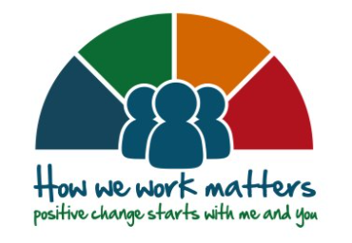

Reflect on the ‘Myself’ and ‘My Team’ section of HWWM:

|  |  |
| --- | --- |
| Myself: **Self leadership** is about you taking the lead and being clear about the difference that your contribution makes:   * take time to think about how you go about your job * consider the impact that you can have on others * think before you speak or act * develop positive attitudes and behaviours to help you achieve personal and organisational goals | |
|  | Notes (optional) |
| **I know how to…**   * demonstrate our commitments * work as part of a team * be healthy and safe at work * cope with change and build personal resilience * communicate effectively * develop my digital skill and make the best use of technology * plan my personal development * develop my emotional intelligence |  |
| **I am…**   * the “face” of the organisation and a role model – because how we work matters * kind and aware of the impact that I can have on others * respectful of others, and act in a way that I would like to be treated * trustworthy, open and honest * responsible for my own performance * adaptive to change * confident and resilient |  |
| **I…**   * put people first; understanding and responding appropriately to their needs * act with integrity and treat others with dignity and respect * listen and act upon feedback from others * contribute to our team, service and organisational plans * take appropriate steps to solve problems and improve my performance * use technology / digital skills to effectively deliver services * look after my own and others’ safety and wellbeing * continue to keep my skills up to date. I look for opportunities to keep learning |  |

|  |  |
| --- | --- |
| My Team: We work as part of lots of different teams and you can be a team leader, whatever your job title is.  For some people leading and managing people is also a responsibility of their job.  What the framework sets out we should know, be and do under 'my team', is a guide to developing leadership and management behaviour **at all levels** of the organisation. | |
|  | Notes (optional) |
| **I know how to…**   * adapt my approach to suit the situation * engage and motivate others * ask for feedback and listen and respond appropriately * practice effective people management * create a healthy and safe workplace * delegate appropriately * have good conversations * encourage people – coach and mentor others |  |
| **I am…**   * optimistic about our plans and priorities * a relationship builder; working positively and effectively with others * visible and accessible; responsive to people’s needs * accountable for the overall performance and actions of my team/s * a coach and mentor * a source of information and guidance |  |
| **I…**   * provide a clear sense of purpose and direction * use different leadership styles and coaching skills to motivate others and improve performance * empower and support others to take a leadership role – to be innovative, bold and make decisions * recognise achievements, give praise and share stories of successful outcomes * support others to learn from their experiences * encourage and support people to contribute to our reform programmes |  |
|  |  |

**The Five Ways**

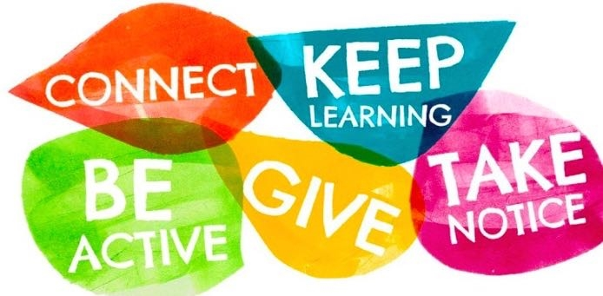

Wellbeing is essential to good personal and organisational performance. Regular conversations allow any issues to be identified quickly, and early action to be taken. Specifically, it is important to consider and manage issues that can lead to workplace stress - if work-related stress issues or particularly serious concerns are raised, it is recommended that you have a separate conversation to discuss, agree and record solutions.

|  |  |
| --- | --- |
|  | Notes: Optional |
|  |  |
|  |  |
|  |  |
|  |  |
|  |  |