

______________________________________________________________________________

Wormit School

Site Traffic Management Plan

August 2025
(Next review date August 2026)

Contents

Section

- Introduction
- Layout / Access
- Pedestrians
- Pupils / Students
- Staff
- Visitors
- Servicing / Deliveries
- School Buses
- Contract Hire Services
- Disabled Access
- Out with the School Grounds

1. Introduction

The purpose of this document is to inform and instruct employees, pupils, parents and others who come onto the school site, including visitors (both pedestrians and people in vehicles), about the rules concerning pedestrian and vehicle separation.

Wormit Primary School takes the health and safety of all site users very seriously. It is therefore very important that individuals take care, exercise caution when in the school grounds or within the vicinity of the school grounds and follow instructions to avoid risk of injury. If there are any concerns about traffic safety, they should be reported to the school management team.

We urge all site users to read this document carefully and to follow the rules as outlined.

This document has been shared with all stakeholders and is available on the website.

The document will be reviewed annually and awareness raised regularly through communication with parents and pupils (electronic and face to face) and, as appropriate, with the local community.

For further information, please contact:

Lucy Jess, Headteacher on 01334 659445

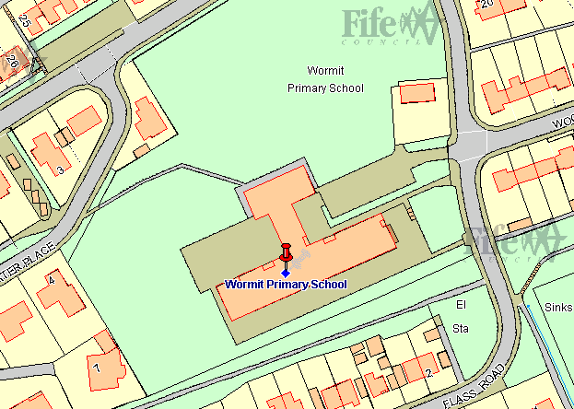
2. School Layout / Access
1. Car Park Entrance
Flass Road
2. Pedestrian Entrance
Direct access to Main School Entrance
Flass Road

NB All cyclists, scooters and skateboarders dismount here and push bike and scooters to the bike and scooter parking ranks or carry skateboards into school.
3. Pedestrian Entrance
Access to Nursery School Entrance
Flass Road

4. Pedestrian Entrance
to school grounds.
Westwater Place

NB All cyclists, scooters and skateboarders dismount here and push bicycles and scooters to the bike and scooter parking ranks or carry skateboards into school.

Main School Entrance
Sheltered
Bike Rank
Scooter Ranks
Nursery Class
Entrance

3. Pedestrians

Pedestrians can access the school grounds from Westwater Place and Flass Road and should only access the school from the designated footpaths. On Flass Road pedestrians need to exercise caution when crossing the entrance to the school car park especially at the start and the end of the school day. Pedestrian entrance via the car park is forbidden at all times.

4. Pupils

It is very important that pupils set a good example to others, particularly in the spirit of being a safe school. There are a number of site related areas pupils should be aware of:
- Entry to the school grounds is only permitted by the designated pedestrian entries into the school ground situated on Flass Road and Westwater Place.
- Pupils must walk when using the footpaths. This will avoid accidents.
- Pupils must dismount bikes and scooters when entering the school grounds and walk within the school at all times.
- Pupils must not enter the school via the school car park at any time. Pupils must not walk across the car park as a pedestrian to access the pedestrian footpath or the playing fields at any time.
- If disembarking the school transport minibus in the car park, pupils must follow the instructions of the bus driver who will direct them on and off the bus to and from the footpath.
Pupils must allow the driver to carry out his/her duties without distraction and behave well whilst on board. This ensures that vehicles can move off on time and the journey is comfortable for all.

Drop Off

The designated drop off for pupils travelling in school transport is in the carpark. Parents/Carers who drive their child to school can not make use of the car park for drop off or pick up – there is not space to do so.

5. Staff

Staff are expected to act responsibly on the site when parking and accessing the school building. The school car park is for the use of all Fife Council staff who work in the building. At certain times, there will not be enough spaces for all staff on site and if a staff member arrives to find no space to park, they should seek a suitable and safe space in the area around the school. There is no parking in the bay beside the bins and the one beside the bike shed between 8.30 and 9.30am and again between 2.30 and 3.30pm – these bays are reserved at this time for the school transport mini-bus/taxis.

6. Parents and Visitors

There is no parking available for parents/visitors on school premises, unless they have a disability and dropping off is prearranged.

Alternative on street parking is available in the surrounding area. Parking space on Flass Road is limited and parents are asked to please make sure that they do not block residential driveways or park where this could cause an obstruction especially to service buses. At busy times this has caused particular problems and parents are encouraged to park on Riverside Road. This allows pupils to walk into school via the Westwater Place pedestrian entry. “Park and Walk” helps the pupils to take part in the school’s Active Travel Plan.

Access into the school is only permitted from pedestrian entrances on Flass Road and Westwater Place. Visitors need to press the security buzzer located at the front door. All visitors must report to reception and sign in before going anywhere in the school. On departure, visitors should sign out at reception and leave the building by the main entrance door.

If visitors need any advice on access or parking before their visit, please
call the school reception on 01334 659445

7. Servicing / Deliveries

Drivers of service vehicles (if they have not been on the site before or obtained instruction in advance) should report to the reception desk in the main building to advise the nature of their visit and get clarification on where they can park. Drivers may be issued with a copy of this plan for reference or simply be advised of the site rules in relation to the area they are parking at the time.

Where the contractor is on site to carry out works by prior arrangement, please call the school reception on 01334 659445 in advance to agree the most suitable parking location.

8. School Buses

Several school transport mini buses and taxis use the car park on school days. There are two parking spaces kept clear at the start and end of the day for the use of the mini-buses/taxis – one beside the bins, the other beside the bike shed. The mini buses and taxis should not park blocking cars in, on double yellow lines or blocking the entrance to the School House which must be kept free at all time.

If the bus bay is not free at the designated times (8.30-9.30am and 2.30-3.30pm) the driver should make staff at reception aware and they in turn will inform the Headteacher, Principal Teacher and/or the Janitor who will address the matter.

The bus should be at a complete stop with the engine switched off before the driver allows pupils to get on or off the bus. The pupils should use the steps to go up onto the footpath. Only when pupils are clear of the vicinity of the bus park (am) or all on board (pm), should drivers exit the bus park following the agreed departure sequence.

Pupils are reminded about good conduct in section 4 of this plan. However if there are any concerns they should be raised with the Headteacher.

9. Contract Hire Services

Contracted vehicle drivers (including taxis and minibuses) will have specific instructions given to them through Transportation & Environmental Services as part of the terms of the contract.

10. Disabled Access

Pedestrian access is via the main front entrance. The door will not open until the buzzer is sounded.

Parking

There are no designated disabled parking bays at Wormit Primary School.
If visitors, staff or pupils require information on access or any other considerations, they should contact the school reception in the first instance on 01334 659445.

11. Out with the School Grounds

The school accepts that parking near the school is not ideal. There is parking on Riverside Road with no parking on Flass Road around the school gates as the double yellow lines have been extended. Flass Road is a residential street, used by Service buses as well as car traffic. Riverside Road is a main thoroughfare and in constant use during the day. Around the school at peak times a 20 mile an hour zone comes into operation on these routes. Parents/Carers are encouraged to park safely away from the school gates and allow their children to walk the remaining distance. There is a Pelican Crossing on Riverside Road which pupils are encouraged to use to allow for safe crossing and this has improved safer access to the Westwater Place Designated Pedestrian Entrance.

Parking indiscriminately, such as mounting pavements, double parking, stopping on any yellow lines, obstructing access points to streets and driveways and parking near junctions causes danger to pupils and other road users. Accidents can arise if views are obstructed or pedestrians have to negotiate between parked vehicles. In addition, the roads can become congested which results in frustration and delays to services and ongoing journeys. Care should be taken when manoeuvring and private driveways and entrances should not be used as turning points.

Please act responsibly by parking as far away from the school as possible to keep the pupils at Wormit Primary School local residents and other road users safe.

