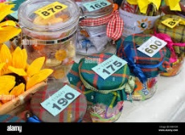

**MENU**

* SOUP
* PARTY BUFFET
* ICE CREAM/ICE POLES
* TEA/COFFEE/JUICE

SERVED AT 12 NOON

**Rio Community Centre**

**St Mary’s Lane, Newport on Tay, DD68AH**

ENTERTAINMENT

TOMBOLA

FUN FOR THE WHOLE FAMILY

**THURSDAY 17TH JULY**

**LET’S DO LUNCH**