HOLIDAY CLUB

RIO COMMUNITY CENTRE
ST MARYS LANE, NEWPORT ON TAY, dd68ah
WEDNESDAY 9TH JULY
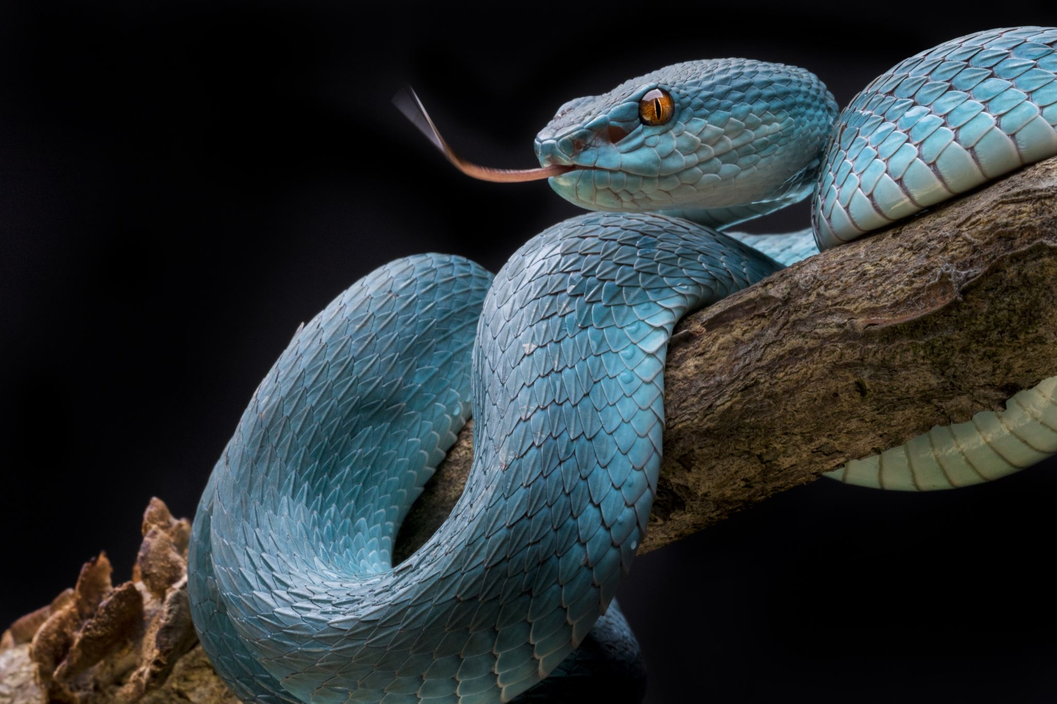
10AM
OFF THE SCALES – ANIMAL MAN

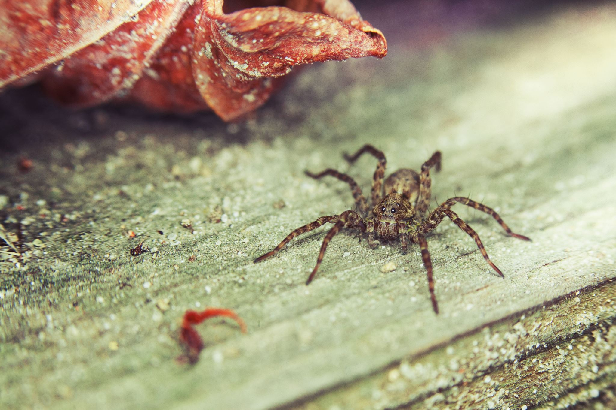
£3 PER CHILD
Book your place:
Goodie Bags
Refreshments
Text 07730685998
Call 01382 543366
Private Message on Facebook: RIO Newport
Email: riocentre@hotmail.com
Places must be booked in advance.
Please call/text/private message or email to book.
Place confirmed once payment has been made.

