ARCHERY

rio community centre
st MARY’S lane, newport on tay, DD6 8AH
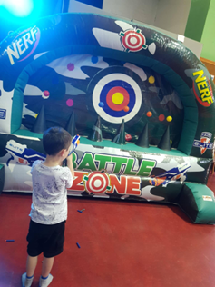
  - FUN AT THE RIO

tuesday 29th july

10.30AM – 1.30PM


£3 per child
FUN AND GAMES
Sandwiches – Crisps – Biscuits – Juice
Goodie bags!
  - BOUNCY CASTLE
Everyone is welcome!

