Family Learning
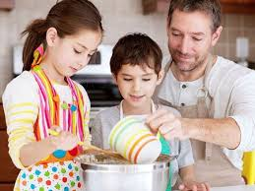

Family learning encourages family members to learn together
Realising the Ambition: Being Me pg 59

We have put together this guide to help you think about everyday ways to support your child’s learning at home.

Literacy
Potential Learning
- Encourages the development of concentration and ability to take part in discussions
- Develop their creativity and imagination
- Develop their growing vocabulary
- Gain knowledge and facts
- Learn that we read from left to right
- Learn the difference between numerals and letters
- Learn what an illustrator and author is
- Develop the ability to retell a story
- Recognise familiar letters and their sound
- Develops fine motor skills
- Develops pre writing and writing skills

Activities to do with your child
- Share a few favourite books each day
- Talk about the pictures, what do you see?
- Encourage your child to retell or re-enact the story by looking at the pictures in order
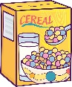
- Talk about what an author and illustrator does?
- Look for other things that have writing on them all around the home e.g. cereal box, shampoo bottle, magazines, tv guide
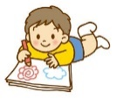
- Hunt for familiar letters
- Draw a self portrait
- Make a card
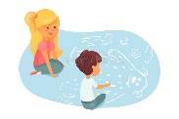
- Encourage children to take part in creating shopping lists by drawing or writing
- Add events to a calendar or diary
- Make marks with paint, chalk, pen, pencil, sticks or even by using a paint brush and water on concrete, a wooden fence or the path
- Draw a picture relating to a story, discuss what detail they could add e.g. eyebrows, ears, patterns on clothes, flowers, leaves etc
- Allow your child to draw a picture then ask them to tell you the story about it. Write it down as they talk and then read it back to them.
- Make and play with tongue twisters
- Share songs and rhymes
- Bang pots and pans or any instruments you have, can they keep the beat?
- Use pegs to hang up the washing
Useful links
Jackanory Junior - https://www.bbc.co.uk/programmes/b007t9wg
Scottish Book Trust - https://www.scottishbooktrust.com/songs-and-rhymes
Topmarks - https://www.topmarks.co.uk/Search.aspx?Subject=37
Crickweb - http://www.crickweb.co.uk/Early-Years.html
Booktrust read along stories - https://www.booktrust.org.uk/books-and-reading/have-some-fun/storybooks-and-games/

Number and Maths
Potential Learning
- Develop confidence in using number names
- Develop confidence using number symbols
- Develop confidence in using the number sequence, forwards and backwards.
- Use numbers to count, create sequences and describe position
- Count on and count back
- Begin to develop simple addition and subtraction by organising groups of objects
- Share out a group of items equally
- Understand that we can split whole items into smaller parts
- Recognise and continue patterns
- Sort items into groups by size, shape, colour and type
- Understand routines and order of events
- Link routines to the time of day/ day of the week
Activities to do with your child
- Look for numbers in the environment and talk about special numbers such as the one on your front door
- Count forwards and backwards (sometimes start at different numbers)
- Count the stairs as you physically walk up and down them
- Count and sort a collection of anything: pebbles, buttons, socks. Make sure you touch each one as you count it
- Add groups of objects together e.g. I have 3 pebbles, you have 2, how many do we have together? What If I pick up 3 more? How many do we have now? I dropped one, how many are left?
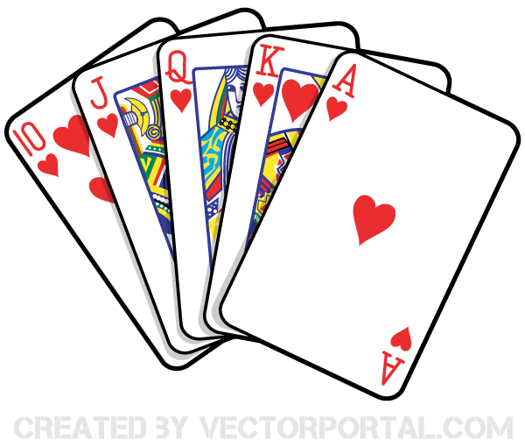
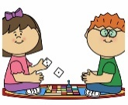
- Play dominoes and dice/board games
- Deal a deck of cards, share the cards equally
- Play card games and notice the patterns on the cards
- Sort the playing cards into suits and number order
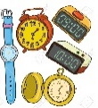
- Look at the time on phones, watches, clocks
- Talk about the routines in your day and week. What do you do in the morning? afternoon? evening? On Monday? What did you do first today? What will you do next?
- Look out the window, how many cars/lorries/motorbikes/ birds can you count?
- Record how many items you count using tally marks, numbers and pictures
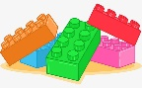
- What shapes can you spot around the house?
- Use junk boxes or blocks to design and build houses, bridges, enclosures and talk about symmetry, shapes and patterns
- Cut food such as fruit, sandwiches and pizza into half, quarters, etc and talk about how many parts there are.
- Join in with baking and cooking, weigh, measure and count ingredients, set timers and talk about temperature
Useful links
Topmarks - https://www.topmarks.co.uk/Search.aspx?Subject=37
Crickweb - http://www.crickweb.co.uk/Early-Years.html
Oxford Owl - https://www.oxfordowl.co.uk/for-home/kids-activities/fun-maths-games-and-activities/

Health and Wellbeing
Potential Learning
- Understand that being active is a healthy way to be
- Describe how energetic activities make us feel
- Develop an understanding of how to keep safe
- Understand how to get help in an emergency
- Understand that they are unique
- Begin to understand what they can do to look after their health
- Develop an understanding of the people who care for them
- Discover how things grow
Activity
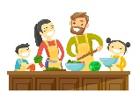
- Encourage your child to help prepare different meals and snacks throughout the day. Have conversations about eating more of some types of foods and less of others and how this is good for our health.
- Remember that meal times are a great opportunity to talk together and share our thoughts and feelings
- Perform and talk about the importance of daily hygiene routines, for example, hand washing and tooth brushing
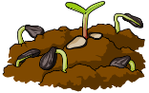
- Go outside and look for signs of change
- Plant seeds for example apple or orange seeds
- Care for houseplants and pets
- Exercise together in the house, put some music on and dance, stretch and balance, roll a ball, how many times can you walk up and down the stairs (if you have any)
- If you have an outdoor space throw and catch a ball, play tag, chase or skipping games
Useful links
BBC Good Food - https://www.bbcgoodfood.com/recipes/collection/kids-cooking
Change 4 Life - https://www.nhs.uk/change4life
Growing seeds - https://brightside.me/creativity-home/8-fruit-trees-you-can-grow-from-the-seeds-and-pits-of-your-own-fruit-498010/
Growing seeds in a plastic bag - https://www.saps.org.uk/primary/teaching-resources/639-growing-seeds-in-a-plastic-bag

