WESTFIELD FAMILY NURTURE CENTRE

Westfield
Family Nurture
Centre

HOME LEARNING ADVICE

Issue 14

Over the coming weeks we wish to support you with ideas on how you can support your child’s continued learning at home.

In this bulletin our team have produced some suggestions on how to keep learning going at home.

THE IMPORTANCE OF PLAY
Play is how our youngest children’s learning and development. It will be very important that time is made within a day for quality play experiences.

Playing alongside your child at times during the day is going to have the maximum impact. This will provide them with the security and comfort that they will require over the coming weeks, but it will also help you have fun together.

Play enables children to develop a range of skills including communication, problem solving, imagination, co-operation etc.

It can take place indoors or outdoors.

The following web links may provide further information and practical ideas.

https://www.playscotland.org/parents-families/

https://education.gov.scot/parentzone/learning-at-home/learning-through-play/

ONLINE RESOURCES
Suggested resources and links have been included below to support learning and development.

As with any online resource, parental guidance and supervision is recommended to ensure children are accessing these in a safe and appropriate manner.

This is the Bear by Sarah Hayes

With your child watch and listen to the following story being read aloud on Youtube.

https://www.youtube.com/watch?v=I16VCM8LOXA

Here are some suggestions to use with this story.

Literacy
- Discuss the title of the book, author and illustrator and what this means.
- Would you call the book something different, what and why?
- Can you describe what the story is about?
- Can you use the pictures and memory to ‘read’ it back?
- Can you recognise any rhyming in the story? “who went to the dump and fell on the pile with a bit of a bump”
- What toy/teddy is your favourite can you draw a picture?
- Can you create a story about the bears next adventure?

Numeracy/Maths
- How many things did the dog smell before finding the bear?
- Can you notice any patterns in the book? for example each sentence beginning with “this is the ….”
- Can you predict what may have happened before the bear went missing?
- Can you count how many other toys are in the story?
- Can you spot any numbers within the story? (hint look at the truck)

Health and wellbeing
- How do you think the boy and the bear felt when he was missing?
- What about when he was found? Can you name these emotions?
- Have you ever felt like this? what made you feel better?
- Could you do a bear hunt around the house or garden?
- How would you have travelled to the ‘dump’? car, bus walk, bike and why?
- Can you create a teddy bear picnic with your toys? What food would you have?

RHYMETIME

Teddy Bear
Teddy Bear, Teddy Bear, turn around,
Teddy Bear, Teddy Bear, touch the ground,
Teddy Bear, Teddy Bear, reach up high
Teddy Bear, Teddy Bear, wink one eye,
Teddy Bear, Teddy Bear, slap your knees,
Teddy Bear, Teddy Bear, sit down please.

- Can you share this rhyme together?
- Can you follow the actions?
- Which words rhyme?
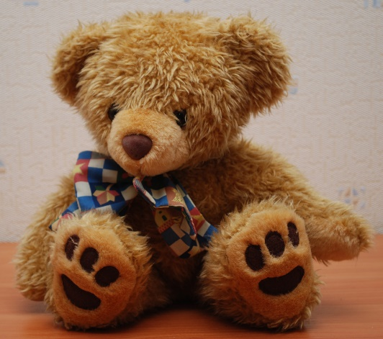
This Photo by Unknown Author is licensed under CC BY-SA

Don’t forget to share your home learning times with us.

Take a photo and email it to us at:
westfieldns.enquiries@fife.gov.uk

By sending us in your photos you are agreeing that we can then post them on our website or social media page to help you keep connected with your friends.

