**PACKED LUNCHES**

**IN NURSERY**

**Information for Parents**

***Working Together to Achieve More***

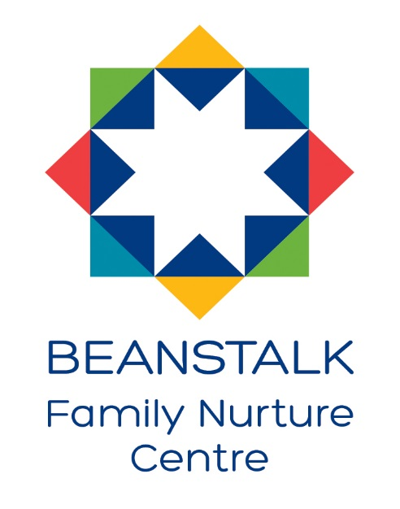

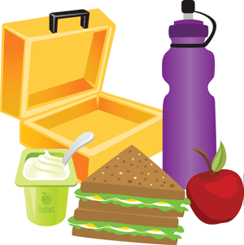 At Westfield Family Nurture Centre, we are striving to promote healthy, nutritious eating for all our children. We have all seen and heard about the worrying rates of child obesity and tooth decay, so with this in mind we have devised this information leaflet to advise parents on what items can be included in a healthy packed lunch.

*“Healthy eating and physical activity are essential for proper growth and development in childhood. To help children develop patterns of healthy eating from an early age, it is important that the food and eating patterns to which children are exposed – both at home and outside the home – are those that promote positive attitudes and enjoyment of good food.”*

*Eating well: Packed lunches for 1-4 year olds*

The key principles of eating well for children in this age group need to be considered to ensure they consume the required amount of energy and nutrients in their packed lunch.

**Key principles of eating well for 1-4 year olds:**

* Provide a variety of foods each day to ensure children receive all the important nutrients
* At least **5 child-sized** portions of fruit/vegetables daily – serve these with meals and snacks and encourage children to taste different ones so that they become familiar with them
* Limit sugar intake – sugary foods like sweets, biscuits and soft drinks are high in calories and have little nutrient value. Fruit can be used to sweeten yoghurts and desserts. Starchy foods like bread, pasta and potatoes are better sources of energy and have a better nutrient value.
* Good-quality food – small amounts of good food regularly are needed, and processed foods like sausage rolls, Scotch eggs and coated fish/meat should be avoided.
* Foods containing zinc and iron e.g. meat, eggs, ground nuts, should be served at main meals.
* Foods containing calcium, riboflavin and iodine e.g. whole/semi-skimmed cow’s milk, cheese, unsweetened yoghurt/fromage frais, should be served daily.
* 1-4 year olds need to be given foods that are low in salt. Foods that are high in salt, like processed meat, salty snacks and biscuits should be avoided.
* Drink water – encourage children to drink water if they are thirsty. Water is always available in the nursery.

**What should go into a packed lunch for 1-4 year olds?**

**STARCHY FOOD – 1 OR 2 PORTIONS**

e.g. white/wholegrain bread, roll, bagel, wrap, pitta bread,

 cooked potato, pasta, noodles, rice, couscous

fruit bun, malt loaf, raisin bread

**PROTEIN FOOD – 1 PORTION**

e.g. chicken, turkey, beef, lamb, pork, sardine, tuna, salmon,

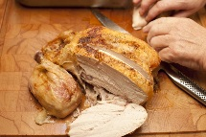 egg, hummus, dahl, tahini, tofu, nut butters

**VEGETABLES – AT LEAST 1 PORTION**

e.g. cucumber, carrots, tomatoes, celery, peppers, sweetcorn,

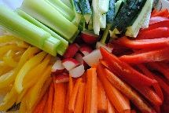 salad, green beans, sugar snap peas

**FRUIT – AT LEAST 1 PORTION**

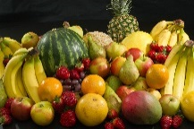e.g. apple, pear, banana, clementine, strawberries, grapes,

kiwi, melon, pineapple, mango, dried fruit,

fruit canned in fruit juice

**MILK OR DAIRY FOODS OR DAIRY ALTERNATIVES – AT LEAST 1 PORTION**

e.g. whole milk (under 2 years), semi-skimmed milk (for children

over 2 years), unsweetened soya milk, oat milk or almond milk, plain yoghurt, plain fromage frais, cheese, rice pudding, semolina pudding, custard

**Don’t worry if your child is a fussy eater, lots of children are. Even**

**including a few healthy items can help!**

Packed lunches should provide the amount of calories required by children at a main meal and promote positive attitudes and enjoyment of good food. Therefore we would suggest that the following items are **not** included in packed lunch boxes:

* Biscuits
* Sweets
* Crisps
* Fizzy/flavoured juice

Any packed lunches can be stored in a nursery fridge, and should be placed in a named, wipeable plastic container. These should be handed to a member of staff on arrival at nursery.



**Ideas and guidance about nutritious, cost-effective and practical**

**packed lunches for children age 1-4 years is available in nursery**

**or on-line at** [**www.firststepsnutrition.org**](http://www.firststepsnutrition.org) **(Eating well: packed**

**lunches for 1-4 year olds)**