Standards and Quality Report
Synopsis for Parents 2025-2026
Warout Primary School
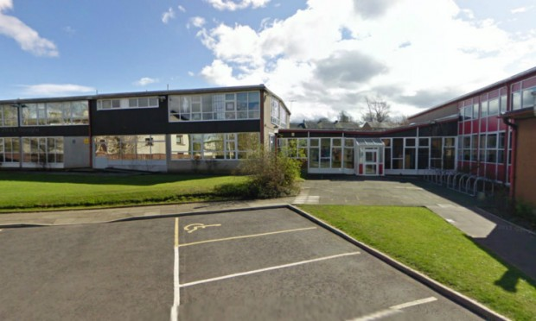

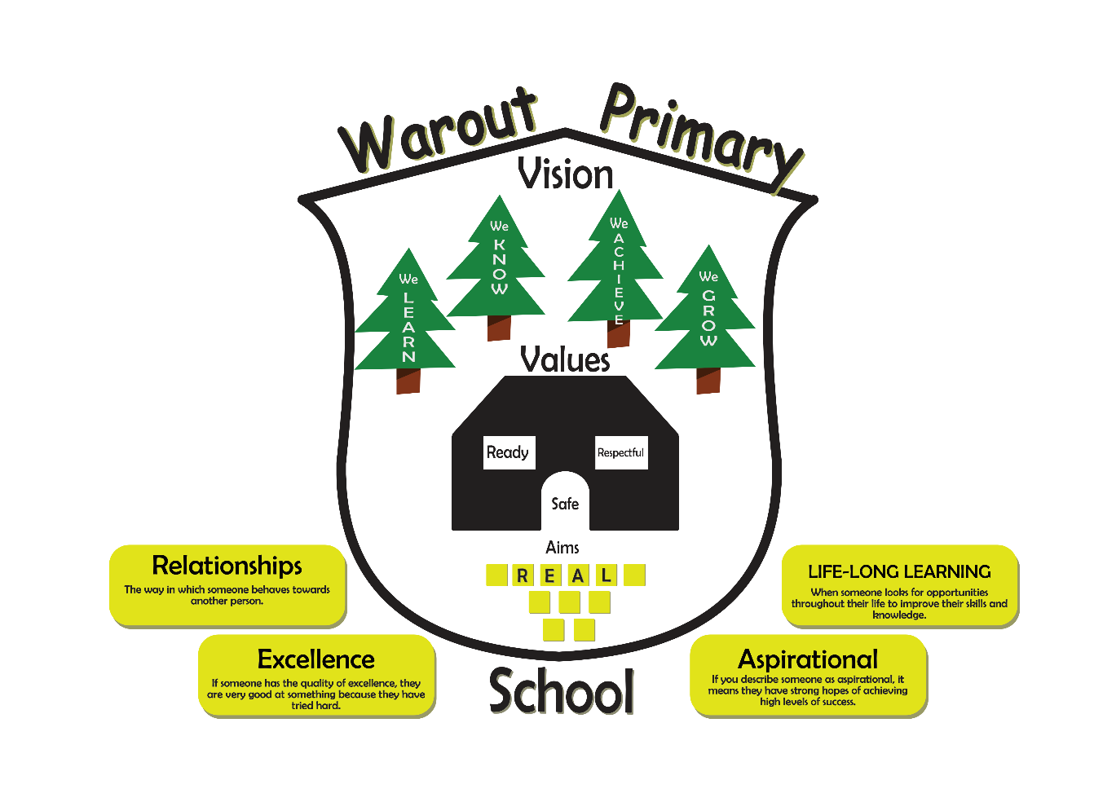
Attainment
How well did our young people learn and achieve in 2025-2026
Stage | Listening and Talking |  | Reading |  | Writing |  | Numeracy
 | Actual |  | Actual |  | Actual |  | Actual
P1 | 44.00% |  | 48.00% |  | 44.00% |  | 60.00%
P4 | 62.50% |  | 62.50% |  | 50.00% |  | 66.67%
P7 | 58.62% |  | 58.62% |  | 48.28% |  | 58.62%
Overall Attainment for 2023 - 2024
 |  | Literacy |  |  |  | Numeracy
 |  | Stretch |  | Actual |  | Stretch |  | Actual
P1 |  | 68.00% |  | 44.00% |  | 76.00% |  | 60.00%
P4 |  | 63.64% |  | 50.00% |  | 68.18% |  | 66.67%
P7 |  | 58.62% |  | 48.28% |  | 65.52% |  | 58.62%

Evaluative statement of attainment over time.

Attainment over time data across the school shows emerging improvement, with evidence that many learners make stronger progress as they move through the stages. Several cohorts demonstrate notable gains, particularly in the middle and upper school. For example, the current P6 cohort increased from 28.1% to 60.7%, while the P5 cohort improved from 43.8% to 64.3% before declining slightly to 57.1%. Similarly, the P4 cohort rose from 24.1% to 50.0% before reducing to 42.3%. These patterns indicate that targeted interventions are having a positive impact; however, improvements are not always sustained over time.
In the early stages, attainment is more variable. P2 attainment increased overall from 65.2% to 76.2% before falling to 71.0%, while P3 attainment initially declined from 40.7% to 34.6% before recovering strongly to 58.3%. Although these trends suggest improving outcomes, progress remains uneven across cohorts and stages, limiting confidence that improvements are fully embedded and sustainable.
Attainment for learners with additional support needs (ASN) is characterised by considerable fluctuation across stages, with significant year-on-year variation rather than consistent progression. This indicates that, while individual learners and cohorts may experience periods of success, progress is not yet secure enough to ensure predictable outcomes over time.
A similar pattern is evident for learners affected by free school meal (FSM) entitlement. While there is evidence of improvement in some cohorts, particularly in the middle and upper stages, attainment remains inconsistent. Notable gains are evident in P3, where attainment increased from 30.8% to 54.5%, and in P6, where it rose from 23.5% to 53.3%. Overall, the data demonstrates improving trajectories but highlights the need to secure greater consistency, sustainability and equity in attainment outcomes for all learners.

Evidence of Wider Achievements
There has been a wide variety of wider achievement opportunities across the school this session. All opportunities have developed a range of skills linked to the 4 capacities: Effective Contributor, Successful Learner, Responsible Citizens and Confident Individuals.
Our REAL awards have been greatly revived by children and parents and 16 children each term have been awarded their REAL award in a ceremony in which their parents/carers are invited.
This session, our Achievement group, have worked to create a certificate that recognises success in one of the taught meta- skills. Pupils have to nominate each other and nomination, through to awarding the certificate is done by the pupils themselves.
- The school continues to gain external recognition for its work. Warout achieved the Sport Scotland Silver School Sports Award and successfully renewed its Eco Schools Green Flag, reflecting the hard work and leadership shown by our Eco Ambassadors. We have achieved our Reading Schools accreditation and have received re-accreditation as a Kit-Bag Ambassador School, demonstrating an ongoing focus on wellbeing, emotional literacy and nurturing approaches.
- This year a group of P7’s secured 2nd place in the Enterprise competition Dragon’s Den and third place in the local Rotary Quiz.
- Learners in the upper school have begun using My World of Work to record and reflect on their personal achievements, supporting progression in skills for learning, life and work. In addition, several teachers are at the early stages of piloting an emerging tracking system designed to capture achievement across the four contexts of learning. This work is helping us identify trends, gaps and strengths in children’s experiences, allowing for more responsive and targeted planning.
All P7’s have been successful in obtaining their Fife Diploma of Achievement this year.
School Aims 2025-2026

Skills and Achievement
Improve our curriculum offering to ensure the development of skills and whole school achievement opportunities.
Digital Literacy
To support all staff through the use of digital technologies and other resources to create a more inclusive, engaging and personalised learning environment leading to improved outcomes for children and young people.
Writing
To develop a whole school approach in delivering writing in order to raise attainment.
Progress against our School Aims 2025-2026

Skills and Achievement
Improving learners’ understanding of achievement and skills was a key priority during the session, following baseline data which showed that only 59% of pupils understood achievement and 50% could discuss their own achievements. Through a targeted whole-school approach, including assemblies, classroom learning and focused teaching, at least 75% of pupils now demonstrate a secure understanding of achievement and can confidently articulate the skills they are developing.
Staff confidence and consistency have improved through refinement of the four-part model, professional learning and participation in the Fife Achievement, Skills and Curriculum pilot group. Achievement Ambassadors, nomination systems and assemblies have strengthened the school’s culture of recognising and celebrating success. Practitioner enquiry and professional dialogue have supported the sharing of effective practice and enhanced approaches to achievement education.
A bespoke tracking system aligned to the four contexts of learning has improved the monitoring and evaluation of achievement. Regular Attainment and Achievement meetings enable staff to identify trends, address gaps and plan targeted interventions. Increased opportunities for achievement and meaningful recognition have contributed to improved learner confidence and a more inclusive, achievement-focused ethos.
Outcomes for P7 learners are particularly strong. All pupils are actively profiling their achievements, can explain how they apply their skills in learning and life, and have successfully achieved the Fife Diploma of Achievement through participation in leadership, enterprise, volunteering and personal achievement opportunities.
Digital Literacy
Professional learning has been effectively planned and delivered, with a clear focus on developing staff knowledge and skills in digital pedagogy. Most practitioners view the learning as accessible, relevant and supportive, resulting in strong engagement, collaborative learning and professional dialogue. This has helped develop a shared understanding of effective digital approaches across the school.
Staff are increasingly confident in using digital tools to enhance learning and teaching. They demonstrate greater awareness of how technology can support creativity, learner engagement, differentiation and formative assessment. Evidence suggests that practitioners are beginning to embed these approaches into classroom practice, creating more interactive and responsive learning experiences.
Pupils also show growing confidence in using digital technology. They value the accessibility of iPads, which provide easy access to learning resources, instructions and feedback. Learners effectively use tools such as immersive readers and audio features to support understanding, inclusion and independence. They recognise that digital platforms help teachers structure lessons clearly and monitor engagement.
The professional learning programme is beginning to impact positively on learning and teaching, with improved learner engagement, increased creativity and greater use of digital formative assessment strategies. Collaborative learning is supporting greater consistency in practice.
However, impact remains inconsistent. Some staff find aspects less relevant to their context, while inequitable access to resources and the pace of delivery have limited implementation. Overall, digital technology is promoting a more inclusive, engaging and personalised learning environment.
Writing
During session 2025–2026, the school prioritised improving writing through a more structured and consistent approach to teaching and assessment. The introduction of the Stephen Graham writing model has established a shared understanding of effective writing pedagogy, leading to greater consistency in planning and delivery across the school. Professional learning, moderation activities and collaborative dialogue have strengthened staff understanding of progression and expectations, although further opportunities are needed to develop this work at stage level. A continued focus on pace and challenge has aimed to ensure learners are appropriately supported and extended.
Pupil voice evidence highlights a positive impact on learners’ experiences. Pupils report increased engagement in writing lessons, greater challenge, more opportunities to discuss their writing and a deeper understanding of different text types. Learners are increasingly able to identify their successes through self- and peer-assessment approaches and demonstrate growing confidence in recognising next steps. They also view mistakes positively as part of the learning process. Attainment data shows encouraging early signs of improvement. While overall attainment in Primary 4 remained stable, writing attainment increased by 8%, suggesting targeted strategies are beginning to have a positive effect. Although attainment did not increase in Primary 1 and Primary 7, the revised P1 literacy target more accurately reflected the cohort’s complex additional support needs. Staff report that the structured writing approach is providing greater clarity and consistency, although further embedding is required to secure sustained improvement across all stages.

What are the school’s improvement priorities for session 2024-2025
Warout Primary School continues to benefit from The Pupil Equity Fund. Our improvement priorities are as follows: -
Focused Priority 1:
To strengthen parental engagement in learning to enhance pupil engagement, attainment and collaborative partnerships between home and school.
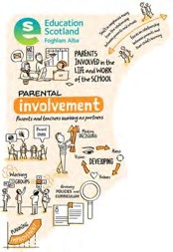

Focused Priority 2:
To develop a whole school approach to moderation and feedback to ensure consistency within the school.

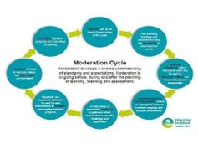
Focused Priority 3:
To enhance our curriculum to ensure the progressive development of skills and promote achievement for all learners.
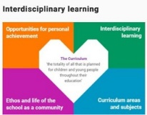

Focused Cluster Priority
All Schools in the AHS cluster will become ‘Reading Schools’ with the AHS cluster becoming a ‘Reading Cluster’ with Reading Schools Scotland
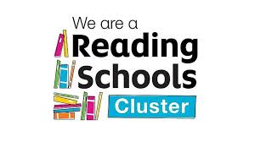
Pupil Equity Funding Priorities
Senior leaders and staff should review systems and processes for collecting and analysing attainment information to lead to improvement.
- 15% increase in Literacy attainment across the school. Increase in attainment in targeted groups.
- 15% increase in Numeracy attainment across the school. Increase in attainment in targeted groups.
- At least 50% of children will have access to a Nurture Intervention to improve wellbeing.

