
Warout Primary
School Travel Plan



Head Teacher: Mrs Lynne Stott
School Address: Malcolm Road
Glenrothes
KY7 4JX

Telephone Number: 01592 583468
Established August 2022, updated August 2025

Summary Page

The following travel plan is a collaborative plan by parents, children, staff and stakeholders who have researched and devised the content, agreeing the actions and aims to make the overall journeys to and from Warout PS safer, healthier and more enjoyable by:

- Increase awareness of Active Travel and educating all about road safety.
- Improving Active Travel facilities (bike and scooter storage, helmet storage, etc.).
- Promoting alternatives to car travel (cycling, walking and scooting), increasing the
percentages of active travel.

The key issues and perception relating to journeys to and from school were identified as – un-walkable routes due to dog litter and not being gritted in winter.

Congestion around the school gate was not seen as a key issue or barrier to active travel.

45% of those surveyed highlighted that they lived within a 2-mile radius of the school.

Routes identified as safer routes to school are:

1: Queen Margaret Drive/Thane Road/McDuff Gardens & Road
2: Malcolm Road/Bruce Road
3: Alexander Road/Stuart Road
4: Cycle/Walking Routes around school

Proposed Behavioural Actions

Promote Active Travel School
Promote Safer Routes to School
Road Safety Education School/Parents/Fife Council
Deliver Cycle Training School/Fife Council
Create a Walking Bus

This plan is valid for 6 years and will be reviewed during year 3.

1.0 INTRODUCTION

  - School background

The primary school which was built in 1957, has eight classes and has two play areas and a large grassy playing field. The aims of the school are to support our pupils in becoming Successful Learners, Confident Individuals, Effective Contributors and Responsible Citizens. We also aim to provide quality teaching and learning experiences for all.
Pupils' achievements are recognised and rewarded at a weekly assembly. An award ceremony at the end of each year also recognises our P7 leavers. Also at the end of each term pupil’s are recognised for a REAL award for pupil’s upholding our school AIMS. The school has pupil’s in Making a Difference Groups so everyone is involved in School Improvement.
Our school is health promoting, enterprising and eco friendly and have achieved our Green Flag. Green Flag. A newly appointed Parent Council , play an active part in the life of the school.
We do lots of activities which raise money for the school and charities. Primary 7 pupils go to Ardroy Residential Centre every year and there are a variety of after school clubs.
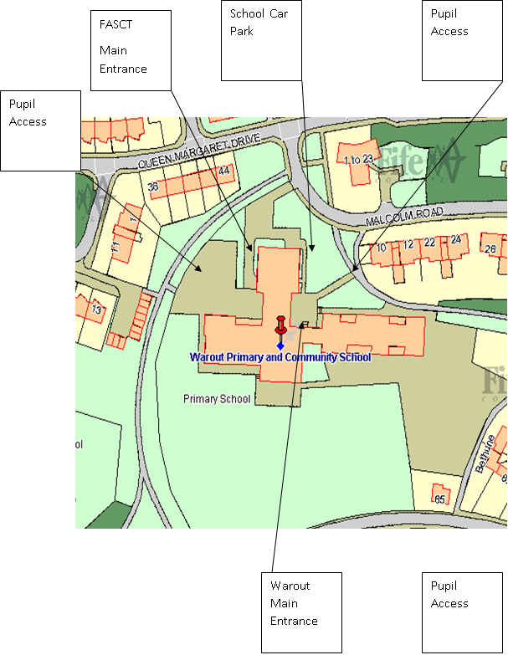

2.0 POLICY AND OBJECTIVES

2.1 Formation of Junior Road Safety Officers

To address the issues raised with congestion around the school gate and to work on future initiatives the school formed its travel action group which consists of Junior Road Safety Officers and members of the school parent council and parent volunteers.
These positions are elected yearly and are part of our Making a Difference Groups.

3. CURRENT TRAVEL PATTERNS

3.1 Questionnaire Surveys

During the consultation period 52 families and 4 staff members responded, and the following analysis is based on the data from those surveys.

3.1.1 Family Survey Data
The main mode of travel to Warout Primary that the survey identified was walking with 35 of those who responded stating that this was their preferred mode of travel; this may be that they also sited that they lived within a 1-mile radius of the school.

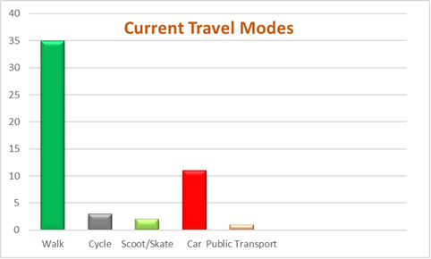

Car was the second most popular mode of transport with 11 respondents even though only 3 of those who indicated that they travelled by car stayed over 2 miles away from the school.

Those who stated that they live within 1 mile of the school and drove didn’t make any further indications on the reasons for doing so.

The main reasons given for travel mode choices are:
- Distance to travel to school
- Near to school, don't like pollution
- We live very close to school and its good exercise
- For exercise and the school is so close. Plus, we don't have to bother with finding
parking

According to the survey 98% of parents would prefer that their child/ren travelled to school in a more active manner and 100% are happy for their child to take part in active travel initiatives throughout the year such as Bikeability, Walk to school week and Active travel month.

When asked “what would encourage you to change your mode of transport to make the routes to school safe for all and ease congestion at the school gate” some of the common responses were

Better bus services and parents to park further away from the school gate – maybe set up a park and stride site. A lot of parents stated that congestion around the school gate was very periodic and didn’t really cause much of an issues as most lived close and the school is serviced well with off road routes.
Carers and pupils were then asked “Is there anything else you would like to share about your own travel choices or how we can make your child's journey to school safer?” the popular responses were:

Safer routes to be gritted in winter and clean up dog litter.

4.0 MAPPING WORK
A mapping exercise was carried out within the school to identify the routes pupils travelled. These were then analysed and the four main routes to school were identified.

Final Map and identified routes

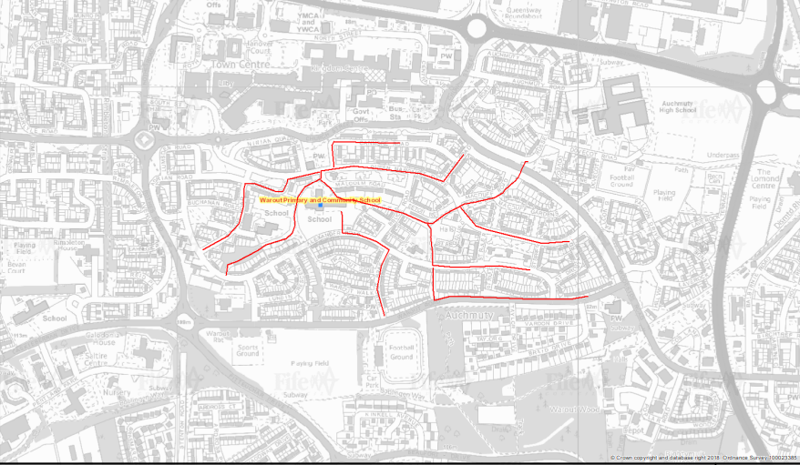

5.0 ROUTE AUDIT OF KEY ROUTES TO SCHOOL
A site visit of the above key routes was carried out on Friday 21st January by the school travel plan officer and the JRSO’s. The weather conditions were cold but bright and sunny.

The purpose of the audit was to help identify a walking bus route as well as looking at the routes identified in the mapping exercise.

The JRSO’s were very enthusiastic and knowledgeable about safer routes to school.

The key findings from the audit are as follows:

- The school is surrounding by a network of remote footways which connect to the streets identified in the mapping exercise.
- Remote footways are light and access is deemed safe, although at the time of the audit there was a lot of winter debris from the surrounding trees and shrubs.
- JRSO’s did note that at times there is an issue with dog fowling in the area, but on the day of the audit this was not an issue.
- There was no engineering works required although the school keep clears could do with refreshing.
- All streets identified in the mapping exercise is within a 20mph zone, all have dropped kerbs and suitable for active travel to school.
- Due to further investigation into a walking bus and which route the school wish to take all streets around the school are deemed safe. Once the school has decided on its route further investigation into that route will be carried out by the school travel plan officer.



7.0 BEHAVIOURAL ACTION PLAN

Action | Solution | Action Owner | Target Date (Academic year)
Promote Active Travel | Take part in Active Travel Months  Take part in Bike Week  Take part in the SUSTRANS BIG PEDAL  Walk to school week | School/TAG  School/TAG  School/TAG  School/TAG | Term 2 & Term 4  Term 4  Term 3  Term 2
Promote Safer routes to school | Upload map to website  Put information board up at parents nights  Articles in school newsletters, social media and assemblies | School  School/TAG  School/TAG | Term 1  Term 2  Term 4  Ongoing
Road Safety Education | Run poster campaigns  Take part in Road Safety Week. | School/TAG | Ongoing  Term 2
Develop a walking bus | Identify route and set up walking bus | School/TAG | Ongoing
Bikeability | Offer cycle training to all P6 and P7 pupils – look at moving cycle parking to front of the building. Apply for cycle parking fund and investigate becoming a Cycle Friendly school. | School | Ongoing

8.0 Physical Measures

Action | Action Owner | Target Date
Relining of school keep clears | Fife Council | TBN

9.0 MONITORING & EVALUATION
The JRSO’s will continue to meet periodically to monitor progress and will review the Travel Plan on an annual basis.
Specific progress will be monitored by participation in the “Hands Up Travel Tally” each year and a repeat of the full travel survey will take place 6 years after initial launch.
The school’s ongoing commitment to travel planning will be publicised in the school handbook, the school newsletters, the Parent’s notice board and through assemblies.

10. DISTRIBUTION OF SCHOOL TRAVEL PLAN

The following bodies will receive a copy of the School Travel Plan:

- Fife Council Assets, Transport and Environment via the Travel Plan Team
- Fife Council Education Service
- Fife Council School Estates Team
- Parent Partnership
- Active Schools
- Copies will also be made available to the parents from the School Office and
via the school information site.

FIFE COUNCIL
ASSETS, TRANSPORTATION & ENVIRONMENT

WAROUT PRIMARY SCHOOL, DUNFERMLINE

ROUTE SAFETY AUDIT

INTRODUCTION

This report results from an Audit of key routes undertaken at Warout Primary School at the request of the school to facilitate their School Travel Plan.

The school is situated within a 20-mph zone on Malcom Road, Glenrothes. All pupils enter the school site from the front of the building and there is an additional entrance for the staff car park.

A site visit of the key routes was carried out on the morning of 21st January 22. The weather conditions were cold but bright and sunny. The audit team consisted of:

Marta Ramage – School Travel Plan Coordinator
Mrs McLure – Principal Teacher
Daniel Williamson – JRSO
Arya Jack - JRSO

The key routes audited were:

Queen Margaret Drive/Thane Road/McDuff Gardens & Road
Malcolm Road/Bruce Road
Alexander Road/Stuart Road
Cycle/Walking Routes around school

Findings and Recommendations

These streets were identified as the main routes taken by all pupils attending Warout. The streets were audited with no engineering requirements recorded. The streets are set within a 20-mph zone, visibility is good at junctions, all junctions have dropped kerbs and although parked cars were noted as a cause for concern when it came to visibility the JRSO’s noted that if you stood further back from the edge of the pavement the sightline was clearer.

There is a network of remote footpaths that surround the school and these should be promoted as the safer routes to school. The school with the aid of the travel plan officer should develop a map highlighting the routes and promote through the school’s online presence.
SUMMARY

Warout Primary School is one of the handful of schools in Fife that does not have congestion issues outside its school gate. The school has a network for remote footways that connect to all streets identified as the routes taken by pupils so therefore promoting these remote footpaths as the safer routes to school is recommended.

The school aim to introduce a walking bus to help with attainment and once the route has been identified a further audit may be required, however, as stated the area is within a residential area with a 20mph zone and no congestion issues.


