Parent summary - September 2025.docxhttps://sway.cloud.microsoft/HfDK4IQSxICVC7AV?ref=LinkParent summary - September 2025.docx

3.
To enhance our curriculum to ensure the progressive development of skills and promote achievement for all learners.
opportunities.

1.
To strengthen parental engagement in learning to enhance pupil engagement, attainment and collaborative partnerships between home and school.

Warout P.S.
Improvement Priorities
2026-2027

Further develop and implement a consistent Cluster Continuum of Support to ensure all children and young people receive the right support at the right time, leading
to improved outcomes, earlier intervention, and more effective partnership working.

Targeted Early Intervention in P1 and P2. To support improved well-being and engagement in learning which in turn should increase attainment.
Increase the percentage of P4 pupils achieving expected CfE levels in literacy and numeracy, with a particular focus on writing.

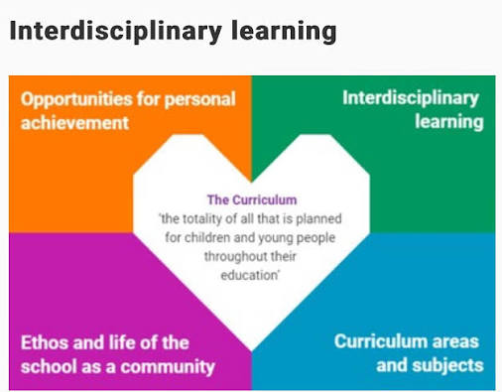
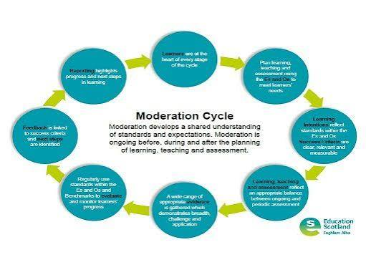
2.
To develop a whole school approach to moderation and feedback to ensure consistency within the school.
Focused Priorities

Auchmuty Cluster Priority
Pupil Equity Funding Priorities

