Parent summary - September 2025.docxhttps://sway.cloud.microsoft/HfDK4IQSxICVC7AV?ref=LinkParent summary - September 2025.docx
3.
To develop a whole school approach in delivering writing.
1.
Improve our curriculum to ensure the development of skills and whole school achievement opportunities.
Warout P.S.
Improvement Priorities
2025-2026

To facilitate the development of skills and whole school achievement opportunities so children are fully aware of all their successes.

Increase in Emotional resilience across the school and in targeted groups.

Raised attainment in Writing in P4 and P7. – (SIP Improvement Priority 3)
Baseline P3 = 36%
Baseline P6 = 27%


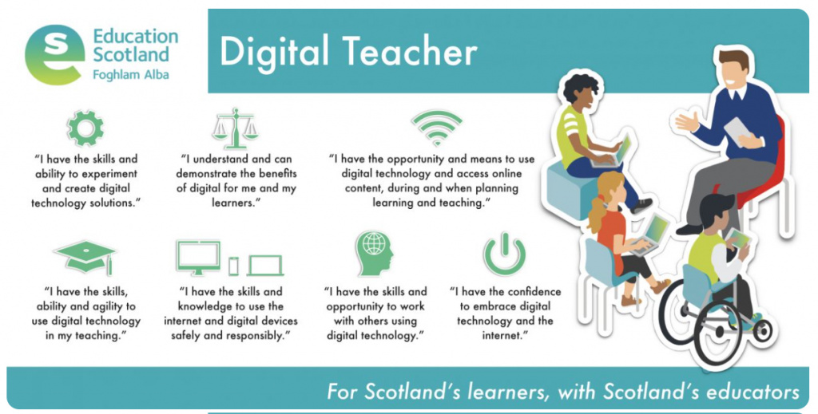
2.
To support all staff through the use of digital technologies and other resources to create a more inclusive, engaging and personalised learning environment leading to improved outcomes for children and young people.
Focused Priorities


All Schools in the AHS cluster will become ‘Reading Schools’ with the AHS cluster becoming a ‘Reading Cluster’ with Reading Schools Scotland

Auchmuty Cluster Priority

Pupil Equity Funding Priorities

