|  |
| --- |
| Key Contacts  Social Work Contact Centre  **03451 55 15 03** |
|  |
|  |
| Out of Hours Social Work (after hours, weekend and public holidays) 03451 55 00 99 |
|  |
| Emergency Services  101 or 999 in an emergency |

**Warout Primary School  
Child Protection Procedures**

The Child Protection Coordinator is:

Lynne Stott

The Depute Child Protection Coordinator is:

Lisa Smart







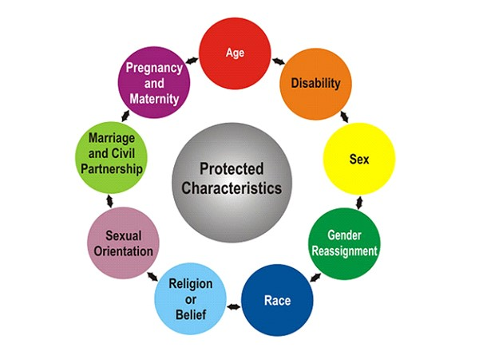

Please report any discrimination you witness immediately by recording on a

Care and Welfare form

(found at reception / All Staff and staff room)

**Guidelines for Responding**

The role of school staff is to **recognise, respond, report and record:**

* **Recognise** when the child’s behaviour and demeanour is a cause for concern and **respond.**
* **Report** concerns immediately to the Child Protection Coordinator.
* **Record** what you have seen and heard, and when, using the young person’s own words where possible.

**Procedures for dealing with a disclosure**

* Listen with care and take the allegation seriously.
* Do not give a guarantee of confidentiality.
* Use open ended questions to establish the basic facts - **Who, What, Where and When,** then STOP.
* Reassure the young person that you know it is not their fault
* Tell the young person that the Child Protection Coordinator will have to be informed
* Report **immediately** to the Child Protection Coordinator/Deputy Child Protection Coordinator
* Record on a Care and Welfare form (found at reception, guidance, staff room).

**If you are on your own, don’t delay, phone Social Work, Police or Health yourself (Contact Numbers overleaf).**

**Remember: Keep a record of all calls.**

**Child Protection Procedures for all Staff and Volunteers**

We fully adhere to the processes and procedures contained within the National Guidance for Child Protection in Scotland 2014.

**Responding to Concerns**

Wellbeing / Child Protection concerns may arise in the following circumstances:

* through observation of the child’s behaviour or appearance, or comments the child has made;
* by a child telling a member of staff they have been abused or feel unsafe;
* through a third party, this could be another pupil, a parent or carer or member of the public;
* by letter or phone call, which may be anonymous.

**Protected characteristics:**

The Equality Act became law in 2010. The Equality Act protects people from discrimination, harassment and victimisation under the protected characteristics.