

Warout Primary School

Whole School Nurturing Approach

to Positive Relationships

August 2019
Updated August 2022

Ready Respectful Safe

RATIONALE

The purpose of this policy is to enhance a whole school nurturing approach and the development of positive relationships between pupils, staff, parents and other members of the school community.

We recognise that clear behaviour expectations and a fair, consistent approach throughout the school are necessary in order to promote positive relationships within the school

This policy responds to recommendations from:-
- The Scottish Executive report “Better Relationships, Better Learning, Better Behaviour”(2013)
- Education Scotland’s with Glasgow City Council’s publication; “Applying Nurture as a Whole School Approach” (2018)

SCHOOL AIMS

The aims of this policy are to:

- Promote the importance of every member of Warout Primary School
- Recognise, reward and value effort and exceptional behaviour
- Outline the responsibilities and role of staff, pupils and parents
- Promote positive discipline and restorative discussions in order to teach expected behaviour within the school
- To ensure children and young people will feel that they're listened to, and where they feel secure in their ability to discuss sensitive aspects of their lives
- Promote a climate in which children and young people feel safe
- Model behaviour which promotes health and wellbeing and encouraging it in others
- Be sensitive and responsive to the wellbeing of each child and young person
- Ensure the school engages directly with parents and carers and foster a positive environment where parents and carers are encouraged to work in partnership to ensure where possible a consistent message between the home and school environment.
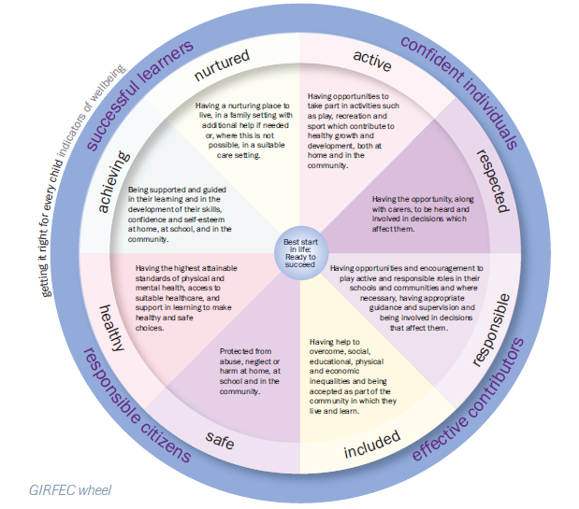

PROMOTING A WHOLE SCHOOL NURTURING APPROACH TO POSITIVE RELATIONSHIPS

Taking into account the following key themes:-
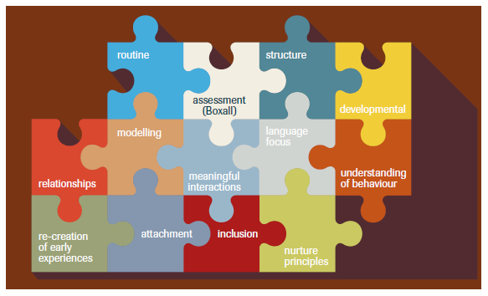

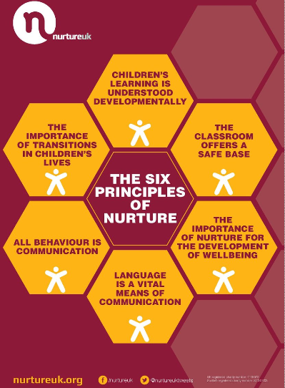

We promote:-

- Establishing and discussing class and school rules with the pupils.
- Encouraging positive peer relationships and responsibility.
- Praising pupils for exceptional behaviour and effort e.g. positive note/phone call/group call home, Hot Chocolate Fridays, House Points, weekly certificates
- Displaying achievements throughout the school
- Matching a “buddy” to younger pupils who require support particularly at times of transition.
- Bringing the school community together regularly
- Implementing Recognition boards throughout the school
- Visible positive consistency of boundaries, routines and verbal communication throughout the school
- Encouraging a mutual respect between all members of staff and pupils.

SCRIPTS

- I understand… (that you are angry/upset/livid)

- I will know you are ready when …(I see your table is tidy, I see your listening eyes)

- I know you can be respectful when…(you use an inside voice, you say kind words to others, you help clean up the mess)

- I know you are safe when …(you keep your hands, feet and objects to yourself)

- Thank you for…(making a good choice, showing me safe walking)

KEYSTONE ROUTINES WITHIN THE SCHOOL

- All staff to support children into school in the morning in a prompt fashion.
- Pupils will walk in an orderly line with their teacher, stopping to regroup at regular intervals.
- Children to pass the door to the next person in line whilst moving through corridors.
- Pupils will be greeted in the morning before entering the school/classroom.
- Children will knock first before entering a classroom or office.
- Teachers/Support staff and SLT will be at various points in the school to welcome pupils to school.
- A member of the SLT will be in the playground before the bell at 9am and at the end of the day.
- Every class to have a recognition board to praise achievements.
- Class teachers will have the opportunity to establish relationships by inviting parents/carers in to school at the start of each session.
- All staff to inform parents/carers that they will not accept money from children at the school gates. Money should be given to the class teacher (clearly marked envelope best in early years) or handed into school office.
- Any parent wanting to speak to a class teacher when they are bringing in the lines should be politely asked to go to the school office and either the CT or a member of the SLT will be in touch with the parent later on that day.
- Every class expected to respect the school environment by carrying out a ‘Friday Tidy’ of both their classroom and cloakroom.
- During interval/lunchtime all pupils should be outdoors unless alternative arrangements have been made with a member of staff.

