**Standards and Quality Report**

**Synopsis for Parents 2023-2024**

**Warout Primary School**

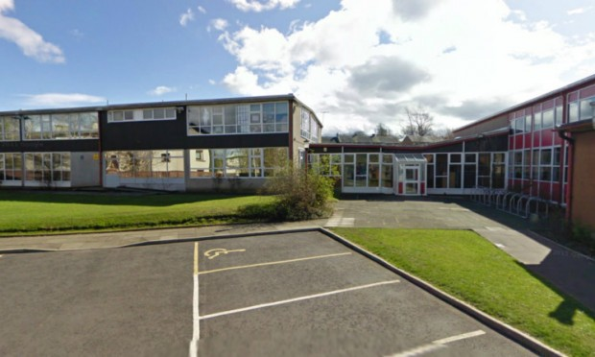

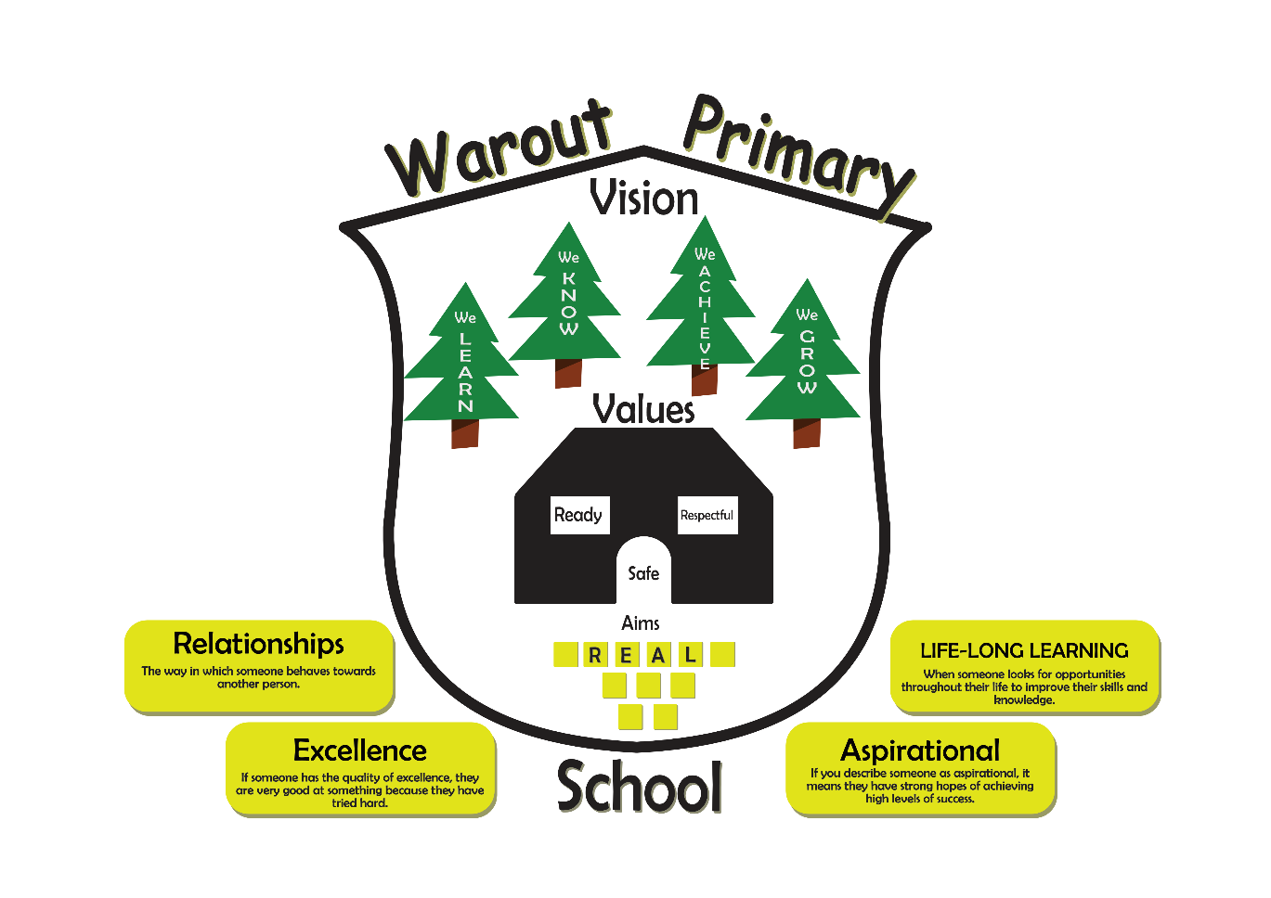

**Attainment**

**How well did our young people learn and achieve in 2023-2024**

|  |  |  |  |  |  |  |  |  |
| --- | --- | --- | --- | --- | --- | --- | --- | --- |
| **Stage** | **Listening and Talking** | | **Reading** | | **Writing** | | **Numeracy** | |
|  | **Actual** | | **Actual** | | **Actual** | | **Actual** | |
| **P1** | 66% | | 66% | | 66% | | 76% | |
| **P4** | 57% | | 53% | | 50% | | 53% | |
| **P7** | 55% | | 52% | | 40% | | 58% | |
| **Overall Attainment for 2023 - 2024** | | | | | | | | |
|  | | **Literacy** | | | | **Numeracy** | | |
|  | | **Stretch** | | **Actual** | | **Stretch** | | **Actual** |
| **P1** | | **77%** | | 66% | | **80%** | | 76% |
| **P4** | | **60%** | | 53% | | **70%** | | 53% |
| **P7** | | **70%** | | 49% | | **77%** | | 58% |

**Evaluative statement of attainment over time.**

Although in year 2023-2024, the school never made it’s stretch targets the following value added in attainment can be noted:

**P1 -** By the end of P1, **a majority of** children achieve early level in reading, writing, talking and listening and **most** children achieve early level in numeracy. This in an increase in numeracy attainment levels since 2022-2023 when it was only **a majority** of pupils.

In 2022-2023 - a **minority** of PEF pupils in Primary 1 achieved early level in literacy compared to this session 2023-2024 when the **majority** of PEF pupils achieved early level. This equates to a **26%** increase in attainment of this pupil group.

**P4 -** Our current P4’s have increased their attainment in reading by **20%** since P1 in 2020-2021.

Our current PEF pupils in P4, when in P1, the **minority** achieved early level in reading whereas in P4, the **majority** have achieved first level, thereby closing the attainment gap.

Our current PEF pupils in P4, **the majority** have achieved first level in writing, numeracy and listening & talking.

By the end of P4, the **majority of** children achieve first level in reading, listening & talking and numeracy.

**P7 -** Our current P7’s have increased their attainment levels in reading by **45%** since last year in P6.

Our current P7’s have increased their attainment levels in numeracy by **60%**  since last year in P6.

Our current P7’s have more than **doubled** their attainment in writing since P6.

By the end of P7, **a majority of** children achieve second level in reading, talking and listening and numeracy.

**Evidence of Wider Achievements**

There has been a wide variety of wider achievement opportunities across the school this session. All opportunities have developed a range of skills linked to the 4 capacities: Effective Contributor, Successful Learner, Responsible Citizens and Confident Individuals. These have been linked to your school values through Hot Chocolate Fridays.

These have been shared throughout the session through newsletters and Seesaw, Parent portal, website and celebrated through star of the week and assemblies.

**Bikeability** **- Most** pupils from P4 upward to P6 were given the opportunity to gain a Bikeability award.

Also this year we have had **most** children take part in our yearly Warout has talent contest. All children take part in our whole school Scottish afternoon and the majority of children taking part in an after-school sports event.

**School Aims 2023-2024**

**De-Escalation/ Nurturing Relationships**

School to enhance effective practices and approaches in positive behaviour management and to manage distressed/dangerous behaviour in a practical, effective and safe manner in any specific school context.

**Attendance**

Targeted group of 10 pupils will have their average attainment raised from 80% to 90% for the session 2022-2023.

Focused attendance before Holiday times especially December. Increase in attendance December 2023 from December 2022 which was 79%.

**Moderation Cycle**

All staff understand the moderation cycle and the importance of learners being at the heart of every stage. We have shared expectations for standards and have robust arrangements for moderation across stages and across the curriculum.

**What’s in a level**

Teachers use a range of assessment evidence to ensure confident professional judgements when declaring pupils’ levels within CfE and how they are progressing.

**Assessment framework**

There is an assessment framework with clear key checkpoints for assessments ensuring there is clarity around the school’s approach which is used consistently.

**Progress against our School Aims 2023-2024**

**De-escalation/Nurturing Relationships**

This early work on the new de-escalation pack has identified areas of strength and also steps for next year. After two years in school where we had evidence of highly dysregulated behaviours amongst some classes, we have managed a year with no high dysregulated learners however HMIe identified low level disruptions. Looking at the pack and the audit carried out with staff and pupils our barriers are:-

* Inconsistent staff responses.
* Unclear organisational aims and vision.
* Clear procedures in place for pupils opting out.
* Learner’s experiences that do not match learner’s needs.

To fit in with our Emotion Works, the following was devised to be used at whole school level and be added into our Whole School Nurturing Relationship Policy.

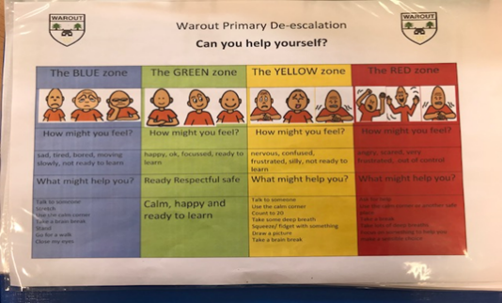

**Attendance**

**Most**  targeted pupils (8 out of 10) increased their attendance from below 90% to 90% or above. In November and December 2023, our PT Nurture had a focus on attendance and sent out Attendance SWAY to combat the decline in attendance at Christmas time. Session 2022-2023, December **attendance was 79%** and Session 2023-2024, December **attendance was 86%.**

**Moderation Cycle**

A Writing pack is available at each stage of the school with marking criteria for each text type with placemats to facilitate peer and self-evaluation. **Almost all** staff are at an early stage of engaging with the pack however the pack has been used during moderation activities. Again, **almost all staff** are at an early stage of this.

**What’s in a level**

Progression pathways are fully embedded in the planning documents for the school this session and **all** teachers are using Records for Understanding for literacy and numeracy.

**All** teachers have been part of **Collegiate Activity Time (CAT)** sessions and **In-set** days to look at data needed to make robust professional judgements of progression through the CfE levels. Information has been shared via our cluster PT Closing the Attainment Gap on “**What’s in a level”** and recently at our in-set day, we have looking at **Multiple Measures of data** as set out by ***Victoria L. Bernhardt.*** This way of looking at data for progression through a level was gained by looking outwards and working with colleagues in Dumfries and Galloway as part of the HeadT’s Headteacher’s role as Education Scotland Associate.

Throughout the year, **all** staff have used a variety of range of evidence sources which include use of SWAYS(P7), pupil sampling, formative assessment and summative assessment strategies.

The school tracking system has been updated and all information on attendance, tracking, Support plans, ASN needs are all together on a GLOW team. In preparation for tracking meetings, **all** staff come prepared to talk about pupils who are not on track and also who need challenged. At tracking meetings, the Support for Learning teacher is there along with our PT Nurture so a professional dialogue around next steps to ensure support and challenge are in place for each child.

**Assessment framework**

**All** staff have been involved with agreeing as Assessment framework that will be used at the start of Session 2024-2025. This will support staff further to develop appropriate use of diagnostic assessments at classroom level to inform planning for children’s next steps in learning. Alongside this document, our Learning and Teaching policy has been updated to include our assessment policy so the “Warout Way” of Learning , Teaching and Assessment can be started in session 2024-2025 and will be used to quality assure during the year.

**School Improvement Plan 2024-2025**

**Synopsis for Parents**

**What are the school’s improvement priorities for session 2024-2025**

Warout Primary School continues to benefit from The Pupil Equity Fund. Our improvement priorities are as follows: -

**Focused Priority 1:**

All Stakeholders will be involved in reviewing the Vision Value and Aims for the school to demonstrate consistently high expectations and raised aspirations for all children.

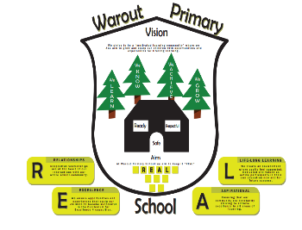

**Focused Priority 2:**

Teachers need to improve learning and teaching, with a particular focus on pace, challenge and progress.



**Focused Priority 3:**

Senior leaders should ensure there are improvements in children’s attainment, achievement and attendance.



**Focused Priority 4:**

Senior leaders and staff should review systems and processes for collecting and analysing attainment information to lead to improvement.

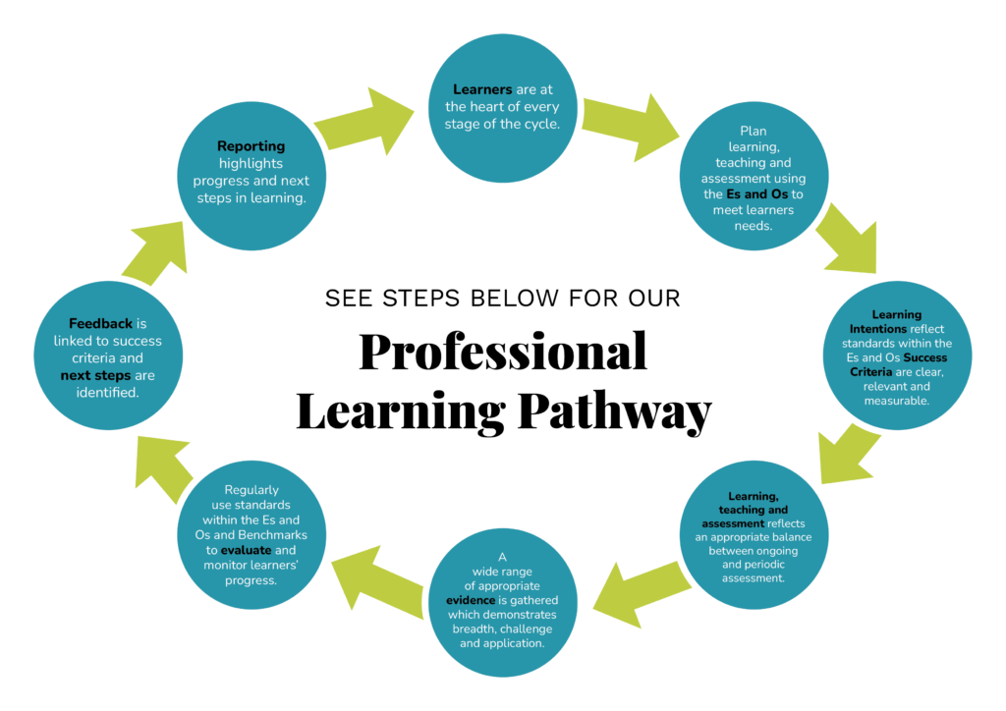

**Focused Cluster Priority**

All Schools in the AHS cluster will become ‘Reading Schools’ with the AHS cluster becoming a ‘Reading Cluster’ with Reading Schools Scotland

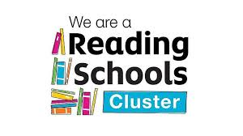

**Pupil Equity Funding Priorities**

Senior leaders and staff should review systems and processes for collecting and analysing attainment information to lead to improvement.

* 15% increase in Literacy attainment across the school. Increase in attainment in targeted groups.
* 15% increase in Numeracy attainment across the school. Increase in attainment in targeted groups.
* At least 50% of children will have access to a Nurture Intervention to improve wellbeing.