**4.**

**Improvements in Learning and Teaching with particular focus on pace, challenge, and progress**

**1.**

**All stakeholders will know our Vision Value and Aims to ensure consistently high standards and raised aspirations for all pupils**







**All Schools in the AHS cluster will become ‘Reading Schools’ with the AHS cluster becoming a ‘Reading Cluster’ with Reading Schools Scotland**

**At least 50% of children will have access to a Nurture Intervention to improve wellbeing**

**15% increase in Numeracy attainment across the school. Increase in attainment in targeted groups**

**15% increase in Literacy attainment across the school. Increase in attainment in targeted groups**

**Auchmuty Cluster Priority**

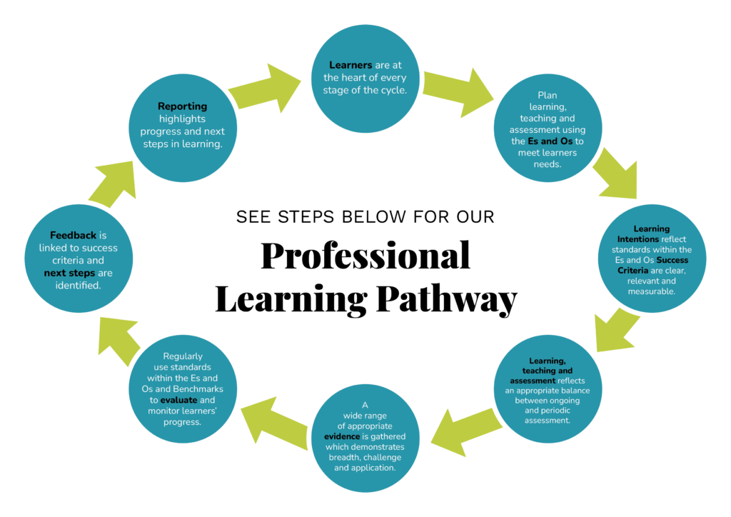



**3.**

**Improvements in children’s attainment, achievement and attendance**

**2.**

**Improved systems and processes for collecting and analysing attainment to lead to improvement**

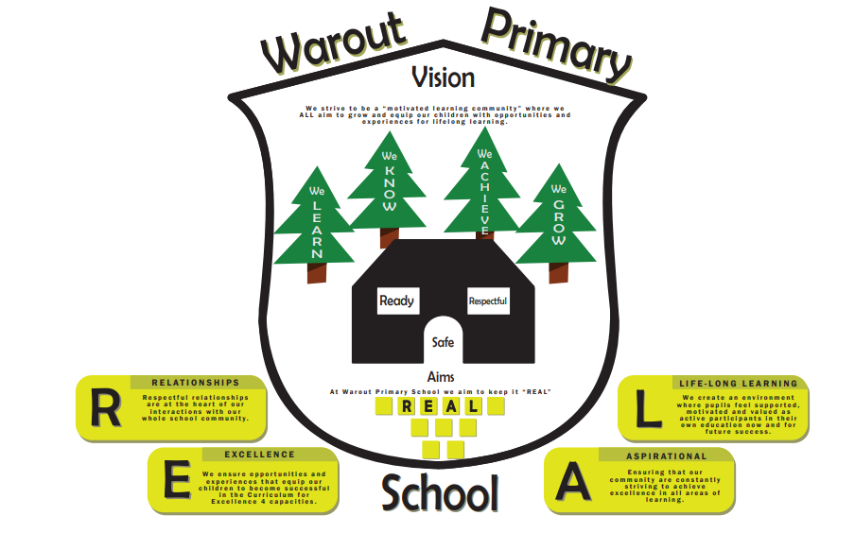



**Pupil Equity Funding Priorities**

Focused Priorities