Standards and Quality Report
Synopsis for Parents 2021-2022
Warout Primary School
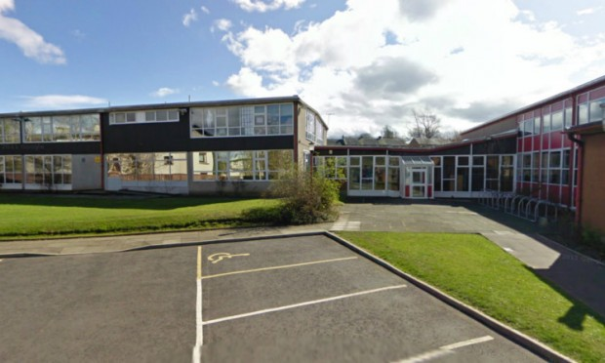

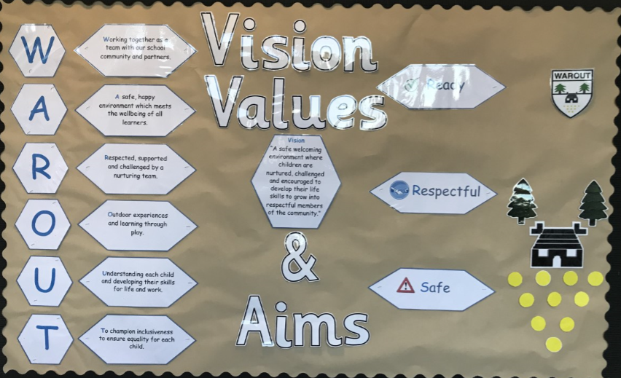

In August 2015, Warout Primary School became part of the Scottish Attainment Challenge and our key aims are focused on achievements in Literacy, Numeracy and Health and Well Being.
Attainment
Our projected attainment figures prior to school closure due to COVID 19 for 2019-2020
Literacy | 74% | Numeracy | 73%

How well did our young people learn and achieve in 2021-2022
Stage | L and T |  |  | Reading |  | Writing |  |  | Numeracy
Primary 1 | 69% |  |  | 59% |  | 59% |  |  | 55%
Primary 4 | 59% |  |  | 48% |  | 34% |  |  | 41%
Primary 7 | 71% |  |  | 58% |  | 46% |  |  | 33%
Overall | 66% |  |  | 41% |  | 48% |  |  | 33%
 | Literacy |  |  | 56% |  | Numeracy |  |  | 43%
Stretch Targets Warout PS |  | 2020/21 | 2021/22 |  | 2022/23 |  | 2023/24 | 2024/25
Literacy |  | 58.8 | 65.5 |  | 72.1 |  | 78.7 | 85.3
Numeracy |  | 64.9 | 70.5 |  | 76 |  | 80.7 | 85.4

School Aims 2021-2022
Attendance
Targeted group of 10 pupils will have their average attainment raised from 80% to 90% for the session 2021-2022.
Feedback Through Quality Assurance
Almost all children can give a sophisticated response to their next steps in learning for literacy and numeracy and how they are going to achieve it.
Pupil Participation
Pupils engaged and involved in decisions around equal opportunities for inclusive, voluntary participation.
Respect for children and young people’s rights and differences and transparency and accountability in decision making
Transition Nursery
Children will come up to P1 with a clear assessment portfolio with identified next steps to ensure pace of learning
Learning Environments
100% of classrooms will have a consistent learning environment that supports their learning needs and will aid transition from class to class.
Nurture
To reach 10 identified pupils with Social Emotional difficulties. All 10 children will have Boxall profiles carried out and 80% will show an increase in their developmental scores.
These 10 identified pupils will show an improvement in their ability to re-engage in their learning back in the classroom.
Whole school nurturing Ethos sustained in the school –
20% increase in staff knowledge, understanding and use of skills in applying nurture within the school
Most children, (75%) will have the opportunity to be part of a nurturing group within the school (25% increase from the session 2019-2020)
Warout Primary School will become a Kit Bag Ambassador school so the school will feel calmer, children more respectful of each other and relationships will deepen and strengthened as a result.
Warout primary School to use Emotion works to support pupils in Emotional Literacy.

Progress against our School Aims 2021-2022
Attendance
Our DHT contributed by delivering training and facilitating schools in the Tayside Regional Improvement Collaborative. Warout was part of this, and one staff member attended the training along with one of our clerical assistants. Three pupils were identified in the class teacher’s group of pupils. The nurture hub played a key role in
supporting this improvement priority and will do next year as well moving forwards. Out of the 10 pupils identified, 50% of pupils (Majority) have increased their attendance levels from the previous session. One piece of work that the class teacher found useful in identify potential barriers to attendance was a Quality Improvement tool, the Fish-bone analysis. This can be used next year when this work is continued.

Feedback
As a result of the 4-part lesson model being used in all classrooms, this has meant that learning targets and steps to success are used more successfully in lessons and children are aware of their targets and next steps and becoming more confident in explaining the why.
Almost All teachers are using the 4-part model lesson format in class thereby having uniformity throughout the school. This is either via printed board or PowerPoint presentation. Both are linked to career standard skills.
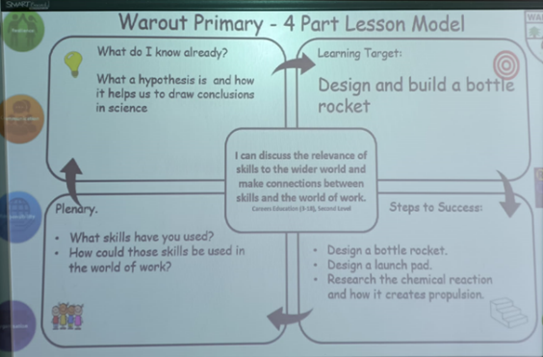
Almost all pupils asked about feedback could articulate how feedback helps them in what they’ve done well and what their next steps are. Some jotters are now showing children acting on their feedback which we know supports them in their next steps from our previous work with our Educational Psychologist.
Pupil Participation
This year everyone almost all pupils have been involved in a pupil voice group throughout the school. We have also been using the HGIOURS for self-evaluation.
Although every pupil has been part of a group, we fell that we want to look at Learner Participation through the 4 arenas next year. We were hoping that Our Food for Thought Grant would help with some of the work however we need to look at this again next year and our further aims are contained in our School Improvement Plan.
Transition Nursery
This year, we have had regular meetings to look at transition between nursery and school so ensure progression of learning. This year we have continued our weekly newsletter during the month of May and June for Pre school nursery children.
Learning Environments
There is a start to uniformity across the school which has resulted in pupils using their learning environments for support in their learning.
Nurture
We are continuing to have success this year and our Nurture Hub is making a huge difference to how our children can engage in their learning. The skills they learn in a smaller supported environment are crucial to support their learning now and later life.
9/10 children had Boxall profiles taken during the year and have had significant support in our Nurture Hub.
5 out of the 9 (The Majority) children who had Boxall profiles, showed an increase in their developmental scores.
Restorative Approaches are now embedded in the school.
All classes now use Kit bag on a regular basis, and we have been awarded Kitbag Ambassador Status
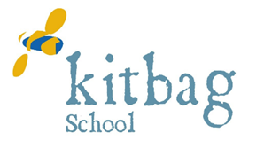

School Improvement Plan 2022-2023
Synopsis for Parents
What are the school’s improvement priorities for session 2022-2023
Warout Primary School continues to benefit from The Pupil Equity Fund. Our improvement priorities are as follows: -

Improvements in Teaching and Learning

Our school communities will deliver high quality learning and teaching in a uniform manner throughout the school.
Each child will have a voice in Learning, Teaching, and Assessment, Opportunities for Personal Achievement, Decision Making Groups, and a connection with the Wider Community

Learner Participation
A better school ethos based on trust, respect, and collaboration with the community.
Opportunities for increased participation across the “Four Arenas of Participation” that will deeply enrich their educational experiences in raising attainment, aspirations, and achievement.
Digital Award
A whole school approach to the use of digital technology in school. Staff to have the knowledge so pupils will be able to safely navigate the digital world.
Transition Nursery
Children will come up to P1 with a clear assessment portfolio with identified next steps to ensure pace of learning.
Writing
Raised attainment in Writing in P1, P4 and P7. Baseline P1 = 59%, P4 = 34%, P7 = 57%

Promoting Children’s Resilience

Our school communities will share an understanding of wellbeing where our learners will benefit from high quality wellbeing activities.
Each child will be considered as an individual with his or her own needs, risks and rights. Children and young people will be active participants in these activities.

Attendance
Targeted group of 10 pupils will have their average attainment raised from 80% to 90% for the session 2022-2023.

Nurture
•To reach 10 identified pupils with Social Emotional difficulties and support their re-engagement in their learning.
•Whole school nurturing Ethos sustained.
•Most children, (80%) will have the opportunity to be part of a nurturing group within the school (16% increase from the session 2021-2022)
•Warout Primary School to use Emotion works to support pupils in Emotional Literacy.

