**Standards and Quality Report**

**Synopsis for Parents 2022-2023**

**Warout Primary School**

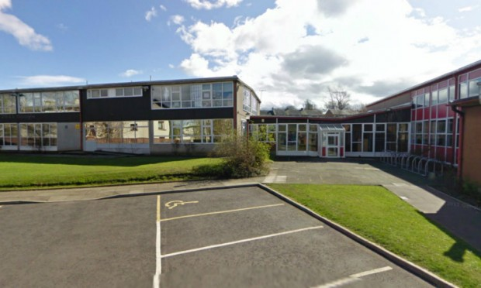

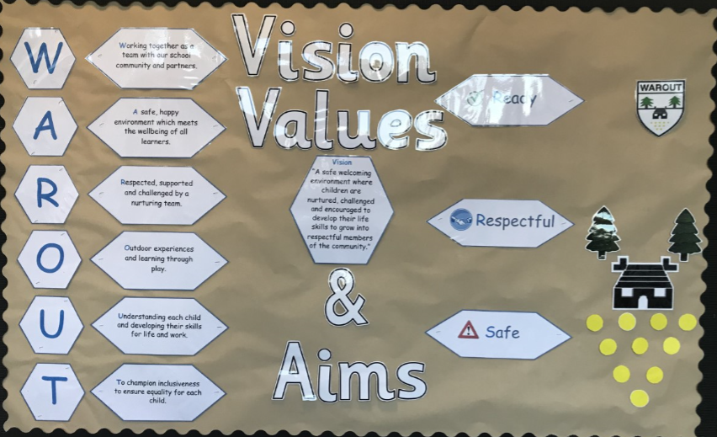

In August 2015, Warout Primary School became part of the Scottish Attainment Challenge and our key aims are focused on achievements in Literacy, Numeracy and Health and Well Being.

**Attainment**

Our projected attainment figures prior to school closure due to COVID 19 for **2019-2020**

|  |  |  |  |
| --- | --- | --- | --- |
| **Literacy** | **74%** | **Numeracy** | **73%** |

How well did our young people learn and achieve in 2022-2023

|  |  |  |  |  |
| --- | --- | --- | --- | --- |
| **Stage** | L and T | Reading | Writing | Numeracy |
| **Primary 1** | **71%** | **71%** | **71%** | **71%** |
| **Primary 4** | **59%** | **56%** | **44%** | **63%** |
| **Primary 7**  **2016-2017 (P1)** | **68%**  **52%** | **68%**  **43%** | **52%**  **47%** | **60%**  **38%** |
| **Overall** | **66%** | **65%** | **56%** | **65%** |
|  | **Literacy**  **Stretch Target** | **62%**  **69.3%** | **Numeracy**  **Stretch Target** | **65%**  **73%** |
|  | | | | |

**School Aims 2022-2023**

**Writing**

Raised attainment in Writing in P1, P4 and P7. Baseline P1 = 59%, P4 = 34%, P7 = 57%

**Attendance**

Targeted group of 10 pupils will have their average attainment raised from 80% to 90% for the session 2022-2023.

**Nurture**

* To reach identified pupils with Social Emotional difficulties and support their re-engagement in their learning.
* Whole school nurturing Ethos sustained.
* 80% of pupils will have the opportunity to be part of a nurturing group within the school (16% increase from the session 2021-2022)
* Warout Primary School to use Emotion works to support pupils in Emotional Literacy.

**Progress against our School Aims 2022-2023**

**Learner Participation – Partially achieved, Continued into next session**

All staff have undertaken professional learning to increase their knowledge and understanding of the UNCRC in order that staff can take cognisance of the UNCRC when planning learning experiences for pupils. This was done through collegiate sessions, professional learning on the UNCRC, professional reading and discussion on feedback from classroom visits.

All classes made links with UNCRC links with the school values of Ready, Respectful and Safe and these were displayed in class charters**.**

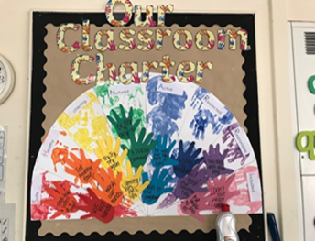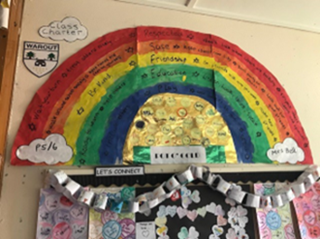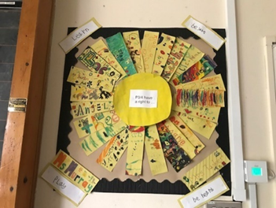

**Fab Friday groups**

All pupils in school became part of a Fun 31 group on a Friday afternoon which was linked to UNCRC Article 31 the right for all children to have rest and leisure, to engage in play and recreational activities appropriate to their age and to participate freely in cultural life and the arts. This was linked also to one of the four DYW skills adopted by the school which ties in with out four capacities and our I’ve been spotted achievement board.

**Four Arenas of Participation**

With the support of the Active Schools co-ordinator, the majority of our families gave information of wider achievements outside school. As a result of this information, Active school staff came and gave extra active sessions to pupils in P4, P5, P6 and P7. Also working with Glenrothes Strollers, we had 16 boys from P4 and P5 attend an early morning breakfast and football session on a Friday morning. All families that recorded inactivity of wider achievements from sport and outside clubs got additional sessions of sport at school.

As a request from the pupils from pupil voice sessions last session, they had asked for more recognition for achievements in school. This year we re-introduced house points and had a system in place to recognise class of the week. For pupils following the school values of Ready, Respectful and Safe, one pupil from each class was invited to attend for Hot Chocolate Friday with the HT on a Friday. Also, two pupils were awarded certificates based on skills shown through the 4 capacities at our weekly school assembly.

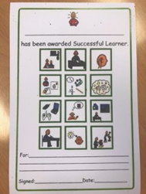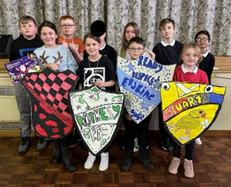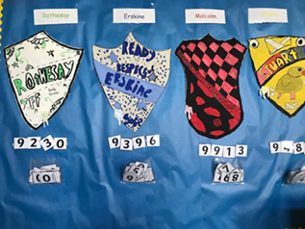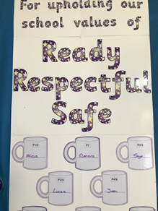

This year everyone almost all pupils have been involved in a pupil voice group throughout the school. We have also been using the HGIOURS for self-evaluation.

**Digital Award**

The increased use of digital literacy within the school has meant that pupils can learn at their own pace and have more independence when completing their work. The use of technology means that they feel more included, and their learning is easier to access. It has also been evident the pride that pupils show, especially after completing a piece of written work with Clicker and classroom observations have shown the enthusiasm pupils have for writing when in the past, many pupils have shown reluctance in writing using more traditional methods,

**Transition Nursery**

As we don’t have a nursery, we want to make sure that accurate assessment data for each pupil comes up from nursery so next steps in learning are clear to ensure Pace and Challenge. Information contained in the PLJ of each pupil contains an accurate assessment profile however discussions between nursery and our P1 teachers has focussed on how this system marries up with our records of understanding which is used as a record of assessment for each Primary aged child. As the school now has adopted records of understanding this session, links have been made with nursery staff to look at how a record of assessment can be taken form the PLJ and matched into the RFU’s, so each child comes up with a Records For Understanding profile.

**Writing improvements**

|  |  |
| --- | --- |
| **Stage** | Writing |
| **Primary 1 (June 2023)**  Baseline | **71%**  **59%** |
| **Primary 4 (June 2023)**  Baseline | **44%**  **34%** |
| **Primary 7(June 2023)**  **2016-2017 (P1)** | **52%**  **47%** |

**Nurture**

We are continuing to have success this year and our Nurture Hub is making a huge difference to how our children can engage in their learning. The skills they learn in a smaller supported environment are crucial to support their learning now and later life.

showed an increase in their developmental scores.

Restorative Approaches are now embedded in the school.

All classes now use Kit bag on a regular basis, and we have been awarded Kitbag Ambassador Status

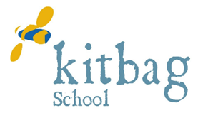

**School Improvement Plan 2022-2023**

**Synopsis for Parents**

**What are the school’s improvement priorities for session 2022-2023**

Warout Primary School continues to benefit from The Pupil Equity Fund. Our improvement priorities are as follows: -

**Improvements in Teaching and Learning**

*For the school to have a robust shared assessment framework as a result of engaging consistently with the “Learning, Teaching and Assessment Cycle”.* *teachers will have the information necessary to determine where the children are in their learning at any given moment and identify any gaps which may prevent them progressing and moving forward. Also enabling pupils to take an active role in their own learning.*

* Understanding of the moderation cycle and the importance of learners being at the heart of every stage.

.

* There is an assessment framework with clear key checkpoints for assessments ensuring there is clarity around the school’s approach which is used consistently. Assessment approaches which allow learners to demonstrate their knowledge and understanding, skills, attributes and capabilities in different contexts. Pupils know what their strengths and the areas they need to improve.
* Across our school we have shared expectations for standards to be achieved and have robust arrangements for moderation across stages and across the curriculum.

**Promoting Children’s Resilience**

*Our school community will share an understanding of wellbeing where our learners will benefit from high quality wellbeing activities.*

*Each child will be considered as an individual with his or her own needs, risks and rights. Children and young people will be active participants in these activities.*

**Attendance**

Targeted group of 10 pupils will have their average attainment raised from 80% to 90% for the session 2022-2023.

**Nurture**

School to enhance effective practices and approaches in positive behaviour management.