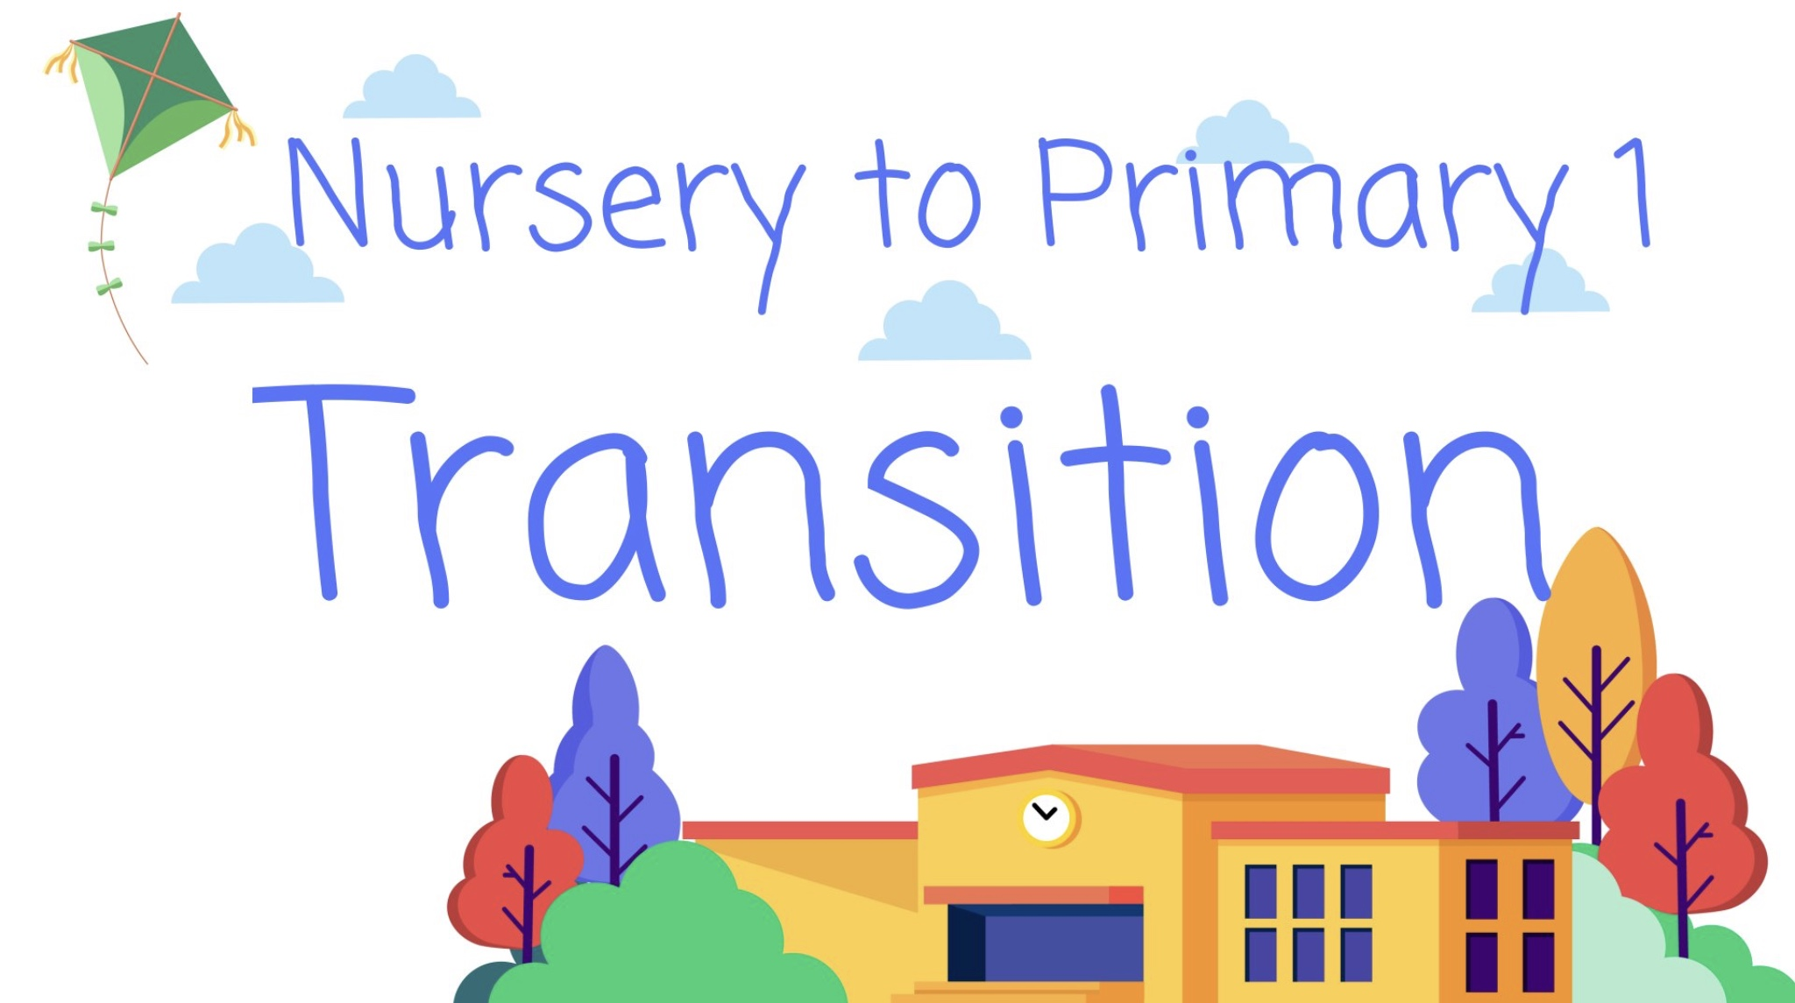

**Children will come up to P1 with a clear assessment portfolio with identified next steps in Learning to ensure pace** **of learning is maintained**

**We will achieve our Digital School Award**

Focused Priorities

**Increase Children’s Participation in Learning across all Four Arenas of Participation**

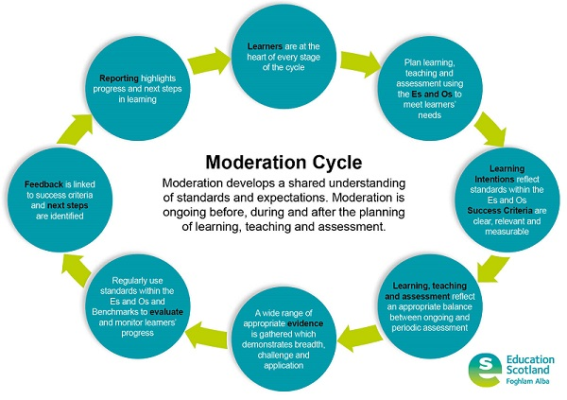

**Our Assessment overview which outlines a range of robust assessment procedures in Literacy and Numeracy and plans for regular moderation activities**

Continue to embed

**Targeted intervention to increase pupils engagement in learning and improve social emotional difficulties**



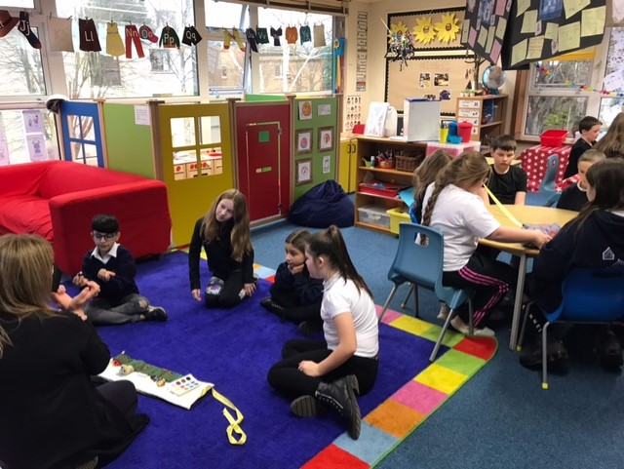



**Attendance**

Targeted Intervention

**91.4% whole school**

**Update our Website and share our Curriculum Rationale**





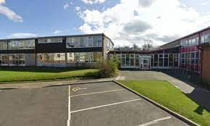

69% of children in P1, P4 & P7 will be on track for **Writing by 2023**



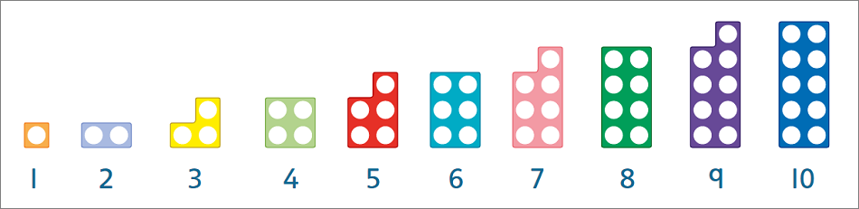

73% of children in P1, P4 & P7 will be on track for **Numeracy by 2023**

69% of children in P1, P4 & P7 will be on track for **Reading by 2023**



**Attainment and Attendance**

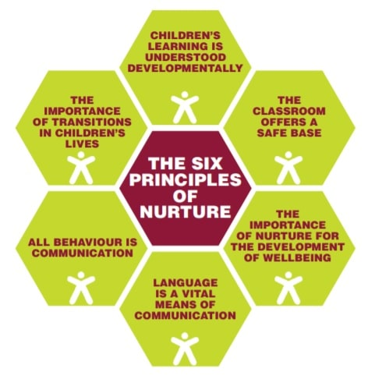

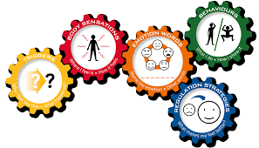

**Emotion Works to support our children’s social-emotional learning and well-being**

**Promote positive relationships and nurturing approaches to support learner needs.**

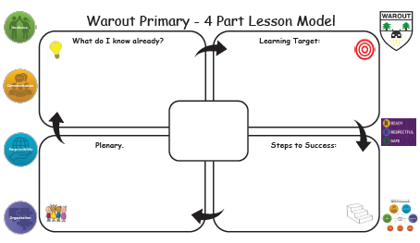

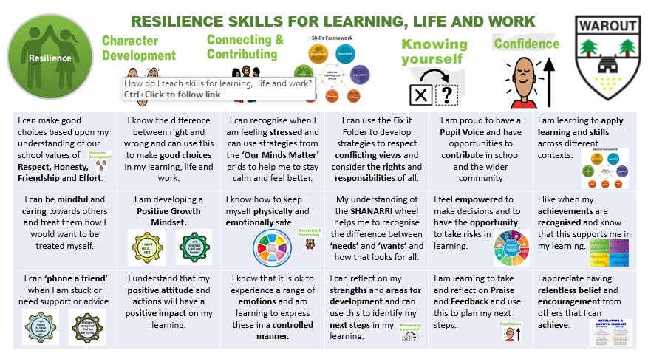

**Consistent use of our 4-part Learning and Teaching model and our DYW grids**