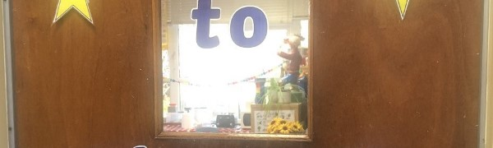
The Nurture Hub
Our Nurture Room was first developed at Warout Primary in August 2019.
Go to this Sway

