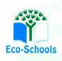
Primary One Family Learning Grid – Term 1
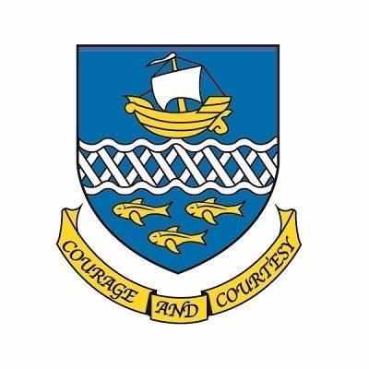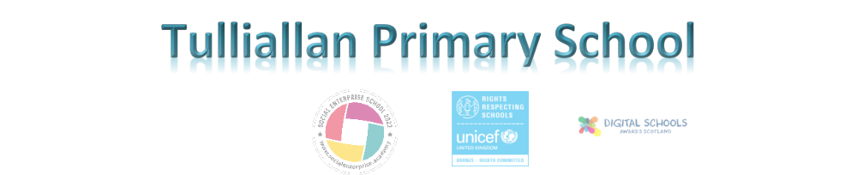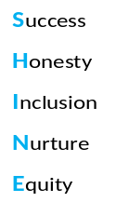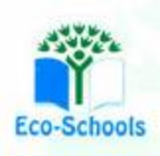

Primary Two Family Learning Grid – Term 1
The tasks on each home learning grid are designed to cover a variety of curricular areas and important life skills as well as making connections with the United Nations Convention on the Rights of the Child. The UNCRC promotes children’s rights including the right to education, family guidance and rest, play, culture and arts. Completing at least one task a week
allows children the opportunity to make links between these rights at school and at home.

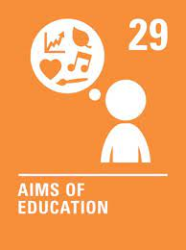
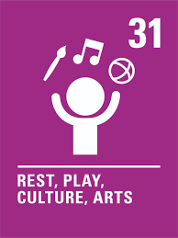
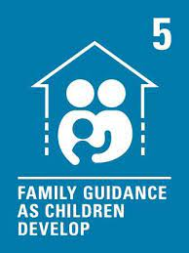

I can take part regularly in a sports class or club. | I can talk about why I should use the lollypop person. | I can out about and/or join a club in my local area such as rainbows or cubs. | I can dance/move along to music and follow some actions/steps and choreography.
I know who can help me to look after myself and I can draw a family picture. | I can draw and write instructions, for example, how to make a sandwich. | I can be active by going for a local walk with my family. | I can read o’clock and half past times on digital and analogue clocks.
I can help with the recycling in my home. | I can talk about the qualities a good friend can have. | I can show an adult at home how I log into and account, e.g. GLOW.  . | I am learning to ride my bike.
I can confidently get ready for PE myself. | I can talk about what I would like to learn in P2. | I can choose a healthy snack for school and explain why I chose it. | I can carry out an act of kindness for a family member or a person in my community.

You will have a chance to share your completed tasks in class every Friday

You can also choose to upload any photos or written pieces of work to Teams.

