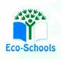
Primary One Family Learning Grid – Term 1
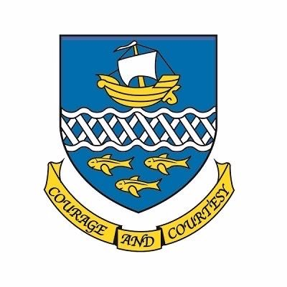

Primary Two Family Learning Grid – Term 4
The tasks on each home learning grid are designed to cover a variety of curricular areas and important life skills as well as making connections with the United Nations Convention on the Rights of the Child. The UNCRC promotes children’s rights including the right to education, family guidance and rest, play, culture and arts. Completing at least one task a week
allows children the opportunity to make links between these rights at school and at home.

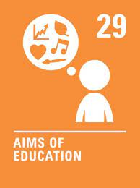
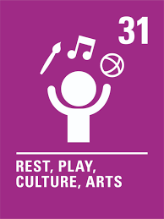
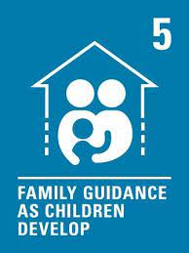

I can work to improve my fitness by completing reps of a specific movement, for example star jumps. | I can use coins to make a purchase. | I can use my senses to take notice of the changing seasons in my local area. | I can construct a 3D object.
I can act as a character from a book, TV show, film or game for others to guess, using my voice and body. | I can demonstrate a practical skill when using kitchen equipment e.g. chopping. | I can create and follow rules for looking after a digital device. | I can use a variety of words to talk about how I feel in different situations.
I can find tricky words in my reading book and practise spelling them. | I can visit my local library and choose a book I would like to borrow. | I can estimate how tall an object is and check using non-standard units e.g. hands, cubes | I can design a healthy packed lunch and explain why I chose each item.
I can sing a short song or nursery rhyme. | I can identify odd and even numbers:  Place Value Basketball - Dienes Game(topmarks.co.uk) | I can make a list of people I can talk to if I feel worried or sad. | I can pick a non-fiction book to learn about something I am interested in.

You will have a chance to share your completed tasks in class every…………

You can also choose to upload any photos or written pieces of work to Teams.

