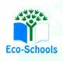
Primary One Family Learning Grid – Term 1
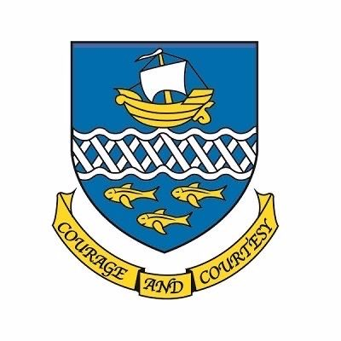

Primary One Family Learning Grid – Term 4
The tasks on each home learning grid are designed to cover a variety of curricular areas and important life skills as well as making connections with the United Nations Convention on the Rights of the Child. The UNCRC promotes children’s rights including the right to education, family guidance and rest, play, culture and arts. Completing at least one task a week allows children the opportunity to make links between these rights at school and at home.
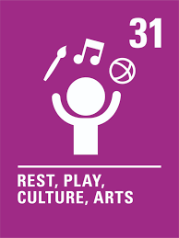
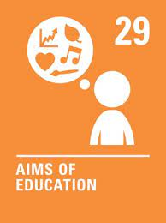
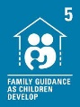

I can throw/kick a ball at a given target. | I can measure ingredients using cups and spoons. | I can complete a scavenger hunt using the letters in my name. | I can create a number sign/plaque for my door.
I can spend time doing calming activities I enjoy. | I can make rules for looking after a digital device. | I can give examples of things which are big and small and heavy and light. | I can play a topmarks game: Learning to Count up to 15 with Teddy Numbers Interactive Maths Game (topmarks.co.uk)
I can draw a new front cover for a favourite book. | I can talk about what I have learned and what I would like to learn next. | I can use different coins and notes when role playing or at the shops. | I can choose a favourite animal and draw it. I can explain why I like it.
I can write a story. | I can talk about things I am looking forward to in P2. | I can choose a healthy snack for school. | I can talk about ways technology helps me.

You will have a chance to share your completed tasks in class every Friday

You can also choose to upload any photos or written pieces of work to Teams.

