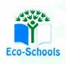
Primary One Family Learning Grid – Term 1
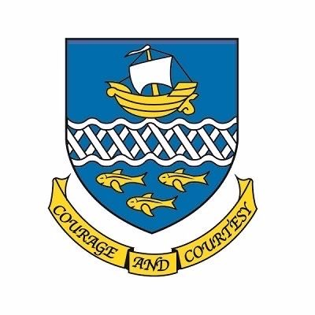

Primary Three Family Learning Grid – Term 4
The tasks on each home learning grid are designed to cover a variety of curricular areas and important life skills as well as making connections with the United Nations Convention on the Rights of the Child. The UNCRC promotes children’s rights including the right to education, family guidance and rest, play, culture and arts. Completing at least one task a week
allows children the opportunity to make links between these rights at school and at home.

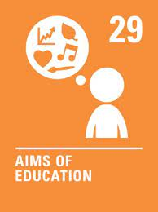
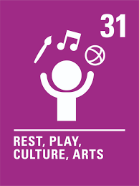
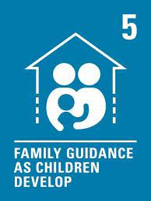

I can make up a game to play in the playground and share the aim and rules with my friends. | I can give change in a play scenario. | I can talk about how to save energy in my home and make a plan with my family to put my ideas into action. | I can act as a character from my favourite book, TV show, film or game for others to guess, using my voice, body and facial expressions.
I can use my senses to practise mindfulness – e.g. stand outside with my eyes closed and make a list of all the things can hear and smell | I can talk to an adult about staying safe online. | I can think of a problem in my local community and draw and label a picture of my invention to solve it. | I can make a shape picture using a variety of different shapes.
I can write an acrostic poem using my own name or someone else’s. | I can write a book review for a book I have read and make a recommendation about who might enjoy it. | I can design a new front cover for a book I have enjoyed. | I can design a boardgame to help someone learn their timestables.
I can make a leaflet or poster about a place that I have visited and found interesting. | I can set myself a fitness target and work towards it, for example, running a mile. | I can make a poster to teach younger children about road safety. | I can design a science experiment.

You will have a chance to share your completed tasks in class every Friday
You can also choose to upload any photos or written pieces of work to Teams.

