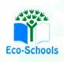
Primary One Family Learning Grid – Term 1
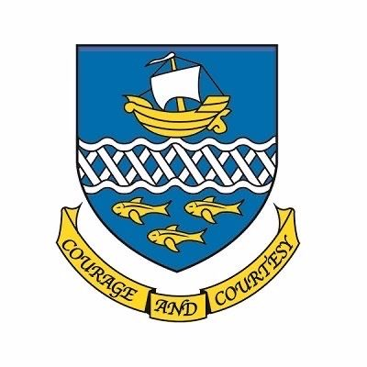

Primary Three Family Learning Grid – Term 3
The tasks on each home learning grid are designed to cover a variety of curricular areas and important life skills as well as making connections with the United Nations Convention on the Rights of the Child. The UNCRC promotes children’s rights including the right to education, family guidance and rest, play, culture and arts. Completing at least one task a week allows children the opportunity to make links between these rights at school and at home.
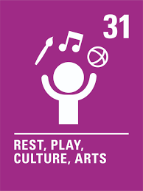
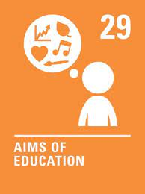
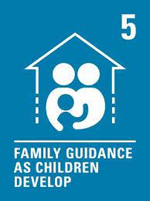

I can enjoy dancing to music with my family. | I can zip my own coat and independently tie my laces. | I can observe wildlife in its natural habitats. | I can make a model of a boat and explore floating and sinking.
I can describe different jobs that adults do. | I can research a topic that I am interested in and share some information as a poster, leaflet or presentation. | I can use estimation and rounding to add up the total of items when shopping before I get to the till. | I can use a variety of passes to throw and catch a ball.
I can write a story with a beginning, middle and end. | I can find examples of symmetry in the world around me. | I can help to prepare a simple lunch. | I can play a word game like Scrabble or Boggle with my family or friends.
I can carry out an act of kindness for a family member or a person in my community. | I can invent a new game to play in with my friends or in the playground. I can make it fair and explain the rules to others. | I can sort foods as healthy or unhealthy. | I can access the Beebot app (free) and explore levels 4-6.

You will have a chance to share your completed tasks in class every…………
You can also choose to upload any photos or written pieces of work to Teams.

