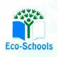
Primary One Family Learning Grid – Term 1
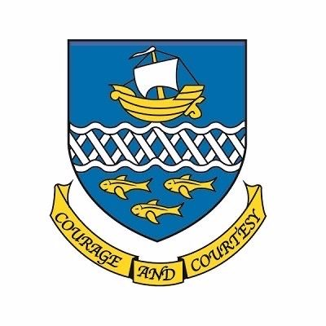

Primary Two Family Learning Grid – Term 2
The tasks on each home learning grid are designed to cover a variety of curricular areas and important life skills as well as making connections with the United Nations Convention on the Rights of the Child. The UNCRC promotes children’s rights including the right to education, family guidance and rest, play, culture and arts. Completing at least one task a week
allows children the opportunity to make links between these rights at school and at home.

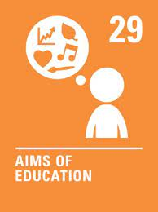
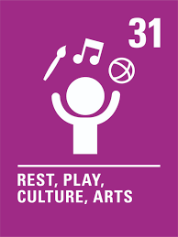
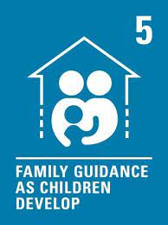

I can enjoy dancing to music with my family. | I can make a poster about crossing the road safely. | I enjoy talking about my food. | I can take action for the environment by taking part in litter picking or a beach clean.
I can name the primary colours. | I can identify the people, jobs and workplaces in my local community. | With an adult, find information about something you are interested in online.  Access Beebot app (Free) and explore levels 1- 3. | I can construct a 3D object.
I can explain why recycling is important. | I can give examples of a time I have been a good friend. | I can talk about a sport I enjoy taking part in. | I can write a story with a beginning, middle and end.
I know my own address. | I can practise skip counting in two’s. | I can say the days of the week in order. | I can talk about the four seasons and the features of each.

You will have a chance to share your completed tasks in class every…………

You can also choose to upload any photos or written pieces of work to Teams.

