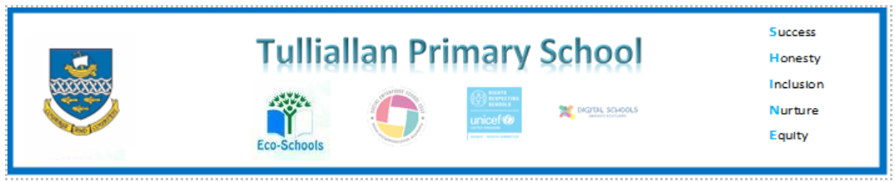

Primary Three Family Learning Grid – Term 2
The tasks on each home learning grid are designed to cover a variety of curricular areas and important life skills as well as making connections with the United Nations Convention on the Rights of the Child. The UNCRC promotes children’s rights including the right to education, family guidance and rest, play, culture and arts. Completing at least one task a week allows children the opportunity to make links between these rights at school and at home.
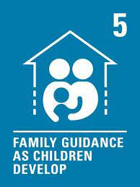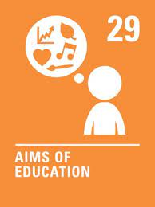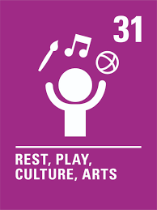
I can improve my fitness by completing an increasing number of reps of a specific movement, for example star jumps. | I can choose something from home for my Digital Learning Journal that shows I am a confident individual. | I can take responsibility for caring for a garden or outside space. | I can make a homemade percussion instrument and play it, keeping a steady beat.
I can demonstrate skills when using kitchen equipment. | I can design my own decoration for a cake. | I can plan a simple menu and find out how much it would cost to make. | I can use a variety of passes to throw and catch a ball with increasing confidence.
I can choose a book I have read and design new illustrations for it. | I can write a letter or postcard to someone and address it correctly. | I can look for examples of fractions in the world around me, for example, half price. | I can write a book review for a book I have enjoyed.
I can name the people that can help me if I am worried about something. | I can research an author I like and find out some facts about their life. | can log on to Glow and access Teams to share some learning. | I can practise my times tables - https://www.topmarks  .co.uk/maths-games/hit-the-button.

You will have a chance to share your completed tasks in class every .....
You can also choose to upload any photos or written pieces of work to Teams.

