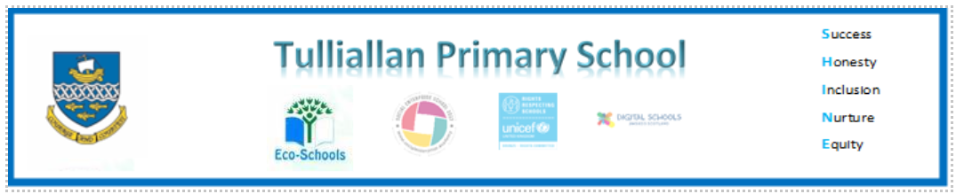

**Primary Three Family Learning Grid – Term 1**

The tasks on each home learning grid are designed to cover a variety of curricular areas and important life skills as well as making connections with the United Nations Convention on the Rights of the Child. The UNCRC promotes children’s rights including the right to education, family guidance and rest, play, culture and arts**. Completing at least one task a week**

allows children the opportunity to make links between these rights at school and at home.

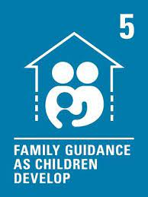 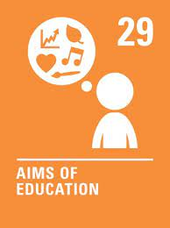 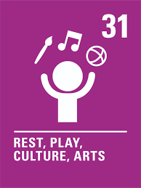

|  |  |  |  |
| --- | --- | --- | --- |
| I can regularly take part in a sports class or club. | I can write a shopping list and use it. | Talk about and prepare to share information about a club in my local area such as rainbows or cubs. | I can dance/move along to music and follow actions/steps and choreography. |
| I can talk about how to look after a baby. | I can write a set of instructions, for example, how to build a Lego model. | I can enjoy longer family walks. | I can read ¼ to and ¼ past on digital and analogue clocks. |
| I can identify and find Fairtrade products in my local shop. | I can create a symmetrical pattern. | I can give examples of how to make friends. | I can change my password on glow and remember it. |
| I am learning to ride my bike. | I can write a book review of a book I have enjoyed. | With an adult I can find out about ways to cross the road in Kincardine. | I can identify tricky words in my book and practise spelling them. |

**You will have a chance to share your completed tasks in class every .....**

You can also choose to upload any photos or written pieces of work to Teams.