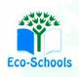
Primary One Family Learning Grid – Term 1
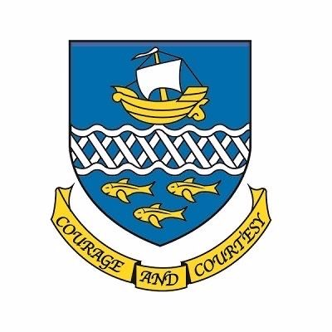

Primary Two Family Learning Grid – Term 3
The tasks on each home learning grid are designed to cover a variety of curricular areas and important life skills as well as making connections with the United Nations Convention on the Rights of the Child. The UNCRC promotes children’s rights including the right to education, family guidance and rest, play, culture and arts. Completing at least one task a week
allows children the opportunity to make links between these rights at school and at home.

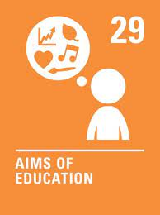
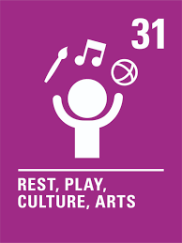
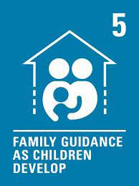

I can throw and catch a ball with two hands. | I can follow a simple recipe with support. | I can go for a walk in my community and appreciate wildlife. | I can construct a 3D object.
I can prepare a simple healthy snack or drink.  . | I can choose something from home for my Digital Learning Journal that shows I am a successful learner. | I can create and enjoy a homemade obstacle course. | I can order the days of the week and give examples of things I do on each day,
I can write a diary entry about a day I have enjoyed. | I can make a thank-you card for someone who has helped me. | I can explain the rules of a game that I enjoy and write them down. | I can say a few words in French or Scots.
I can sing a short song or nursery rhyme. | I can practise ordering numbers: Caterpillar Ordering - An Ordering and Sequencing Game (topmarks.co.uk) | I can talk about people in our community who help me. | I can talk about ways to stay fit and healthy and know why this is important.

You will have a chance to share your completed tasks in class every…………

You can also choose to upload any photos or written pieces of work to Teams.

