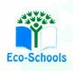
Primary One Family Learning Grid – Term 1
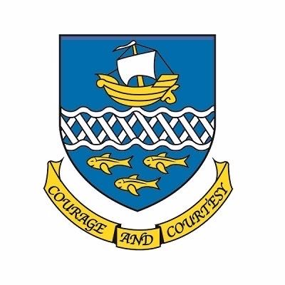

Primary One Family Learning Grid – Term 3
The tasks on each home learning grid are designed to cover a variety of curricular areas and important life skills as well as making connections with the United Nations Convention on the Rights of the Child. The UNCRC promotes children’s rights including the right to education, family guidance and rest, play, culture and arts. Completing at least one task a week allows children the opportunity to make links between these rights at school and at home.
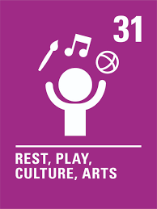
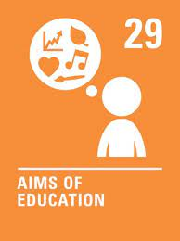
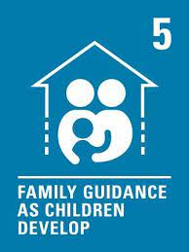

I can use a variety of balls to practise throwing and catching. | I can try new foods, selecting what I like. | I can take part in the RSPB Big Bird Watch. | I can make a bird feeder to put outside.
I can talk about the months of the year. | I can sit down for a meal with my family. | I can order items using words like ‘tall’ ‘taller’ and ‘tallest’. | I can play a topmarks game:Shape Patterns (topmarks.co.uk)
I can share a favourite song or nursery rhyme and explain why I like it. | I can choose a piece of work from home to add to my digital learning journal. | I can identify different coins and notes. | I can use items I find in nature to make a picture or piece of art.
I can go for a walk and write or draw about the things I have seen. | I can talk about the jobs I would like to do when I grow up. | I can name some examples of healthy food. | I can use IT to make a piece of art.

You will have a chance to share your completed tasks in class every Friday

You can also choose to upload any photos or written pieces of work to Teams.

