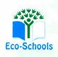Primary One Family Learning Grid – Term 1

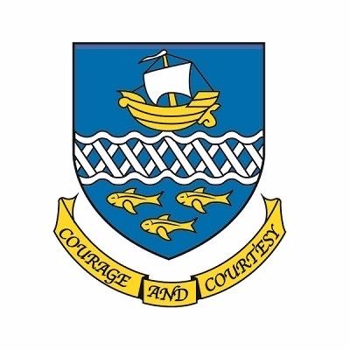

**Primary One Family Learning Grid – Term 2**

The tasks on each home learning grid are designed to cover a variety of curricular areas and important life skills as well as making connections with the United Nations Convention on the Rights of the Child. The UNCRC promotes children’s rights including the right to education, family guidance and rest, play, culture and arts**. Completing at least one task a week**

allows children the opportunity to make links between these rights at school and at home.

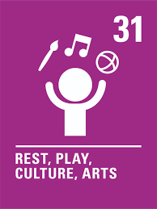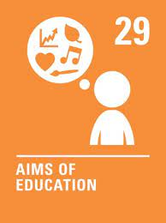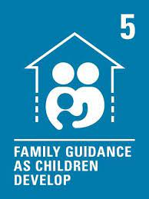

|  |  |  |  |
| --- | --- | --- | --- |
| I am learning to ride my bike. | I can follow a daily routine talking about what I do in the morning, afternoon and evening | I can identify the different shops in my local area and discuss how these help me. | I can construct a simple tower. |
| I can talk about the days of the week. | I can draw a picture of my favourite character in a story. | I can practise counting. | I can create a pattern with different shapes or colours and can explain my pattern to others. |
| I can do the actions for different songs. | I can retell a story with a beginning, middle and end. | I can tie my shoe laces with support. | I can make a card/picture for the local care home to celebrate National Day of Arts in Care Homes in September. |
| I can use junk material to create a model/vehicle etc. | I can say what job I am role playing. | I can compare foods which we should eat less of and more of. | With an adult, I can open a search engine |

**You will have a chance to share your completed tasks in class every…………**

You can also choose to upload any photos or written pieces of work to Teams.