Primary One Family Learning Grid – Term 1

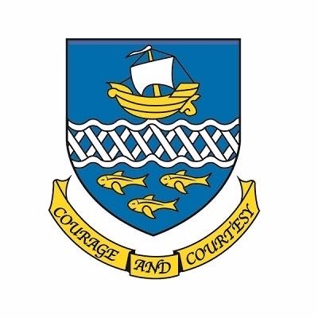

**Primary Six Family Learning Grid – Term 1**

The tasks on each home learning grid are designed to cover a variety of curricular areas and important life skills as well as making connections with the United Nations Convention on the Rights of the Child. The UNCRC promotes children’s rights including the right to education, family guidance and rest, play, culture and arts**. Completing at least one task a week**

allows children the opportunity to make links between these rights at school and at home.

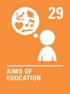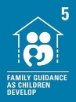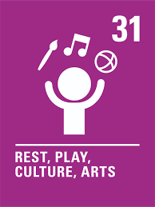

|  |  |  |  |
| --- | --- | --- | --- |
| With support I can teach someone else the skills I have been learning in a club or class. | I can research and discuss the rules of the highway code.  . | I can carry out an act of kindness for a family member or a person in my community. I can report on the event. | I can dance/move to music while counting out loud in time with the music using some of my own steps/Choreography. |
| I can help look after my local community by being a responsible citizen. | I can create and test out an algorithm to make sure there is nothing missing or unclear. | I can take part in the couch to 5k programme. | I can use a variety of timetables to calculate the duration of different journeys. |
| I can go for a walk in the local area and share what I find. I can share ways to make my environment a better place to stay. | I can create an interesting piece of text using examples of figurative language. | I can write a healthy eating plan for myself. | I can add to my Digital Learning Journal. |
| I can demonstrate a variety of cooking techniques such as baking, grilling, chopping, kneading. | I can take part in a team activity. I can discuss my role in the team. | I can identify and evaluate the best deals in the supermarket. | I can talk about the Global Goal: Zero Hunger, I can visit the local food hub. |

**You will have a chance to share your completed tasks in class every Friday.**

You can also choose to upload any photos or written pieces of work to Teams.