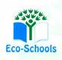Primary One Family Learning Grid – Term 1

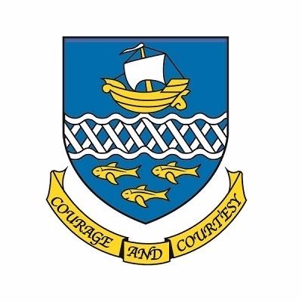

**Primary One Family Learning Grid – Term 1**

The tasks on each home learning grid are designed to cover a variety of curricular areas and important life skills as well as making connections with the United Nations Convention on the Rights of the Child. The UNCRC promotes children’s rights including the right to education, family guidance and rest, play, culture and arts**. Completing at least one task a week**

allows children the opportunity to make links between these rights at school and at home.

|  |  |  |  |
| --- | --- | --- | --- |
| I can cross the road safely with an adult. | I can learn some nursery rhymes/ songs and share them with others. | I can identify and create a pattern using shape and colour. | I can be active by going for a local walk with my family. |
| I can look for numbers in the world around me. | I can take part in a sports class or club. | I can practise counting. | I can dance/move along to music with an adult while following actions/steps. |
| I can talk about who is in my family. | I can order items using words such as: ‘big’ ‘bigger’ ‘biggest’. | I can list at least three things I know that use passwords. | I can talk about a favourite book and why I like it. |
| I can practise writing my name. | I can talk about my new school friends. | I can identify where the lolly pop lady stands. | I can notice and collect evidence of the seasonal changes in my garden/ local environment/park etc. |

**You will have a chance to share your completed tasks in class every Friday.**

You can also choose to upload any photos or written pieces of work to Teams.

